RIVANNA RIVER STEWARD MONTHLY REPORT
Date: July 2014
River Steward Name(s): Dan Triman and Justin Altice

River Sections Paddled this Month:
- Darden Towe Park To Riverview Park (2 times)
- Riverview Park to Milton (1 time)
- Milton to Crofton (1 time)
Total River Miles Paddled this Month: 18.5 miles
General Weather Conditions: mid 70’s – lower 90’s, mostly sunny
General Precipitation: fairly dry month with the occasional afternoon storm
General Water Characteristics (Flow, Color, Odor, Depth, Temp):
Slower flow rates most of the month, with less rainfall. Color was clear most of the time, with minor occurrences of murkier water. Depth of water was typically in the 3.2-3.7 foot range in Fluvanna County and the 1.4 foot range near Charlottesville. Water temperatures were in the 26-28 deg C range. No odor noticed in water.
Water Testing Summary:
3 water quality tests were completed. 1) 3 miles before Crofton access point, near rocks in middle of river (DO: 2 ppm, PH: 8, Turbidity: 20 JTU), 2) under I-64 bridge underpass (DO: 1 ppm, PH: 7.0 , Turbidity: 40 JTU), 3) just before Riverview Park boat landing at River right (DO: 2 ppm, PH: 7.0 , Turbidity: 20 JTU)
Major Findings:
We saw turtles, birds (ducks, geese, hawks, a bald eagle, and kingfishers), beavers, an otter, deer, frogs, and fish (including long nose gar). We saw other several fishers, people enjoying beach areas, hikers along the trails, and a lot of people swimming at Riverview Park. We removed litter (plastic, food trash, tires, soda and beer cans, etc.) from the River. Saw about 15 tires between Milton and Crofton. We found a piece of farm equipment on the bank (near Crofton), a piece of a car on the bank (near Darden Towe) and a table stuck up in a tree (near Crofton). The River near Charlottesville had more litter than the River in more rural areas. Some bank erosion was noticed, as well as many downed trees. We also noticed a new pipe that was discharging water into the river just past Darden Towe Park at River left.

Future actions include the following:
- Talk to City and County about creating better signage at access points.
- Remove a few more tires found in the River.
- Repair damaged Milton RCS Kiosk.

Photo Highlights:

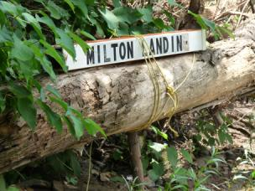
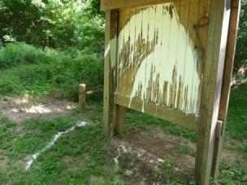

Photo 1: Milton RCS Kiosk in need of repair.
Photo 2: Example of signage needing updating for clearer indication of where put in / take out locations are along the River

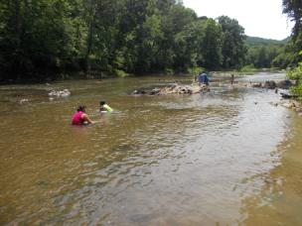
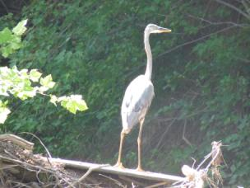

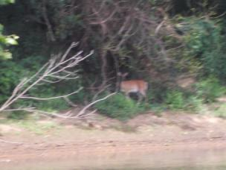
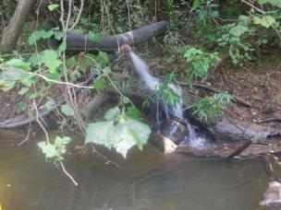
Photo 5: Pipe discharging water into River near Darden Towe park
Photo 6: Deer along the River bank
Photo 4: People swimming at Riverview Park
Photo 3: Heron along the bank of the River

