RIVANNA RIVER STEWARD MONTHLY REPORT
Date: May 2014
River Steward Name(s): Dan Triman and Justin Altice

River Sections Paddled this Month:
- Darden Towe Park To Riverview Park (2 times)
- Riverview Park to Milton (1 time)
Total River Miles Paddled this Month: 8 miles
General Weather Conditions: upper 60’s – lower 80’s, mostly sunny
General Precipitation: a few heavy thunderstorms during the month
General Water Characteristics (Flow, Color, Odor, Depth, Temp):
Regular flow rate most of the month, with some heavier flows after the thunderstorms. Color was clear most of the time, with murkier water after storms due to sedimentation. Depth of water was typically in the 2-4 foot range, with the exception of a large spike after the severe storm we got in the middle of the month. Water temperatures were mostly in the 18-22 deg C range.
Water Testing Summary:
2 water quality tests were completed. One at a pipe outfall approx. 0.2 miles past Free Bridge on the east side of the River (DO: 3 ppm, PH: 7, Turbidity: 20 JTU), and one under the I-64 Overpass just past Riverview Park (DO: 2.5 - 3 ppm, PH: 7.5 – 8.0 , Turbidity: 40 JTU)
Major Findings:
We saw turtles, various birds including ducks and geese, snakes, and fish. We came across several people fishing on the water and on the river banks, as well as people using the Rivanna Trail alongside the River. These sections of the River had significant litter present. We removed about 1 ½ large trash bags full of litter from the River, including a metal bucket, plastic bags, plastic bottles and containers. We also removed 2 tires from the River near Free Bridge. Some bank erosion was noticed, as well as many downed trees.

Future actions include the following:
- Remove a shopping cart located just past Free Bridge in water on west side of river
- Remove a few more tires found in the River.
- Address the Milton put in / take out as it is not well marked and is likely in need of some attention due to its poor condition.
- Repair Darden Towe boat launch that was washed away during rains.

Photo Highlights:

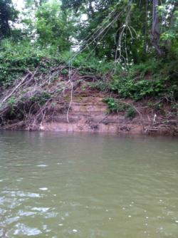
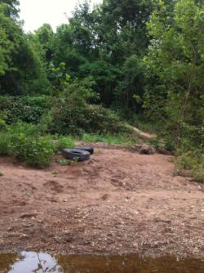
Photo 2: Example of erosion along the river bank
Photo 1: The 2 tires we removed from River near Free Bridge.

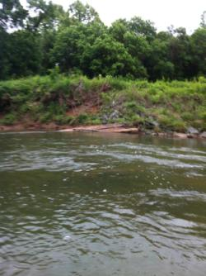
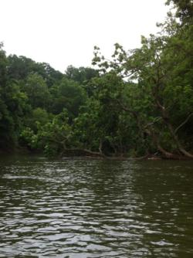
Photo 3: Tree that fell during the recent heavy rains before Riverview Park blocking half of the River.

Photo 4: Piece of Boat Launch originally at Darden Towe Park, washed down river during recent heavy rains.

