RIVANNA RIVER STEWARD REPORT
River Steward Names: Dan Triman and Justin Altice Date: 7-16-14
Starting Location and Time: Darden Towe Park (12:00 PM)
Ending Location and Time: Riverview Park (1:30 PM)
Weather: Sunny Recent Precipitation: Not much rain lately
Water Flow: Fairly Slow Water Color: Clear Water Odor: None
Water Temp. : 26 deg C Air Temp. : 75-80 deg F
DO: 2 ppm PH: 7 Turbidity: 20 JTU
USGS Water Gauge Reading: Earlysville 1.42 ft.
Physical Location Characteristics: Riverview Park boat landing
Location Tested: In rocky area at river right just before Riverview Park
---------------------------------------------------------------------------------
Land Use:
Residential mainly, with some commercial use

Wildlife Sightings and Plant Life:
Herons, Deer, several turtles sunning on logs, various birds, fish

People Interactions:
Saw three people fishing in the River, several people hanging out along the river banks. Lots of kids and families swimming at Riverview Park.

Litter and Pollution:
Removed half a trash bag worth of litter from the river including plastic bottles and containers, balloons, metal soda and beer cans, etc. We also noticed a new pipe that was discharging water into the river just past Darden Towe Park at river left.

Overall Summary:
Saw a lot of wildlife, as well as more people out in the water than we have been seeing. Picked up some trash along the way. Otherwise, no major issues of note.

Actions Needed – level of priority (1 highest/5 lowest):
Look into pipe discharging water into river near Darden (3)

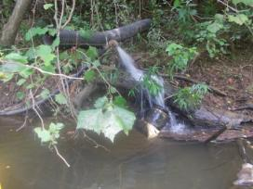
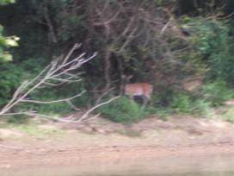
Figure 1: Deer spotted along the river bank Figure 2: Pipe that is discharging into the river with a very steady flow (near Darden Towe Park)
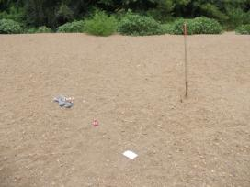
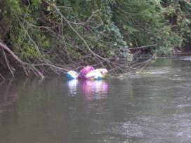
Figure 3: Balloons found in the river Figure 4: Trash (beer cans) and a shovel found along beach

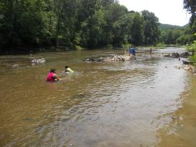
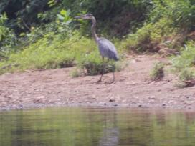

Figure 5: Heron along the river bank Figure 6: People enjoying the water at Riverview Park

