RIVANNA RIVER STEWARD REPORT
River Steward Names: Dan Triman and Justin Altice Date: 8-26-14
Starting Location and Time: Darden Towe Park (4:45 PM)
Ending Location and Time: Riverview Park (6:15 PM)
Weather: Sunny Recent Precipitation: One heavy rain the past week
Water Flow: Slow Water Color: Brown / Murky Water Odor: None
Water Temp. : 26 deg C Air Temp. : 82 deg F
DO: 2 ppm PH: 8 Turbidity: 60 JTU
USGS Water Gauge Reading: Earlysville 1.33 ft.
Physical Location Characteristics: Under power lines near Riverview Park
Location Tested: Middle of the river
---------------------------------------------------------------------------------
Land Use:
Residential mainly, with some commercial use

Wildlife Sightings and Plant Life:
Heron, Kingfisher, several turtles, various birds, small fish jumping out of the water

People Interactions:
Saw several people at Riverview Park fishing. Lots of people out using the RTF trails along the river.

Litter and Pollution:
Removed half a trash bag worth of litter from the river including drink bottles and cans (metal, glass, plastic), and a few pieces of Styrofoam. Also removed 1 rubber tire tube.

Overall Summary:
Saw some wildlife (mostly birds), as well as a few people at Riverview Park. Water levels had risen a good amount compared to the last few weeks, and water was a little browner and murkier than usual from sedimentation. Picked up some trash along the way. One large downed tree at River right just before boat ramp at Riverview Park.

Actions Needed – level of priority (1 highest/5 lowest):
None.

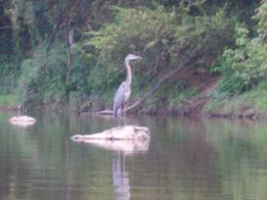
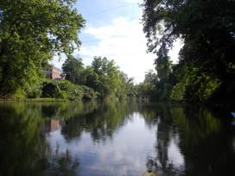
Figure 1: View down river near Darden Towe. Figure 2: Heron standing on a rock in the middle of the river.
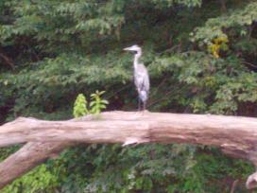
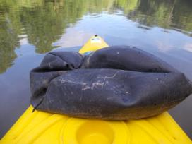
Figure 3: Rubber tire tube removed from river. Figure 4: Another shot of the heron we spotted.

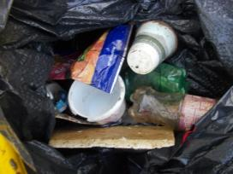
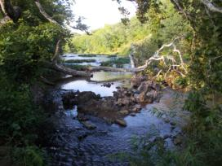

Figure 5: Downed tree near Riverview Park Figure 6: Examples of the trash we pulled from the river.

