**RIVANNA RIVER STEWARD 2015 END OF YEAR REPORT**

**River Stewards:** Dan Triman and Justin Altice

**Description: cid:image001.png@01CA1541.CA60A7B0**

**Overall Summary**

The Rivanna River Steward program was launched in the Spring of 2014 by RCS, with 2 Stewards, 2 boats and a significant amount of enthusiasm. The Stewards just completed the second program year and a summary of their findings and accomplishments, as well as future plans in the local community are outlined below.

**About the Rivanna**

The Rivanna Conservation Society (RCS) is celebrating its 25th Anniversary and to celebrate, the organization is continuing to host events throughout each year for the Annual Rivanna River Makeover, has begun construction of an education center at its Scheier Natural Area in Fluvanna County and is in the process of upgrading and completing the Water Trail and Kiosk system at boat launches along the Rivanna. This is all in addition to the biennial Rivanna River Sojourns RCS hosts, the work of the RCS River Stewards, and the River Guardians Volunteer Corps.

The Rivanna River is often referred to as "Mr. Jefferson's River" because Thomas Jefferson grew up on the shores of the Rivanna and later built his Monticello home along its banks. Sharing Mr. Jefferson's appreciation for this historic river, a group of Fluvanna County residents established The Rivanna Conservation Society (RCS) in 1990.

The Rivanna was named to honor Queen Anne (1665-1714), and is a tributary of the James River, flowing ultimately into the Chesapeake Bay. The Rivanna River is a 42.1-mile-long river originating in the Blue Ridge Mountains (North Fork in Greene County and South Fork in Albemarle County).

The Rivanna watershed is 766 square miles and 100,000+ people live in the watershed. Approximately 65% of the watershed is forested and is considered to be some of the healthiest small Piedmont streams in the mid-Atlantic region. Based on land use, StreamWatch estimates that 70% of Rivanna streams failed the Virginia aquatic health standard. However, only 5% to 10% of streams are severely degraded.

The Rivanna River Watershed is polluted primarily by:

* Pathogens (E. coli)
* Sediment caused by erosion from development and rainwater runoff

**Paddling Season**

From May 2015 through November 2015, the 2 River Stewards, Dan Triman and Justin Altice, paddled the Rivanna river and local reservoirs, typically once a week, to monitor the Rivanna watershed and report on their findings. With winter approaching, the Stewards will be on hiatus until the Spring of 2016.

**The Goal**

The goal of the River Steward program is to give The Rivanna Conservation Society (RCS) a presence on the river, to document pollution sources, interact with community members on and around the river, and to share information about the native flora and fauna. In our second year of the Stewards program we have already been able to reach a wide audience as well as document a significant amount of information about the river and water conditions throughout the Rivanna watershed. RCS is delighted by all that has been accomplished by the River Stewards and we expect that this program will be continually improving as experience is gained, community awareness of the program grows, and with greater on the water participation of the RCS River Guardians Corps.

Of great inspiration to the Stewards and to the Guardians is the natural beauty of the River which cannot be fully appreciated unless one actually is on the Rivanna River. Over time our goal is to have more members of the community on the River so they too can experience this natural beauty located in their backyard. The Stewards have a personal goals to spread the word about what a hidden gem the Rivanna is and to inspire people to enjoy as well as protect their local river.

**Observations**

The River changes significantly in width, depth, and rapids, as well as the surrounding landscape nearby, depending on which section the Stewards are paddling. The characteristics of the Rivanna change as a result of the urban, rural and x-urban areas that the river passes through.

Generally, the Rivanna is, for the most part, healthy. This is largely due to the minimal amount of industrial activity in our area and the large number of forested acres. The Stewards did not notice significant odors, or significant water discolorations. The River does suffer from strong urban runoff following rain events, resulting in noticeable discoloration from sediment and pollution. These events also wreak havoc on the few access points along the Rivanna River.

Water levels were generally good during the early Spring, dropping towards the end of the Spring. We experienced long stretches of time without much rainfall in the Summer (July and August), consequently water levels were extremely low during this time. Then in the Fall (October and November) we had several heavy rain events that caused large spikes in the water levels. These rain events resulted in significant amounts of sediment showing up in the Rivanna. In mid to late November the water levels dropped again with only some light rain here and there. Even during the times of very low or high water levels, the Stewards did their best to paddle the Rivanna River and Reservoirs throughout the paddling season this year. Low water levels can hinder the community’s ability to get out on the water because paddling the Rivanna is very difficult during these times.

**River Areas Covered**

This year, the Stewards were able to monitor the Rivanna from where the Mechums River meets the South Fork of the Rivanna River (just above Reas Ford Rd) at the northern end, down to Columbia, where the Rivanna River meets the James River, at the southern end. The section from the Mechums River down to Earlysville Rd is the South Fork of the Rivanna and is above the Reservoir. Then below the Reservoir and Dam, the Stewards paddled the entire Rivanna from Rio Mills Rd to Columbia. In addition, the Stewards also paddled Beaver Creek Reservoir several times.

This year, the Stewards were able to extend the areas of the River covered going further upstream and down. Upstream on the South Fork above Reas Ford Rd the Stewards added a little under a mile of the Rivanna that they monitored (as far as water levels would allow, and downstream they added an additional 16 miles of the Rivanna River from Palmyra to Columbia at Point of Fork. Although the North Fork of the Rivanna is difficult to paddle, due to very low water levels, the Stewards also explored and monitored some of the areas of the North Fork on foot this season.

The table below shows the sections of the Rivanna paddled by the Stewards, dates paddled, and, the length of each section. The total mileage from all the paddle trips the Stewards completed this year was approximately 129 river miles.

|  |  |  |  |  |
| --- | --- | --- | --- | --- |
| **River Section** | **Starting Point** | **Ending Point** | **Section Mileage** | **Dates Paddled** |
| Section 1 | Mechums River Junction above Reas Ford Rd (South Fork) | Earlysville Rd (Reservoir) | 3.5 | Round Trip: 04/12/15, 04/25/15  One Way: 07/10/15, 09/19/15 |
| Section 2 | Earlysville Rd (Reservoir) | Rio Mills Dam (Reservoir) | 1.5 | Round Trip: 11/04/15, 11/07/15  One Way: 08/01/15 |
| Section 3 | Rio Mills Dam (Reservoir) | Darden Towe Park | 6.0 | 05/25/15, 07/01/15, 10/21/15 |
| Section 4 | Darden Towe Park | Riverview Park | 2.0 | 05/25/15, 06/13/15, 07/28/15, 08/21/15, 10/01/15, 11/11/15 |
| Section 5 | Riverview Park | Milton Shadwell | 4.3 | 03/29/15, 06/07/15, 08/21/15, 11/01/15 |
| Section 6 | Milton Shadwell | Crofton | 10.0 | 05/30/15, 09/16/15 |
| Section 7 | Crofton | Palmyra | 6.5 | 05/13/15, 08/09/15 |
| Section 8 | Palmyra | Columbia | 16 | 05/02/15 |
| Section 9 | Beaver Creek Reservoir | Beaver Creek Reservoir | 2 miles  (round trip) | 10/14/15, 10/18/15 |

**Rivanna River Map**

The map below provides a general context of where the Stewards paddled this year, and where the boat access locations are along the Rivanna River that were used this season. The map shows the South and North Forks of the Rivanna, as well as the main stem of the Rivanna once the two forks meet. From the map you can see that the Rivanna extends from Albemarle County at the north, through Charlottesville, and then down to Fluvanna County at the southern terminus when it meets the James River.



**Water Testing Summary – Chemical and Physical Properties**

Each paddle trip the Stewards completed, they took a basic water monitoring kit with them to record chemical and physical properties of the water. A summary of the water testing data recorded for each paddle trip is provided below.

|  |  |  |  |  |  |  |  |
| --- | --- | --- | --- | --- | --- | --- | --- |
| **Date Tested** | **Location Test**  **Performed** | **USGS Water Gauge Reading (ft)** | **Air Temp (˚F)** | **Water Temp (˚C)** | **DO (ppm)** | **PH** | **Turbidity  (JTU)** |
| 03/29/2015 | 38˚00.8’N 78˚25.7’W  River Left near bank | Earlysville – 2.70  Palmyra – 4.55 | 45 | 10 | 3 | 8 | 80 |
| 04/12/2015 | 38°07.3’N 78°31.5’W  River Right Mechums River at Confluence | Earlysville – 2.18  Palmyra – 3.61 | 68 | 14 | 4 | 8 | 10 |
| 04/25/2015 | 38°05.8’N 78°29.2’W Rivanna Reservoir at UVA Boathouse Dock | Earlysville – 2.50  Palmyra – 4.20 | 50 | 14 | 3 | 7 | 40 |
| 05/02/2015 | 37°48.1’N 78°13.8‘W  River Right near  Fork Union | Earlysville – 2.20  Palmyra – 4.10 | 70 | 16 | 6 | 8 | 40 |
| 05/13/2015 | 37°51.6’N 78°16.0‘W  River Right just before Palmyra | Earlysville – 1.67  Palmyra – 3.18 | 70 | 20 | 5 | 8 | 40 |
| 05/25/2015 | 38°04.4’N 78°26.4’W  River Right just below NF and SF Confluence | Earlysville – 1.47  Palmyra – 2.94 | 80 | 26 | 4 | 8 | 10 |
| 05/30/2015 | 37°57.3’N 78°20.9’W  River Left near Rivers Edge community | Earlysville – 1.49  Palmyra – 2.97 | 75 | 24 | 5 | 8 | 10 |
| 06/07/2015 | 38°00.5’N 78°25.4’W  River Right at power line crossing river | Earlysville – 1.55  Palmyra – 3.26 | 74 | 22 | 3 | 8 | 40 |
| 06/13/2015 | 38°02.7’N 78°26.9’W  River Left at Lewis and Clark Center | Earlysville – 1.65  Palmyra – 3.40 | 95 | 24 | 4 | 8 | 60 |
| 07/01/2015 | 38°04.3’N 78°26.3‘W  River Right just below NF and SF Confluence | Earlysville – 1.75  Palmyra – 3.80 | 85 | 24 | 4 | 8 | 60 |
| 07/10/2015 | 38°05.8’N 78°29.2’W Rivanna Reservoir at UVA Boathouse Dock | Earlysville – 1.65  Palmyra – 3.05 | 85 | 25 | 3 | 8 | 40 |
| **Date Tested** | **Location Test**  **Performed** | **USGS Water Gauge Reading (ft)** | **Air Temp (˚F)** | **Water Temp (˚C)** | **DO (ppm)** | **PH** | **Turbidity  (JTU)** |
| 07/28/2015 | 38°02.5’N 78°27.2’W River Left at Darden Towe Boat Ramp | Earlysville – 1.70  Palmyra – 3.60 | 80 | 25 | 5 | 8 | 60 |
| 08/01/2015 | 38°05.8’N 78°29.2’W Rivanna Reservoir at UVA Boathouse Dock | Earlysville – 1.60  Palmyra – 3.25 | 78 | 24 | 4 | 7 | 30 |
| 08/09/2015 | 37°53.8’N 78°16.7’W  Middle of River at Sand Bar | Earlysville – 1.42  Palmyra – 2.85 | 80 | 26 | 5 | 7 | 10 |
| 08/21/2015 | 38°01.0’N 78°26.9’W  River Left at I-64 underpass | Earlysville – 1.30  Palmyra – 2.85 | 75 | 26 | 5 | 8 | 40 |
| 09/16/2015 | 37°55.1’N 78°17.9’W  River Left at Crofton Boat Ramp | Earlysville – 1.13  Palmyra – 2.58 | 75 | 24 | 3 | 8 | 10 |
| 09/19/2015 | 38°05.8’N 78°29.2’W Rivanna Reservoir at UVA Boathouse Dock | Earlysville – 1.10  Palmyra – 2.50 | 80 | 24 | 4 | 8 | 20 |
| 10/01/2015 | 38°01.4’N 78°27.2’W River Right at Riverview Boat Ramp | Earlysville – 3.00  Palmyra – 5.00 | 60 | 20 | 6 | 7 | 60 |
| 10/14/2015 | 38°04.4’N 78°39.2’W At Beaver Creek Reservoir Boat Ramp | Earlysville – 1.58  Palmyra – 3.04 | 65 | 18 | 6 | 8 | 10 |
| 10/18/2015 | 38°04.4’N 78°39.2’W At Beaver Creek Reservoir Boat Ramp | Earlysville – 1.54  Palmyra – 2.92 | 45 | 18 | 5 | 7 | 5 |
| 10/21/2015 | 38°04.5’N 78°26.4’W River Left NF just above SF Confluence | Earlysville – 1.52  Palmyra – 2.88 | 70 | 16 | 6 | 8 | 5 |
| 11/01/2015 | 38°00.4’N 78°24.0’W River Left just past Milton Rd Bridge | Earlysville – 2.20  Palmyra – 3.80 | 60 | 14 | 6 | 8 | 20 |
| 11/04/2015 | 38°06.2’N 78°28.2’W Reservoir Right just above Dam | Earlysville – 1.90  Palmyra – 3.36 | 65 | 16 | 6 | 7 | 20 |
| 11/07/2015 | 38°05.5’N 78°29.3’W At Earlysville Rd Bridge on Reservoir | Earlysville – 1.75  Palmyra – 3.30 | 60 | 16 | 6 | 7 | 20 |
| 11/11/2015 | 38°01.4’N 78°27.2’W River Right at Riverview Boat Ramp | Earlysville – 2.50  Palmyra – 4.30 | 68 | 14 | 5 | 8 | 40 |

**Flora and Fauna**

On every Steward paddle this year, Justin and Dan were able to see some form of wildlife on the Rivanna River. The wildlife came in many different forms and species, including small insects and bugs, birds, fish, reptiles, and some larger mammals. Having now had two years of the Steward program to paddle the Rivanna and get familiar with where wildlife tends to be seen and at what times of day, the Stewards have noticed some patterns. Examples of this are seeing bald eagles (and their nest) in the same location, seeing schools of long nose gar in the same locations, finding specific islands where turtles tend to gather, and noticing that when paddling around twilight the wildlife sightings tend to be the most common. This implies that these animals live in specific areas and are finding these locations suitable for their needs. The most common wildlife observed for the second year in a row were turtles, birds and fish.

During the paddles the Stewards observed the following wildlife:

* *Birds*

Great Blue Herons, Green Herons, Bald Eagles, American Bittern, Ospreys, Wild Turkeys, Hawks, Crows, Geese, Black Swans, Ducks, Bluebirds, Robins, Cardinals, Kingfishers, Cormorants, Tree Swallows, Vultures, Sandpipers, and several other smaller birds.

* *Insects and Bugs*

Spiders, Dragonflies, Damselflies, Bees, Wasps, Butterflies, Water Striders

* *Reptiles and Amphibians*

Water Snake, Copperhead Snake, Hognose Snake, Frogs, Toads, Turtles

* *Fish*

Long Nose Gar, Bass, Catfish, and several other smaller minnows

* *Mammals*

Beaver, Otter, Deer, Squirrel, Bats

As for vegetation, there is a wide range of vegetation to be found in and around the Rivanna River. Some of this vegetation is native species and others are invasive species. The vegetation is especially important to keep the river banks from eroding away. It is always nice to see the seasonal changes in the vegetation along the Rivanna, as the environment surrounding you when you paddle in various seasons looks vastly different depending on what time of year you are on the River.

Below are photo highlights of wildlife and vegetation observed this year by the Stewards. The photos show the Rivanna is fairly healthy and is providing sufficient habitat for the living organisms that depend on the River. The Stewards are looking forward to being back on the water in the Spring to observe, document and share the beauty of the Rivanna River and its tributaries with local governments leaders, the RCS Board of Directors and members and the public at large.

**Fauna Photos**

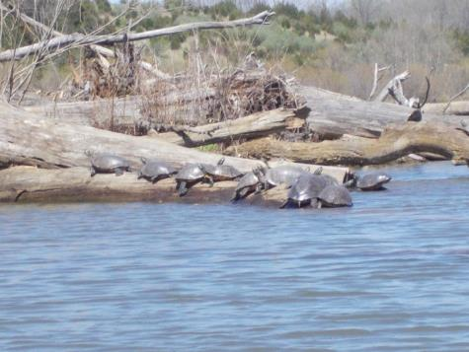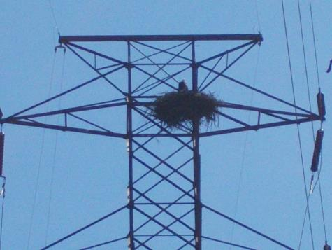

Turtles on a log in South Fork above Reservoir (04-12-15)

Bald Eagle sitting on nest on power line tower (03-29-15)

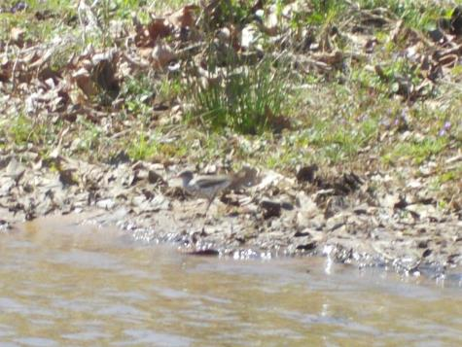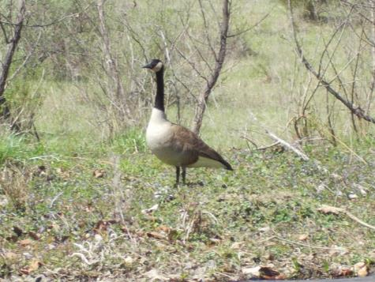

Goose on the bank of the Rivanna (04-12-15)

Sandpiper looking for food in the water (04-12-15)

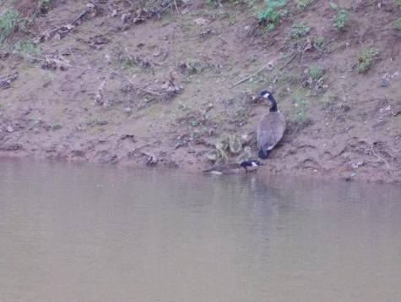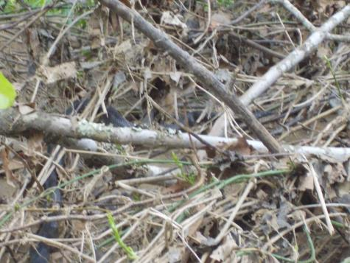

Adult Geese with baby Goslings (05-02-15)

Black Water Snake amongst some brush (05-02-15)

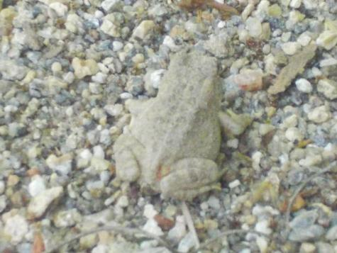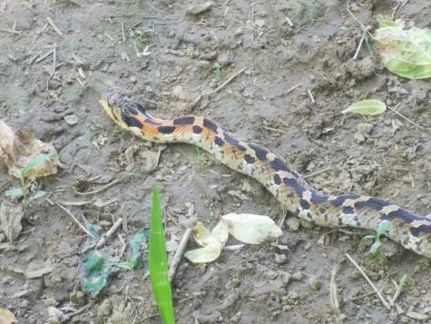

Toad near the North Fork (05-26-15)

Hognose Snake near the North Fork (05-26-15)

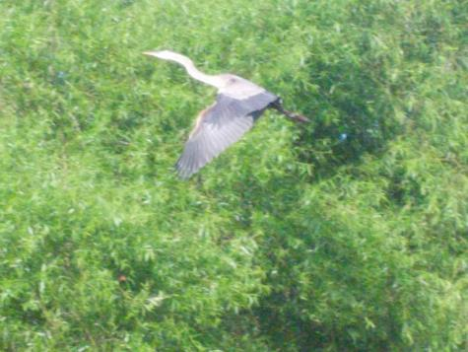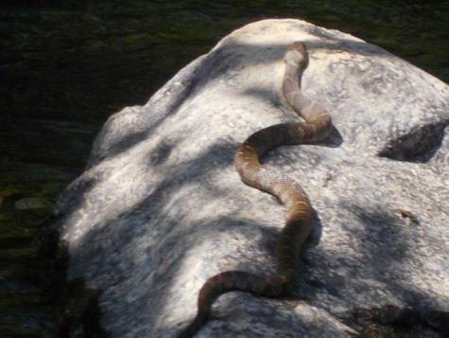

Snake resting on a rock (05-30-15)

Blue Heron in flight (07-10-15)

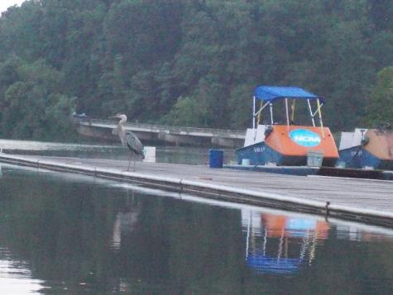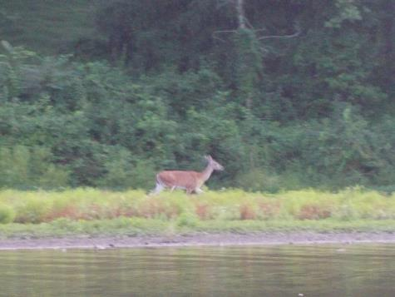

Deer along bank on South Fork above Reservoir (07-10-15)

Heron looking for food on UVA Boathouse Dock (07-10-15)

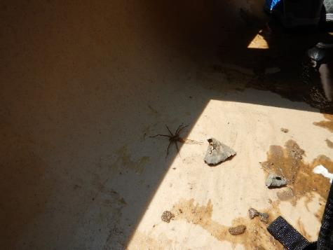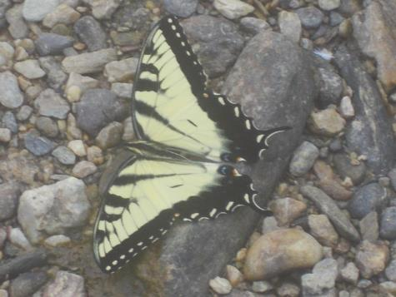

Butterfly perched on a stone (08-09-15)

Spider that crawled into our canoe (08-09-15)

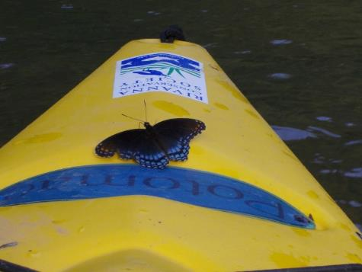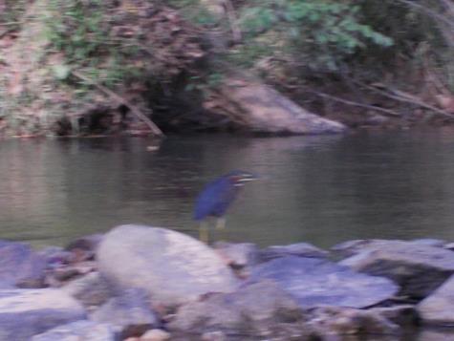

Green Heron (09-16-15)

Butterfly that landed on our kayak (09-16-15)

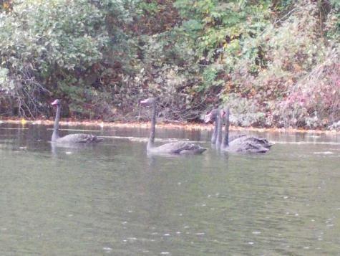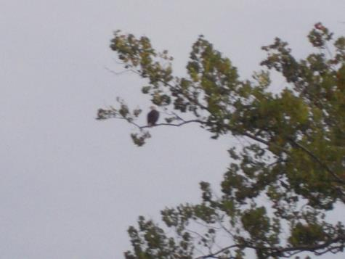

Bald Eagle sitting in tree near Crofton (09-16-15)

Black Swans at Beaver Creek Reservoir (10-14-15)

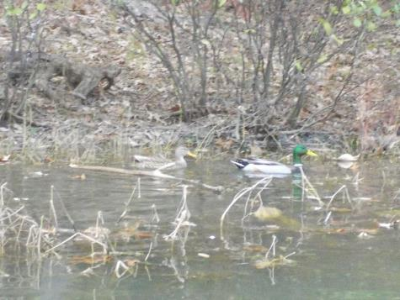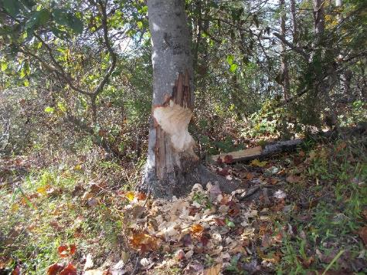

Ducks swimming in the Reservoir (11-04-15)

Evidence of beavers chewing trees at Beaver Creek Reservoir (10-14-15)

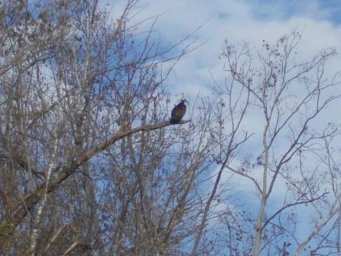

Osprey perched in a tree (11-01-15)

**Flora Photos**

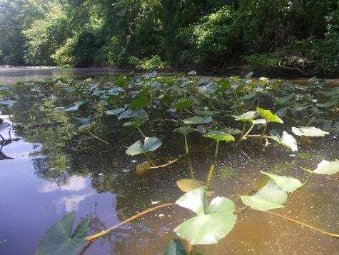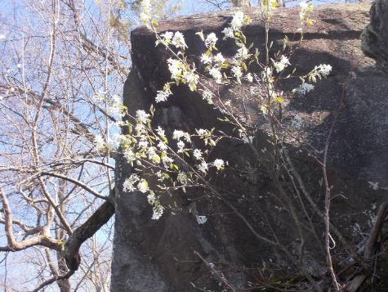

Lily pads growing up out of the water near Rio Mills (05-25-15)

White Flowers (04-12-15)

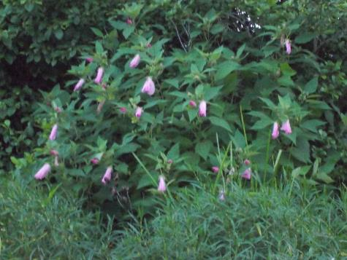

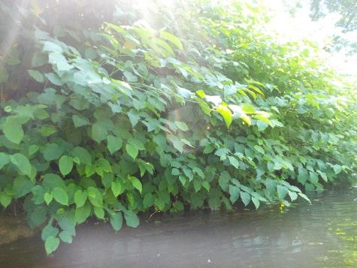

Invasives growing along the bank of the river (05-30-15)

Pink Flowers (07-10-15)

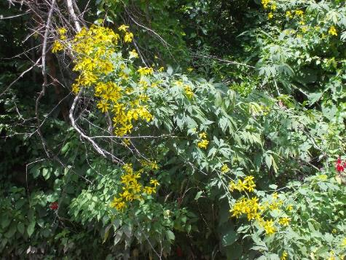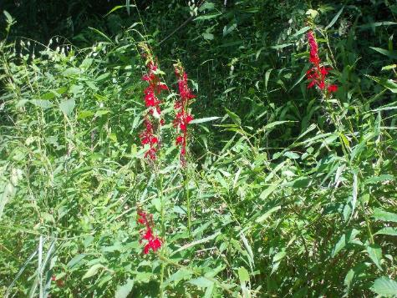

Cardinal Flowers near Lewis and Clark Exploratory Center (08-21-15)

Yellow Flowers (08-21-15)

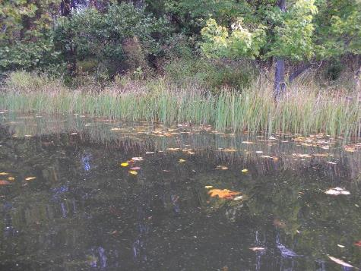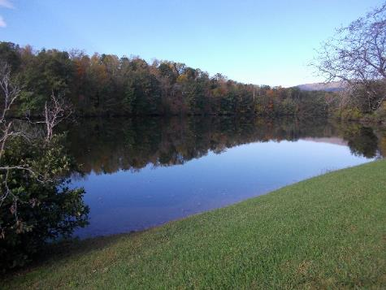

Grasses growing in Beaver Creek Reservoir (10-14-15)

View of the Beaver Creek Reservoir (10-14-15)

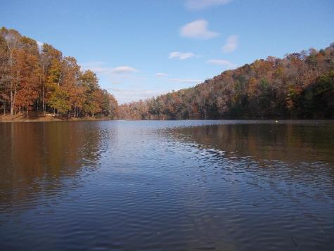

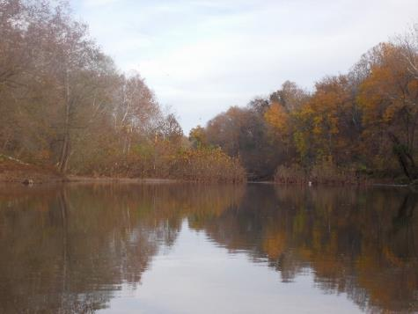

View of the Rivanna between Riverview and Milton (11-01-15)

Fall colors on the Reservoir (11-04-15)

**Partnerships and Community Outreach**

One of the most important aspects of the work being done by RCS and the Stewards is engaging the general public in our efforts to maintain a healthy Rivanna Watershed, as well as partner with other groups and organizations to have a greater impact. They frequently came across people using the River for fishing, swimming, kayaking, canoeing, motor boating, tubing, and rowing. The Stewards also saw a lot of people hiking, or running along the Rivanna Trails that parallel the River near the City of Charlottesville.

The Stewards continued RCS’ past partnerships with or started new partnerships with numerous local groups this year. These organizations included Blue Ridge Mountain Sports, The Lewis and Clark Exploratory Center, Rivanna River Company, Big Brothers Big Sisters of the Central Blue Ridge, Tandem Friends School, Western Albemarle High School, the UVA Batten School, Outdoors at UVA Club, SouthWings, Streamwatch, and Solitude Lake Management. We held our bi-annual Sojourn paddle trips (April and October) where we invited the public to come out and enjoy a paddle trip with us. The Stewards also partnered with Streamwatch to do a paddle trip from Darden Towe to Riverview for their volunteers and staff. The Stewards also took Nick DiPasquale, Director of EPA’s Chesapeake Bay Program out on a paddle in October. Lastly, the Stewards attended a Rivanna River History paddle from Crofton to Palmyra hosted by Fluvanna County Parks & Recreation.

Alex Searls, the Executive Director of The Lewis and Clark Exploratory Center came on paddle trips with us several times throughout the year. We co-hosted several community outreach events at the Center in October as part of the Rivanna Renaissance conference. Blue Ridge Mountain Sports, Rivanna River Company, Outdoors at UVA Club, and Solitude Lake Management all partnered with RCS to help with the Rivanna Sojourn events we hosted this year. The Stewards were also provided an opportunity to complete a Rivanna River flyover in a plane flown by the non-profit SouthWings in July; providing a vauluable aerial perspective of the river and the watershed. Photos taken during this flyover are provided below.

The Stewards were also able to provide opportunities for educational paddle trips for children and students this year. Among them were 2 paddle trips on the Rivanna Reservoir with groups from the Big Brothers Big Sisters of the Central Blue Ridge (group of 6-7 elementary school students and their adult matches each time), a paddle on the Rivanna Reservoir with a group of Tandem Friends students and teachers, and 2 paddles with Western Albemarle High School students. RCS also held a volunteer clean up event in partnership with the UVA Batten School where students and staff came out to Riverview Park and helped clean up the kiosk, and repair the boat launch steps. The Stewards also assisted with the removal of graffiti on the Milton kiosk and repairs to the picnic table at the Milton Boat Launch.

RCS and the River Stewards are also always working on building relationships with the River Guardians, the community volunteers who monitor sections of the River for RCS. The River Stewards have also done several presentations to this year including one at the Rivanna Renaissance Conference in October this year.

**Partnerships and Community Outreach Photos**

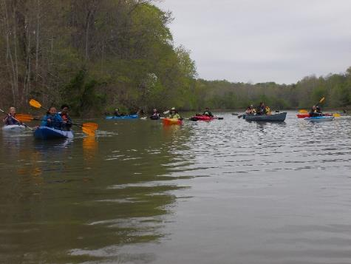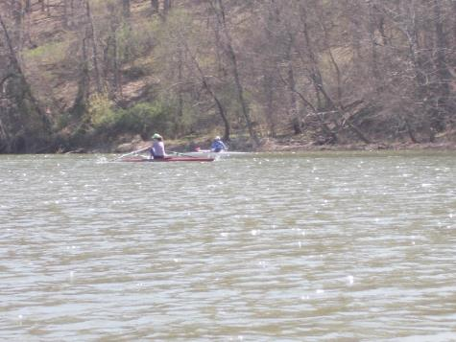

Spring Sojourn on the South Fork above the Reservoir (04-12-15)

Rowers on the South Fork above the Reservoir (04-12-15)

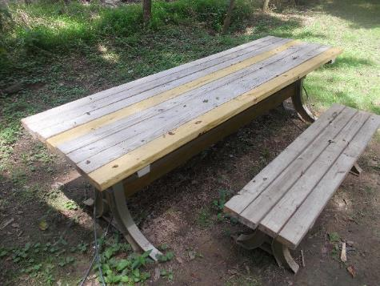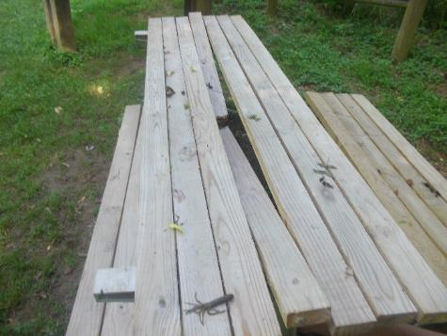

Repaired picnic table at Milton Boat Ramp (08-21-15)

Broken picnic table at Milton Boat Ramp (05-30-15)

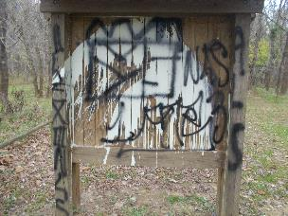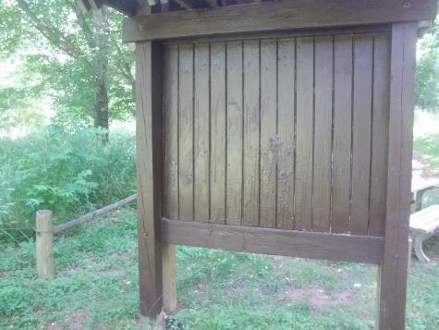

Repainted Milton Kiosk to remove graffiti (05-30-15)

Vandalized Milton Kiosk (November 2014)

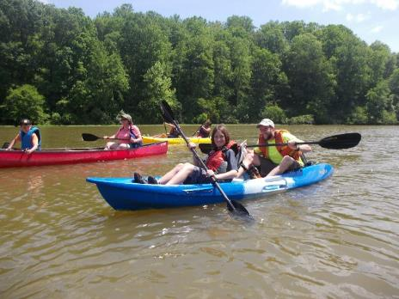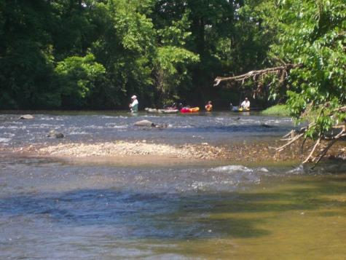

Group of people fishing in the river (05-30-15)

Tandem Friends School paddle on Reservoir (05-18-15)

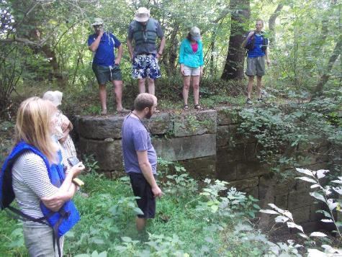

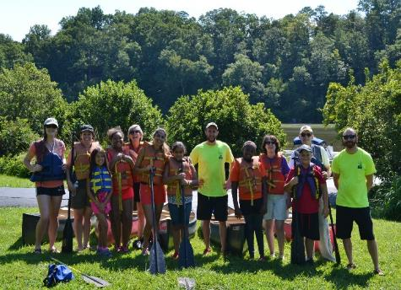

Listening to Brian from Fluvanna County Parks & Rec talk about the history of an old River Locke (08-09-15)

Big Brothers Big Sisters paddle group photo (08-01-15)

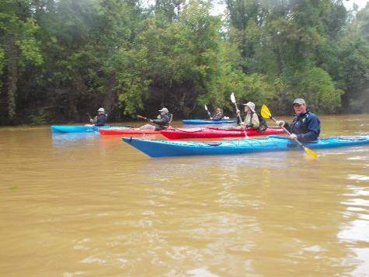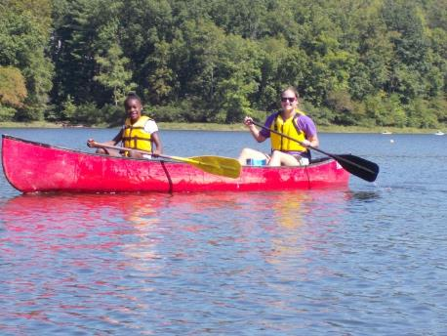

Big Brothers Big Sisters paddle on Reservoir (09-19-15)

Paddle with Nick DiPasquale from EPA (10-01-15)

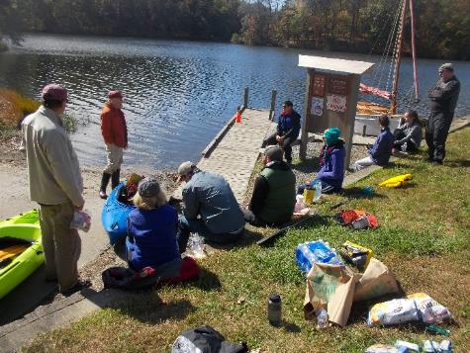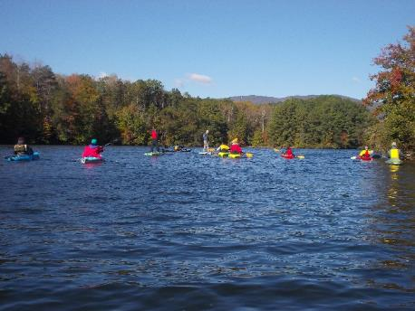

Fall Sojourn at Beaver Creek Reservoir (10-18-15)

Dan Mahon from Albemarle County Parks & Rec talking about local history at the Fall Sojourn (10-18-15)

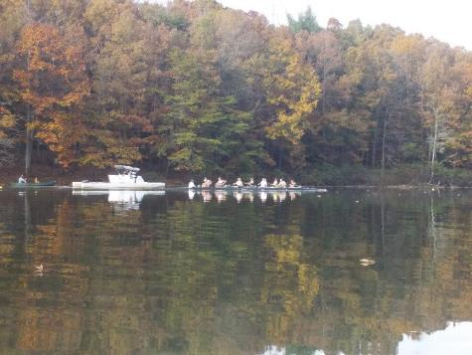

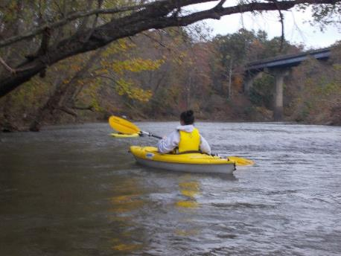

UVA Rowing Team on the Reservoir (11-04-15)

Jenna, a Western Albemarle High School student, paddling with us as part of a school project (11-01-15)

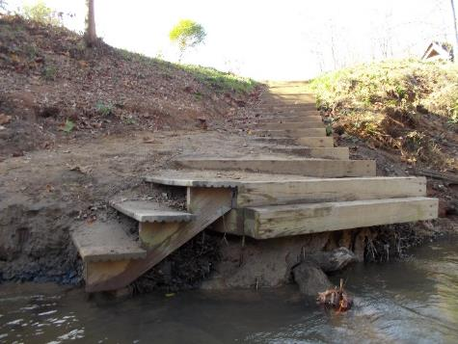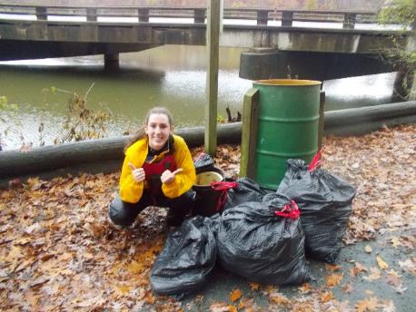

Riverview Park boat put in steps as re-constructed by RCS and the UVA Batten School (11-11-15)

Jessica, a Western Albemarle High School student, after our Reservoir clean-up for her school project (11-07-15)

**Litter / Pollution / Safety Concerns**

**Rivanna Flyover Aerial Photos (07-30-15)**

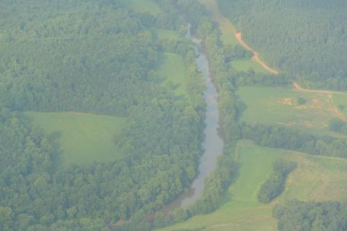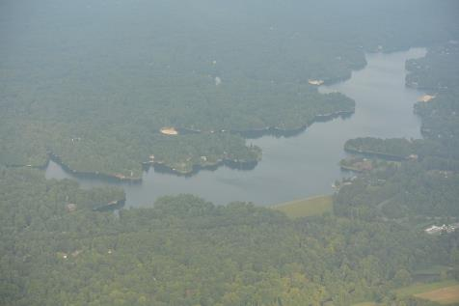

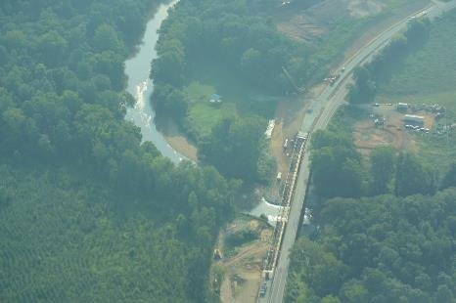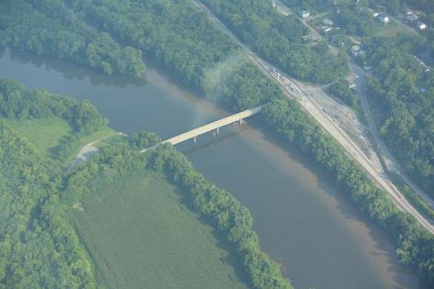

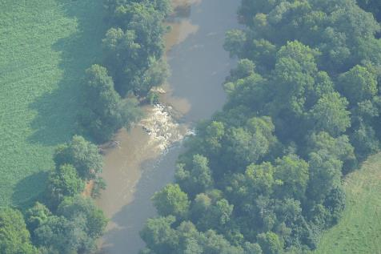

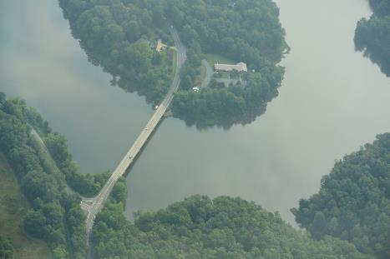

**Litter / Pollution / Safety Concerns**

While the amount of litter and pollution in the Rivanna has been reduced since we began the Stewards program, it still does remain something that needs attention. Several people have mentioned they have been impressed with how clean the Rivanna has looked recently since the implementation of the River Stewards program. On every paddle the Stewards complete, they perform clean-up of litter and other objects that are not intended to be in the water. The Stewards noticed that after heavy rains, the amount of trash in the River was significantly higher, which makes sense due to the heavy stormwater volumes washing the trash into the water. Trees that came down during storms and get lodged in the river also tend to collect debris and trash to prevent it from flowing downstream any further. More urban areas near Charlottesville seemed to have a higher volume of litter and trash then more rural areas upstream or downstream. The Stewards also found that areas where people were fishing or hanging out along the river banks, on beaches, and under bridges tended to have a higher concentration of litter as well.

The majority of the trash that was found in the river was smaller items such as beverage containers (plastic, glass, and metal), plastic bags, food trash, fishing bait boxes, Styrofoam, and sporting equipment (balls and Frisbees). But there also were a wide variety of larger items in the River as well. One of the biggest issues the Stewards continue to come across is tires in the Rivanna. Most of these tires were buried in the riverbed and have been there a long time. Despite previous efforts by the Stewards to remove the buried tires in the Rivanna, it is estimated that there are still probably on the order of 100 tires needing to be removed. Most tires are standard vehicle sized, but several are larger truck sized tires. One tire was removed from the Beaver Creek Reservoir during the Fall Sojourn in October.

In all the Stewards estimate that they removed about 30 large trash bags worth of trash from the Rivanna from the river this year as part of the Steward program. See the Issues To Address section of the report below for some of the larger items found in the Rivanna that should be removed in the near future.

In addition to trash, sediment and pollution from runoff, downed trees and power lines, bacteria from dead animals, and any other safety concerns are all monitored by the Stewards. The Stewards helped to notify local authorities on several occasions of issues and concerns identified during paddle trips. Some of these included: sediment issues from a stream near the Lewis and Clark Exploratory Center; pollution coming from a pipe outfall below the Rio Mills Dam; significant amounts of water being discharged by a pipe near Crofton; a tree down and blocking the river just below the confluence of the South and North Forks of the Rivanna; algae appearing on the top of the Rivanna Reservoir; downed power lines in the Rivanna near Columbia; and several dead animals found in the Rivanna.

Below are some photos of trash found during the Steward paddle trips this year to give a sense of the types of materials typically found in and around the Rivanna. Photos of some of the safety concerns mentioned above appear in the Issues To Address section of the report below.

**Litter / Pollution Photos**

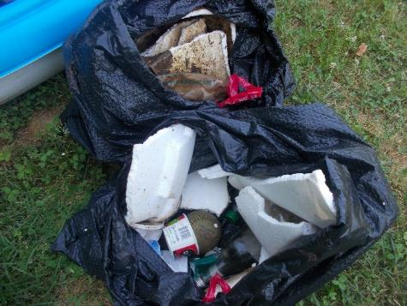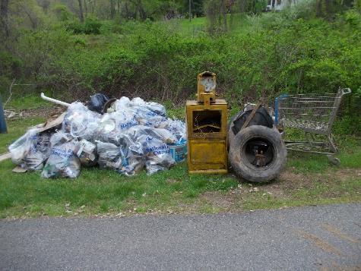

Litter collected by Plow & Hearth from around the Rivanna Reservoir from a clean up event on 04-24-15 (04-25-15)

Trash found between Rio Mills and Riverview (05-25-15)

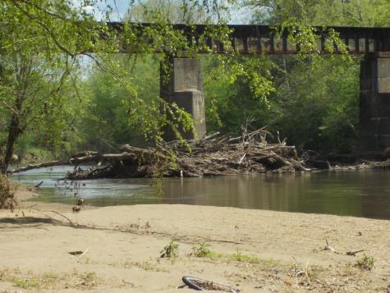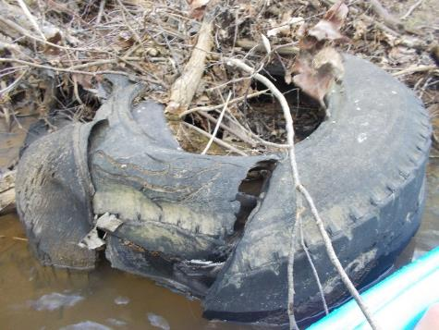

Trees and Logs stacked up at bridge abutment (05-02-15)

Examples of a tire found in the river (05-02-15)

Riverview

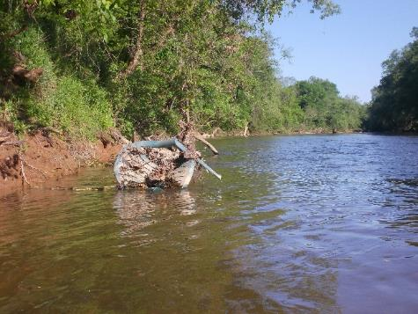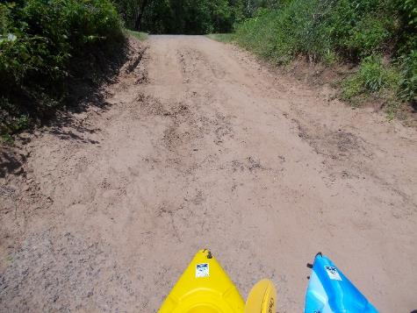

Plastic chair floating in the water (05-13-15)

Sediment deposited on Crofton Boat Ramp after a heavy rain storm (05-13-15)

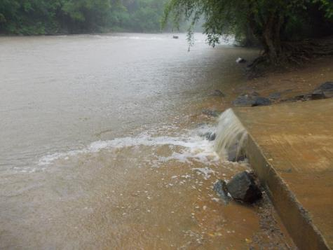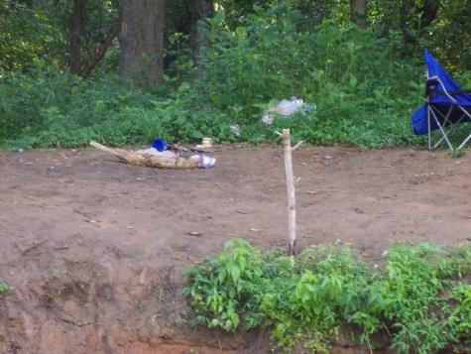

Runoff from Darden Towe Parking Lot during heavy rain storm (07-28-15)

Trash found near Reas Ford put in (07-10-15)

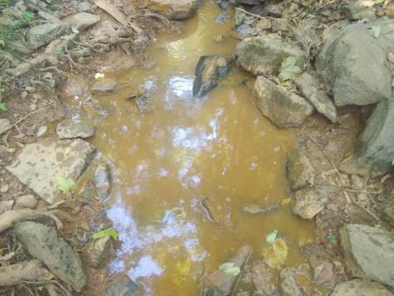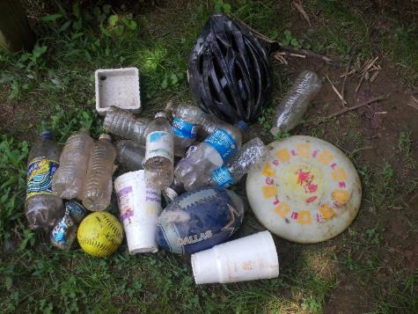

Trevillians Creek leading to Rivanna River sediment (08-26-15)

Trash collected from Darden Towe to Milton (08-21-15)

Riverview

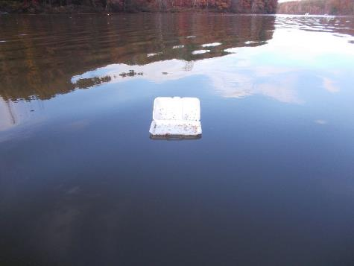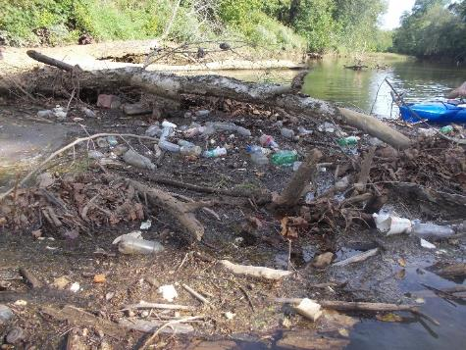

Styrofoam floating in the Reservoir (11-04-15)

Large area of trash from recent storm piled up behind a fallen tree (09-16-15)

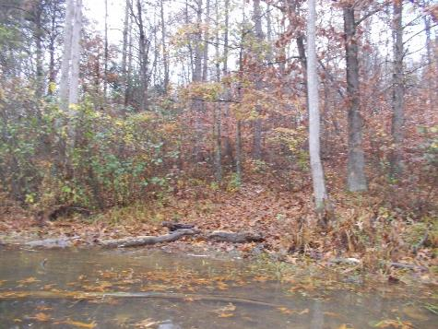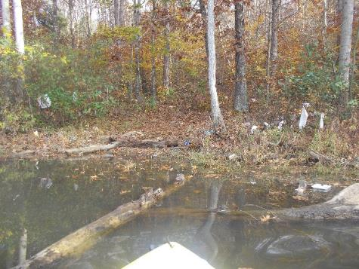

Same area as picture to the left after we removed all the trash (11-07-15)

Large area of trash found just above the Rivanna Reservoir Dam (11-04-15)

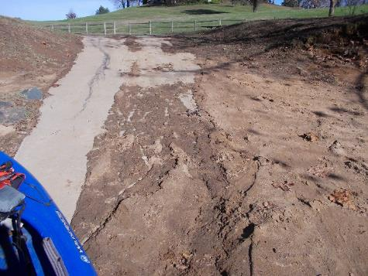

Sediment deposited on Darden Towe Park boat ramp after a heavy rain storm (11-11-15)

**Rivanna Flyover Aerial Photos (07-30-15)**









**Other Interesting Photos**

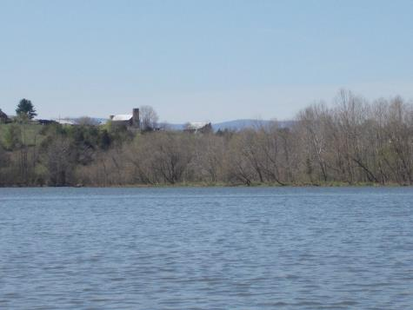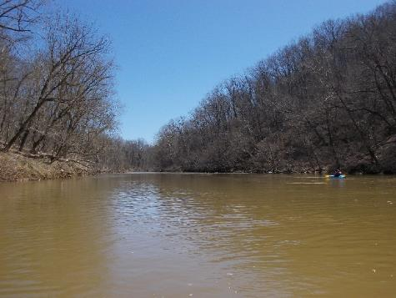

View of a farm and the mountains from the Reservoir (04-12-15)

Rivanna with sediment (brown color) in water after big rain storm and trees still bare (03-29-15)

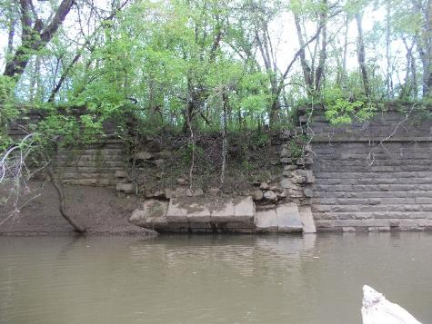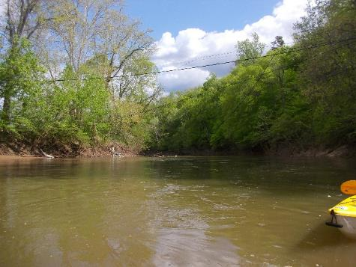

Old bridge remains near Columbia (05-02-15)

Downed power line in water near Columbia (05-02-15)

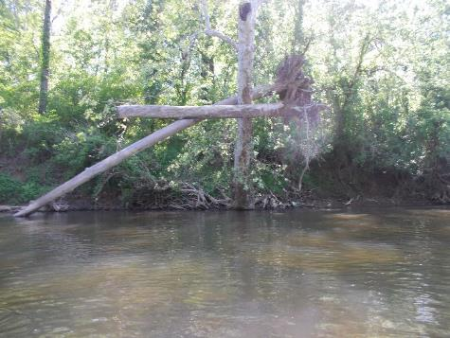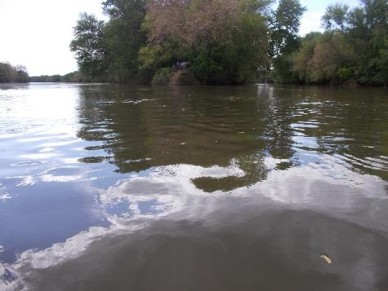

Uprooted tree and roots left hanging in another tree from a recent heavy rain (05-13-15)

View upstream of confluence of Rivanna River (right) and James River (left) (05-02-15)

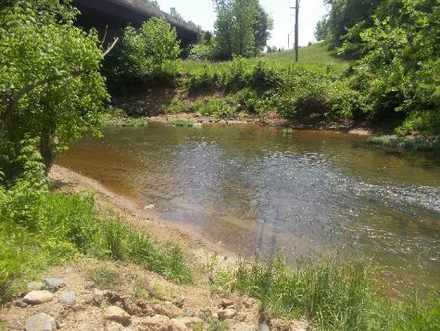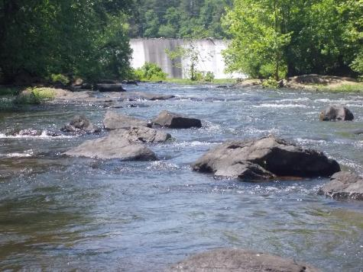

View from below the Rivanna Reservoir Dam (05-25-15)

North Fork of the Rivanna at 29 Bridge (05-26-15)

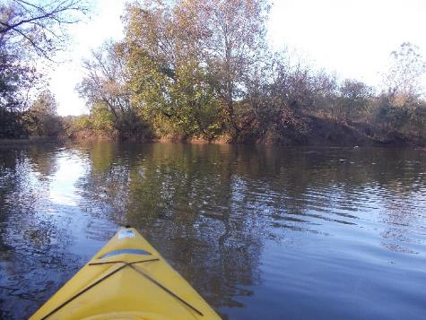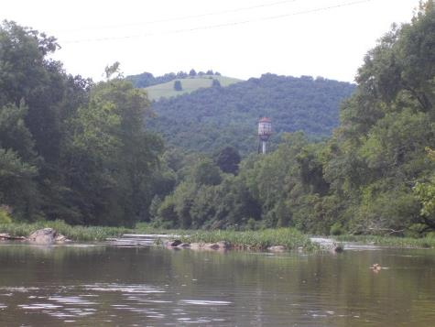

View upstream of North Fork (right) and South Fork (left) Confluence of the Rivanna River (10-21-15)

View of Woolen Mills from the Rivanna (08-21-15)

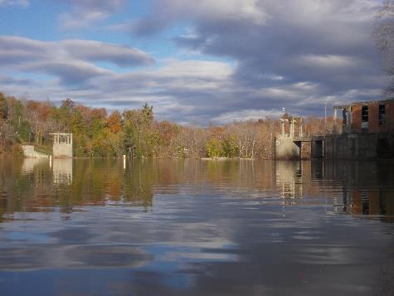

View just above the Rivanna Reservoir Dam (11-04-15)

**Issues To Address**

Throughout the regular paddle trips on the Rivanna, the Stewards noted several areas that need future attention to make sure that the health of the River and the organisms that live in it and depend on it are maintained. Overall, as mentioned above, the River is generally in good shape, and none of the items below is extremely critical or urgent. These items are just ones that RCS thinks could improve the overall experience for people using the Rivanna River, as well as remove items that may cause any harm.

Below is some information about some of the most critical areas of concern that the Stewards hope to address in the future.

Issue #1: Create better signage at boat access points along the River

The Stewards have noticed that it can be fairy difficult to find or see some of the take out locations on the River, and there is little to no signage for people to indicate where these locations are. One of the only signs that exists is the one pictured below at Milton (taken in 2014), which isn’t in very good shape any more after several storms this year. The Stewards feel that better signage or another form of indication where boat ramps are located might help paddlers on the river not miss their take out locations. This year the Stewards had to provide a ride to some paddlers who accidentally got out at the wrong location on the Rivanna, so they needed to get to their vehicle before it got dark outside.

It also makes it look like the River is being taken care of and cared about by somebody if nice signage is present. RCS would like to work with The City of Charlottesville and Albemarle County to create and install some better signage at each of the boat launch / take out locations on the Rivanna River. In general more access points and an increased level of maintenance of existing access points would increase the community’s interaction with the Rivanna River.

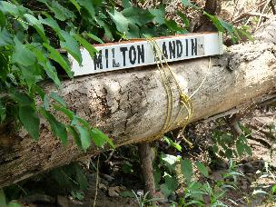

One of the few signs that exists at boat ramp locations (at Milton Shadwell) on the Rivanna. This photo was taken in 2014 and the sign isn’t in as good of shape any more as the photo shows.

Issue #2: Remove the larger objects found in the River

There are several large items requiring removal from the Rivanna. They require heavy equipment to remove. Examples are tires, metal objects, and construction debris. RCS will need the assistance of the City and County for these efforts. Details about when to do the removal (during low water levels), what equipment we need, and disposal locations needs to be worked out. The Stewards have GPS coordinates of some items, like tires, already, and will continue noting other locations in 2016.

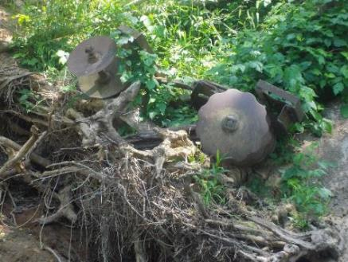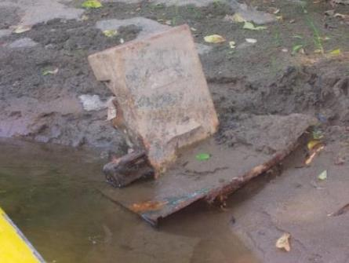

Piece of farm equipment (05-30-15)

Large piece of metal (05-30-15)

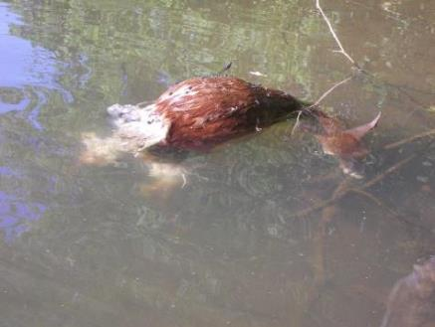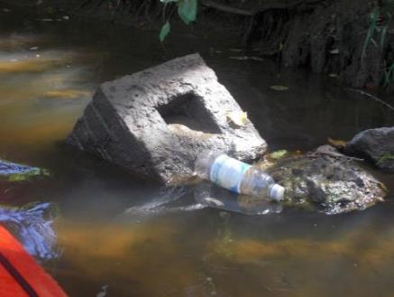

Brick structure floating in River (08-21-15)

Dead baby deer found near Reas Ford put in (07-10-15)

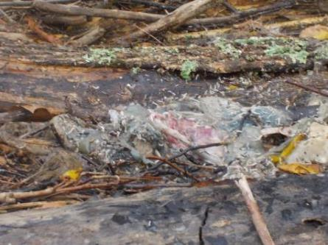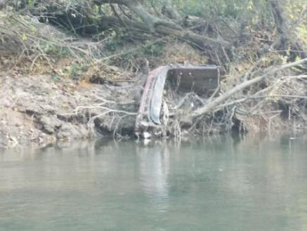

Unidentified dead animal in river between Riverview and Milton (11-01-15)

Piece of an automobile near Darden Towe (10-21-15)

Issue #3: Pipe discharges

The Stewards have noticed numerous pipe (point source) discharges into the Rivanna River during their paddles. Generally there are no issues noticed at these locations as far as pollution coming out of the pipes. There were several occasions though where the Stewards noted items of concern during paddle trips, and reported the information to local authorities. The Stewards have also noted several pipes that don’t seem to be working properly any more as pieces of them are floating in the River, or they have come out of the ground where they were once buried. So far response to the these issues has been timely by the local authorities, but keeping an eye on these point source potential pollution sources is an ongoing effort.

An inventory of all current pipe outfalls locations could be helpful so that any future pipes installed could be identified and checked for validity as well as a check of existing outfalls could be verified.

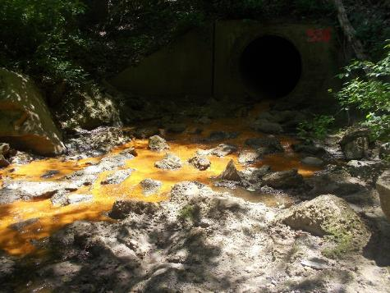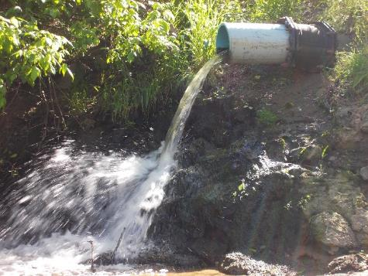

Discharge from pipe just below Rio Mills (05-25-15)

Pipe near Crofton discharging a significant amount of water during a day with no rain (05-13-15)

Issue #4: Erosion of river banks

On several paddle trips and in several locations this year the Stewards have noticed areas where the river banks have eroded away and vegetation has been washed away. It appears that some of these locations have been experiencing erosion for quite some time, but others may have occurred more recently during some of the very heavy storms we experienced this year. These heavy storms also deposited a good amount of fallen trees and other debris in the river in various locations. There are several bridge overpasses where a significant amount of debris has accumulated. RCS plans to see if a few specific areas along the Rivanna can be targeted where it would be possible to implement some re-vegetation and bank stabilization projects to try to avoid further damage to the river banks. RCS will look to partner with the government agencies and other organizations for these efforts.

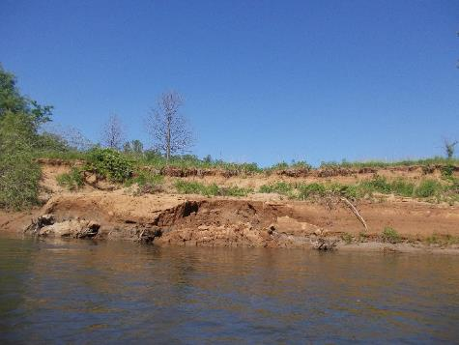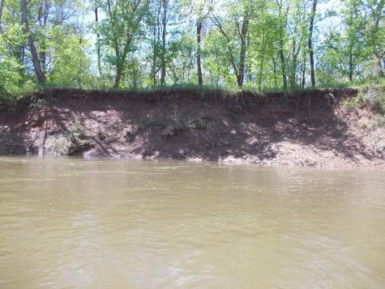

Eroded bank near Crofton (05-13-15)

Eroded Bank between Palmyra and Columbia (05-02-15)