RIVANNA RIVER STEWARD REPORT
River Stewards: Dan Triman and Justin Altice Date: 04-08-16
Starting Location and Time: Reas Ford Rd (3:00 PM)
Ending Location and Time: Earlysville Rd (5:00 PM)
Weather: Cloudy and Windy Recent Precipitation: Some rain this week
USGS Gauges: Earlysville 2.05 ft (119 ft³ / sec), Palmyra 4.20 ft (1,090 ft³ / sec),
Water Color: A little cloudy Water Odor: None Air Temp. : 55 deg F
DO: 4 ppm PH: 8 Turbidity: 30 JTU Water Temp. : 13 deg C
Water Testing Location: Under Bridge Overpass at Woodlands Rd
---------------------------------------------------------------------------------
Land Use:
Mostly farmland and wooded areas with residential areas near Reservoir.

Wildlife Sightings and Plant Life:
Turtles, Crows, Fish, Osprey, Hawk, Blue Heron, Geese, and Ducks.
Vegetation is slowly starting to come back after the Winter. Saw some redbuds, and other flowering plants.

People Interactions:
We saw 3 other kayakers, rowing teams near the UVA boathouse, and several people fishing at the Woodlands Rd boat put in.

Litter and Pollution:
We removed ½ a bag of trash from the River. It was mostly cans and bottles, food containers, fish bait boxes, and plastic bags. There was a large orange construction cone buried in the water just above the Reservoir at River right, which appears to have been there a long time.

Overall Summary:
Water levels were up slightly with the rain this week. The water was a little cloudy with sediment, but no odors noticed. There were a lot of new no trespassing signs on trees for the Panorama Farms property at River left we noticed. Lots of turtles out today, and spotted a good amount of birds as well. Most of the trash found was at the Reas Ford put in location.

Actions Needed – level of priority (1 highest/5 lowest):
4 – Remove orange construction cone from the water

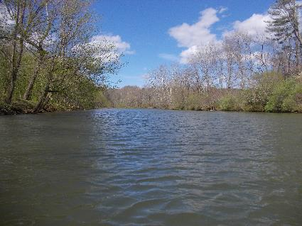
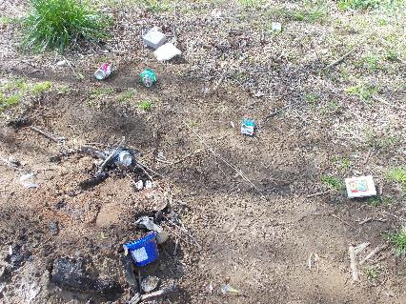
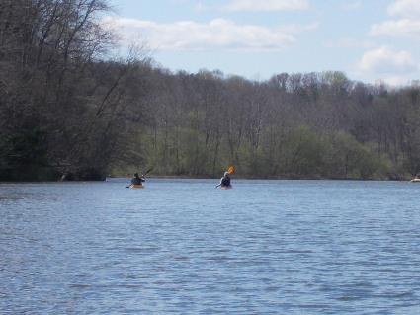
Figure 1: Trash at Reas Ford put in Figure 2: View down river near Reas Ford
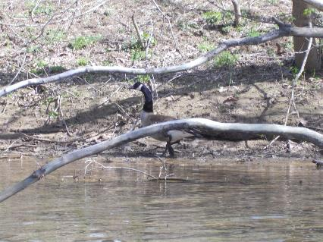
Figure 3: Goose hiding behind a tree branch Figure 4: 2 Kayakers heading up river
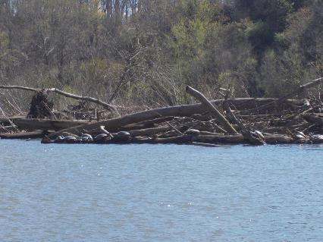
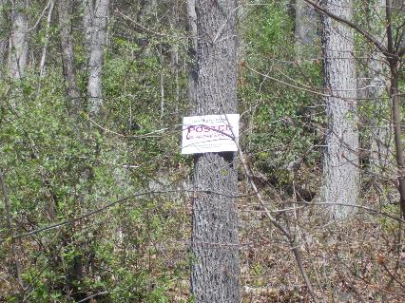
Figure 5: No trespassing signs posted for Panorama Farms Figure 6: “Turtle Island” as we have named it

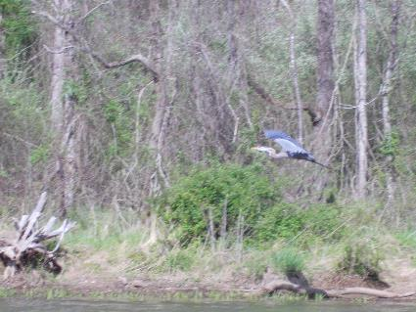
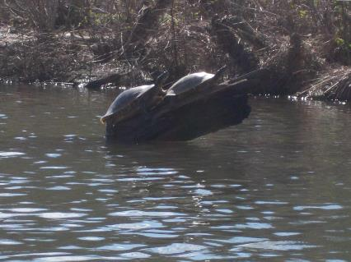
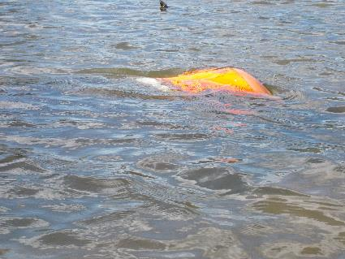
Figure 7: More turtles Figure 8: Blue Heron in flight
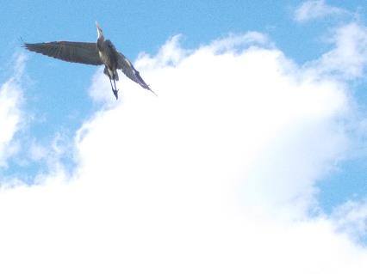
Figure 9: Same Blue Heron flying overhead Figure 10: Orange Construction Cone in water
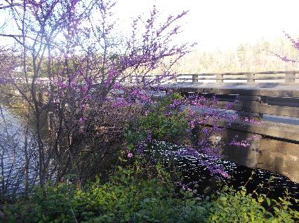
Figure 11: Redbuds at Woodlands Rd boat put in

