RIVANNA RIVER STEWARD REPORT
River Stewards: Dan Triman and Justin Altice Date: 04-24-16
Starting Location and Time: Crofton (10:00 PM)
Ending Location and Time: Palmyra (2:00 PM)
Weather: Sunny Recent Precipitation: Some rain the past few days
USGS Gauges: Earlysville 1.73 ft (67 ft³ / sec), Palmyra 3.30 ft (381 ft³ / sec),
Water Color: Very clear Water Odor: None Air Temp. : 75 deg F
DO: 4 ppm PH: 7 Turbidity: 0 JTU Water Temp. : 17 deg C
Water Testing Location: Pettit Island River Left (37°53'19.9"N 78°16'29.5"W)
---------------------------------------------------------------------------------
Land Use:
Mostly open space and wooded areas, with some farms and residential.

Wildlife Sightings and Plant Life:
Turtles, Crows, Bass, Gar, Hawk, Ducks, Geese, Butterflies, Dragonflies. Vegetation along the banks is getting a little thicker now and plants continue to flower as the weather gets warmer.

People Interactions:
This trip was our Spring Sojourn paddle, and we had a group of 43 people on the trip. We also saw about 15 other people either on the River, getting ready to go on a paddle trip, or finishing up a paddle trip.

Litter and Pollution:
There was not much trash found at all during the paddle. There are still a number of tires buried in the River or on the banks in this stretch of the Rivanna, some of which are pretty large in size.

Overall Summary:
We partnered on this Sojourn paddle trip with Gabe Silver from Rivanna River Company. This was a much larger group than we are used to for our Sojourn paddles, but everyone had a great time, enjoyed the weather, and got a chance to see some wildlife and meet other paddles. Water levels came up slightly with the recent rain. The water continues to be very clear, making for good fish visibility. Lots of turtles out today as well. We stopped for lunch at Pettit Island as part of the Sojourn trip.

Actions Needed – level of priority (1 highest/5 lowest):
4 – Remove remaining tires from the River

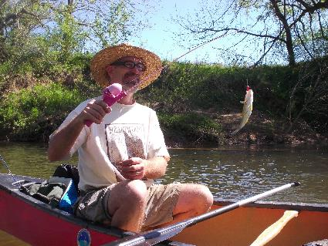
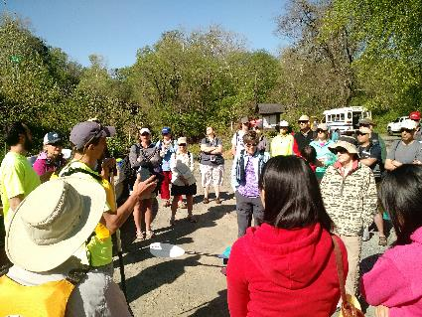
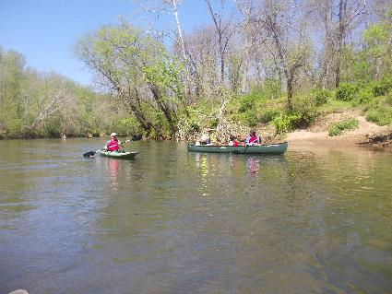
Figure 1: Gabe and Dan doing the pre paddle briefing Figure 2: RCA Board Member Angus Murdoch catching a fish
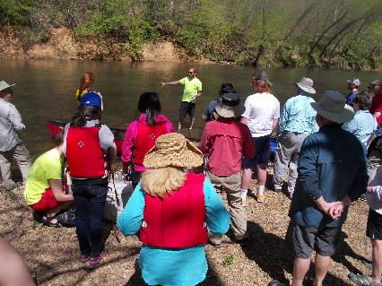
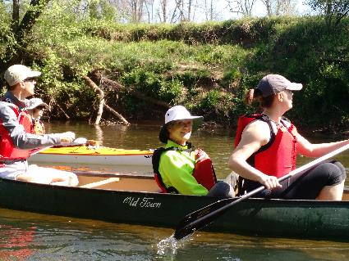
Figure 3: Justin demonstrating water quality testing Figure 4: Some of the paddlers on the Sojourn
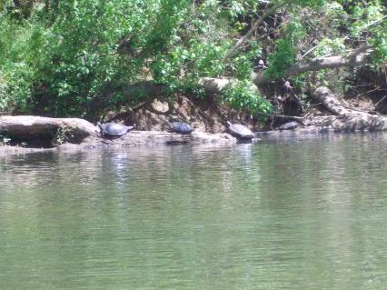
Figure 5: Turtles sunning on a log Figure 6: Some more of our Sojourn paddlers

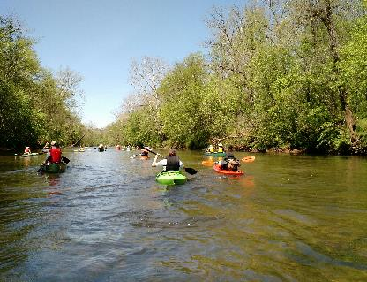
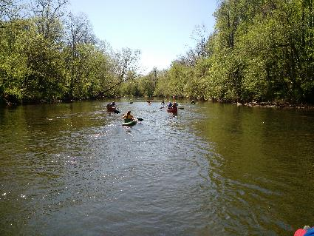
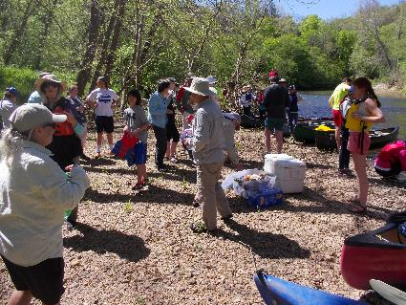
Figure 7: View of the Rivanna downstream Figure 8: Quite the impressive group of paddlers
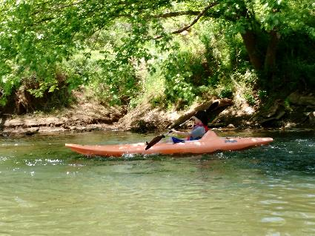
Figure 9: One of our youngest paddlers Figure 10: Taking a break for lunch on Pettit Island
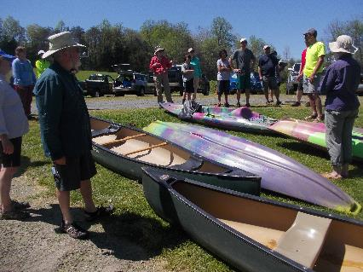
Figure 11: Thanking everyone for coming after the paddle

