RIVANNA RIVER STEWARD REPORT
River Stewards: Dan Triman Date: 5-15-16
Starting Location and Time: Darden Towe (1:00 PM)
Ending Location and Time: Riverview Park (2:30 PM)
Weather: Cloudy, Windy Recent Precipitation: Some rain recently
USGS Gauges: Earlysville 2.10 ft (129 ft³ / sec), Palmyra 3.86 ft (787 ft³ / sec),
Water Color: Mostly Clear Water Odor: None Air Temp. : 60 deg F
DO: 4 ppm PH: 8 Turbidity: 10 JTU Water Temp. : 18 deg C
Water Testing Location: Darden Towe Boat Ramp River Left
---------------------------------------------------------------------------------
Land Use:
Residential mainly, with some commercial use and park property

Wildlife Sightings and Plant Life:
Turtles, Crows, Cardinals, Fish, Geese, Great Blue Heron, smaller birds.
Several patches of dense bamboo near Darden. Vegetation is much fuller now than a few months ago. Turtles were abundant on the River today, and there was at least 3 families of adult Geese and their babies spotted.

People Interactions:
There were a couple of people fishing along the river, as well as 2 other people kayaking the Rivanna today. Numerous other people walking along the trails alongside the River.

Litter and Pollution:
There was not much trash found today. Just a couple of plastic drink bottles, and some fishing bait boxes. There was 1 tire buried in the River noticed as well. Overall the River looked pretty clean today.

Overall Summary:
Water levels are still up slightly, but have come down since the last week or two of heavy rains. The Riverview Park steps still need attention as the soil has eroded at the bottom (see photo below). There was also a pipe that is just hanging out of the water near Darden Towe Park (River Left – see photo below).

Actions Needed – level of priority (1 highest/5 lowest):
4 – Clean sediment off Darden Towe boat ramp and Riverview steps;
4 – Determine if the pipe near Darden Towe needs to be fixed; 2 – fix Riverview Park steps for safety issues

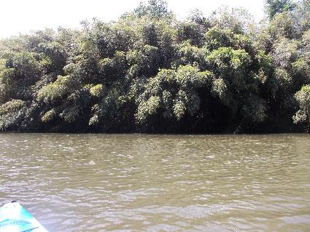
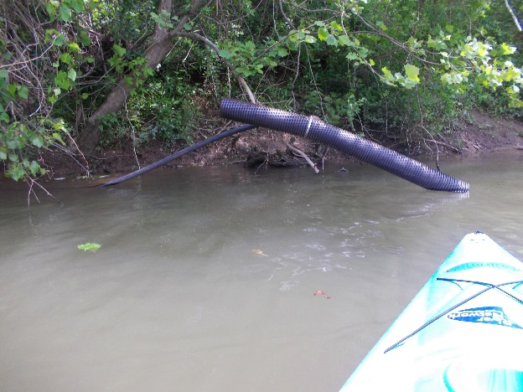
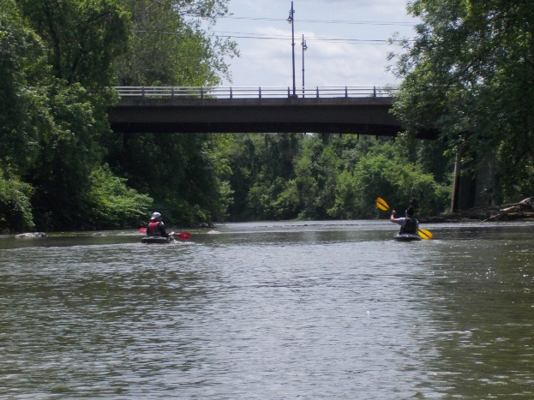
Figure 1: Pipe hanging in water near Darden Towe Figure 2: Patch of bamboo just down river from Darden Towe
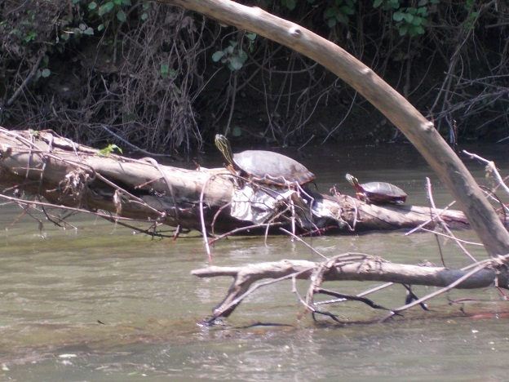
Figure 3: Some of the many turtles seen today Figure 4: 2 Kayakers heading towards Free Bridge
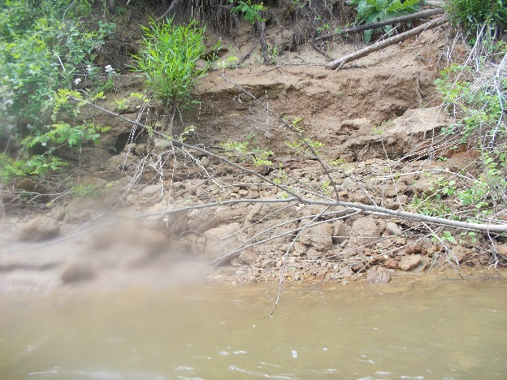
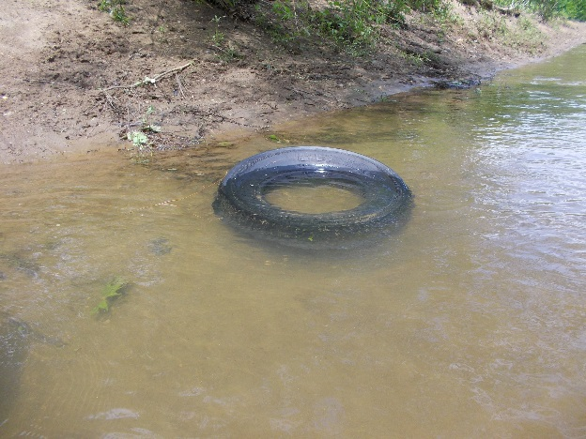
Figure 5: Buried tire in the River Figure 6: Heavy eroded bank

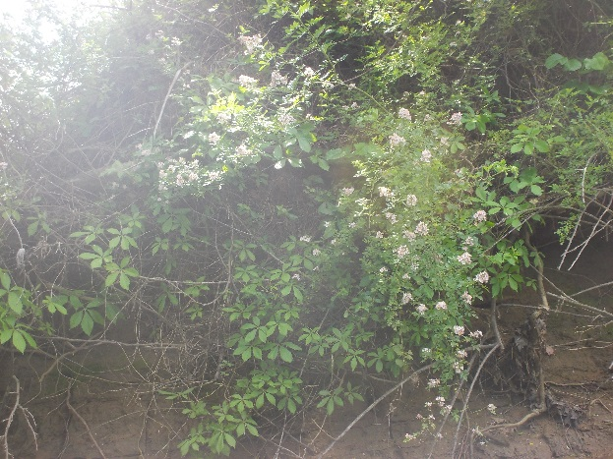
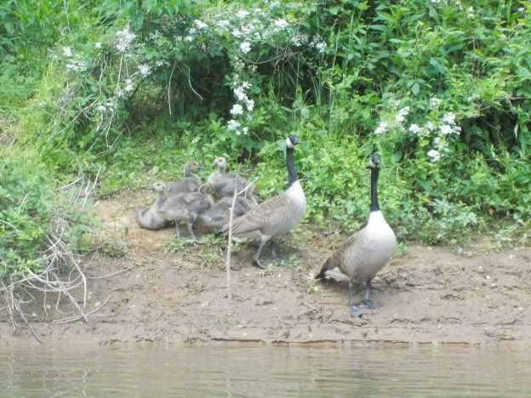
Figure 7: One of the families of Geese Figure 8: Pink flowers blooming
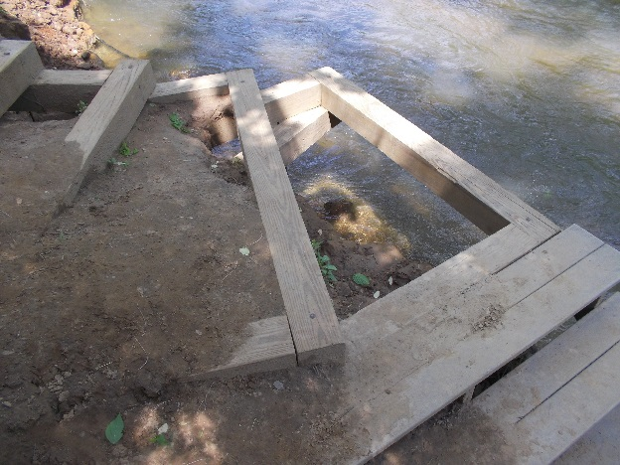
Figure 9: Riverview steps still in need of repair

