RIVANNA RIVER STEWARD REPORT
River Steward Name(s): Dan Triman and Justin Altice Date: 05-30-15
Starting Location and Time: Milton 9:45 AM
Ending Location and Time: Crofton 2:00 PM
Weather: Sunny and Clear Skies Recent Precipitation: One heavy rain recently
Water Flow: Moderate Water Color: Very Clear Water Odor: None
Water Temp. : 24 deg C Air Temp. : 75 deg F
DO: 5 ppm PH: 8.0 Turbidity: 10 JTU
USGS Water Gauge Reading: Palmyra 2.97 ft, Earlysville 1.49 ft
Physical Location Characteristics: Near Rivers Edge Community
Specific Location Testing Performed: River left 37°57'15.3"N 78°20'55.9"W
Land Use:
Mostly rural farms and wooded land, with some residential areas in Keswick and Lake Monticello.

Wildlife Sightings and Plant Life:
turtles, several birds (including kingfishers, crows, 1 red shouldered hawk, cormorants), 3 snakes, and numerous fish (lots of bass and long nose gar).

People Interactions:
Saw several people out fishing on the River today (about 10 total)

Litter and Pollution:
Not much in the way of litter, only a couple of cans and bottles mainly. Several larger metal pieces of litter that were too big to remove. Counted at least 60 tires in the water or on the banks of the River.

Overall Summary:
It was a great trip overall. The water was about as clear as we have ever seen it, so we saw more fish than ever before. There were a lot of tires in this stretch that should be removed in the future. Saw at least a few people out on the water, as well as some downed trees.

Actions Needed – level of priority (1 highest/5 lowest)
4 – Remove Tires, 4- Repair Milton table and put up RCS info with Plexiglas at kiosk at Milton

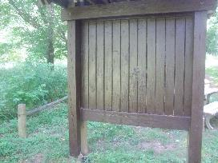
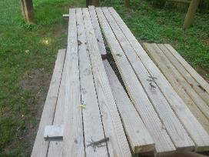
Figure 1: Table at Milton needing reparis Figure 2: Milton Kiosk recently repainted

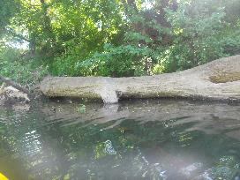
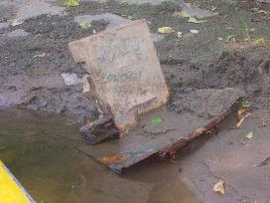
Figure 3: Example of large metal debris found on the bank Figure 4: Example of downed tree in the River

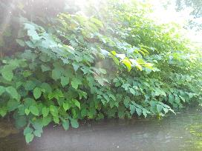
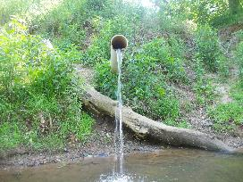

Figure 5: Outfall pipe between Milton and Glenmore Figure 6: Vegetation that was prevalent along the banks

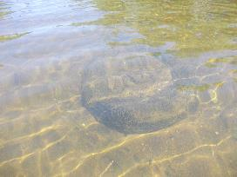
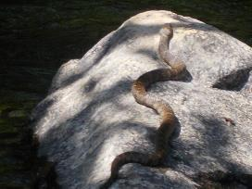
Figure 7: Snake sunning on a rock Figure 8: Example of tire buried in the river bed.

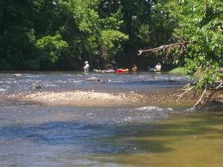
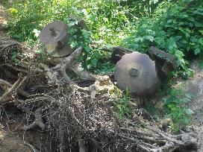
Figure 9: Large piece of farm equipment on the bank. Figure 10: People fishing in the River.

