RIVANNA RIVER STEWARD REPORT
River Stewards: Justin Altice and Dan Triman Date: 05-7-16
Starting Location and Time: Rio Mills Bridge (12:00 PM)
Ending Location and Time: Darden Towe Park (3:30 PM)
Weather: Fair Sky Recent Precipitation: Lots of rain in recent days
USGS Gauges: Earlysville 3.6 ft (480 ft² / sec), Palmyra 6.5 ft (3000 ft² / sec),
Water Color: Brown Water Odor: Musty in spots Air Temp. : 68 deg F
DO: 4 ppm PH: 8 Turbidity: 50 JTU Water Temp. : 17 deg C
Water Testing Location: 38°04.5’N 78°26.4’W River Left NF just above SF Confluence.
---------------------------------------------------------------------------------
Land Use:
Float begins along 29 corridor with commercial use, then transitions to residential use along Polo Grounds Rd area, middle part of float contains open space while the end of the float goes through both Penn Park in the City and Darden Towe Park in the County

Wildlife Sightings and Plant Life:
Turtles, Ducks, Geese, Crows, Heron, Small Birds, and Hawk.

People Interactions:
Saw a few folks with their dogs along the beaches in parks. One man was fishing along the beach areas.

Litter and Pollution:
We removed almost 2 full bags of trash. With all the recent rains most trash was collected from strain areas where trash gets caught. Mostly consisted of plastic bottles, bags, cans, Styrofoam items, and sports balls. A lot of trash was observed on the banks leading from shopping center down to the River adjacent to 29 bridge near Rio Mills start point.

Overall Summary:
Water levels were really high due to recent rains. The water was extremely murky with sediment. This section had some rapids that are not usually present due to the high water levels. Many rocky areas and islands were not visible. Flow of the River was fast which facilitated less paddling on the trip.
One new notable project observed was what appeared to be a new bridge being constructed over the River near the South fork Reservoir damn. This project contained a great deal of activity right on the River banks on both sides (pictures below).
A baby turtle was rescued from the rushing waters in the middle of the River and taken to Darden Towe park for release.
Large dirt piles were observed being erected on a private property near the edge of the River along Polo Grounds road.

Actions Needed – level of priority (1 highest/5 lowest):
4 – Identify project being conducted over the River near the Damn
2 – Identify private property containing dirt pile and possible regulations involving activity
3 – Organize a cleanup effort behind shopping center along River

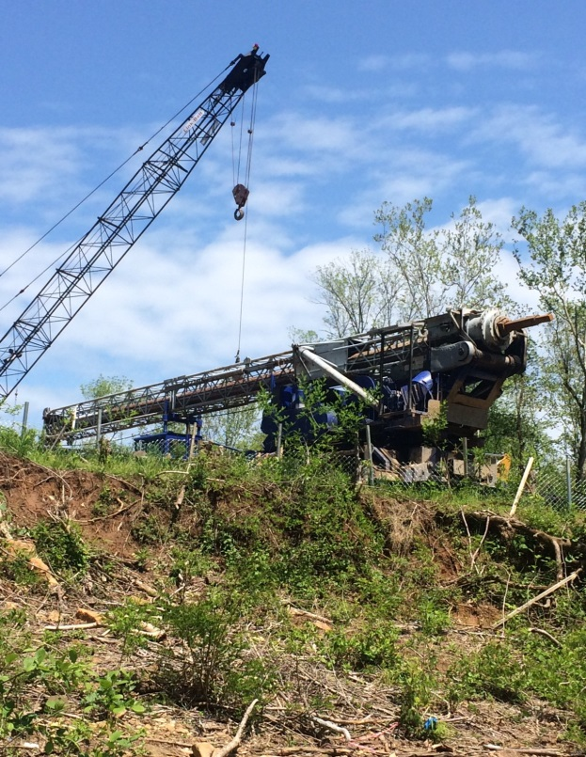
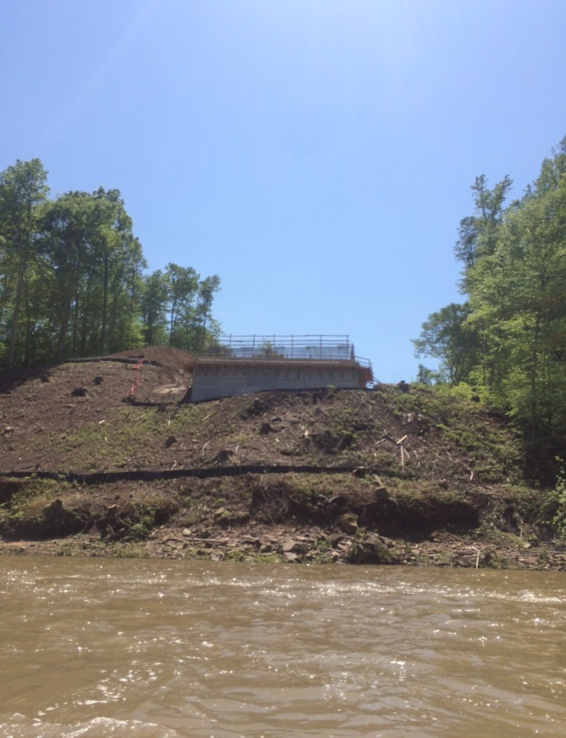
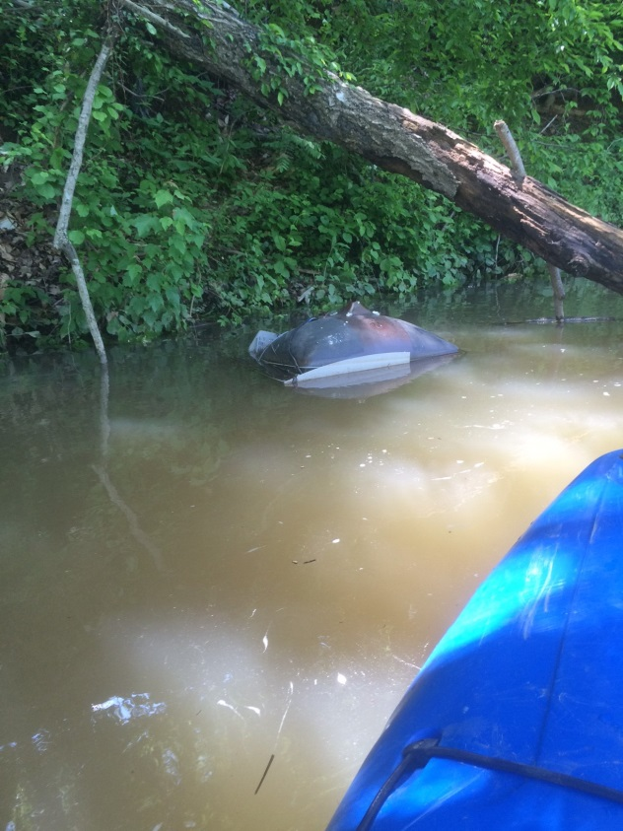
Figure 1: Project over the River near Damn. Figure 2: Same project on other side of River.
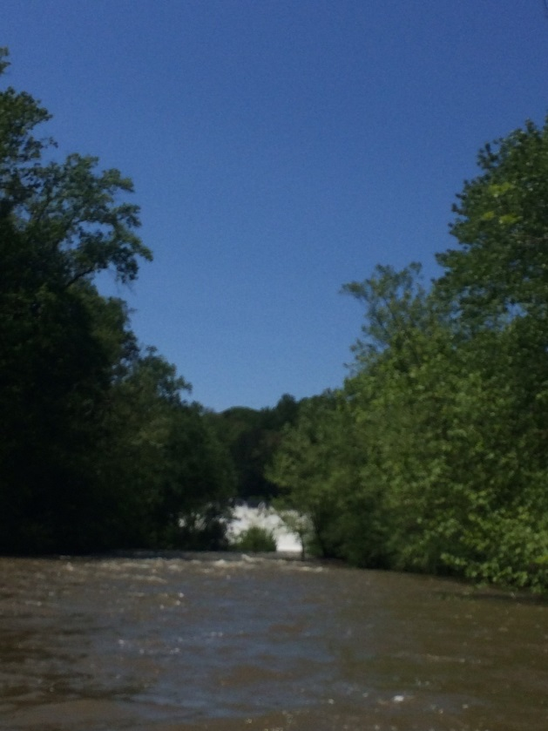
Figure 3: South Fork Reservoir Damn. Figure 4: Large piece of trash.

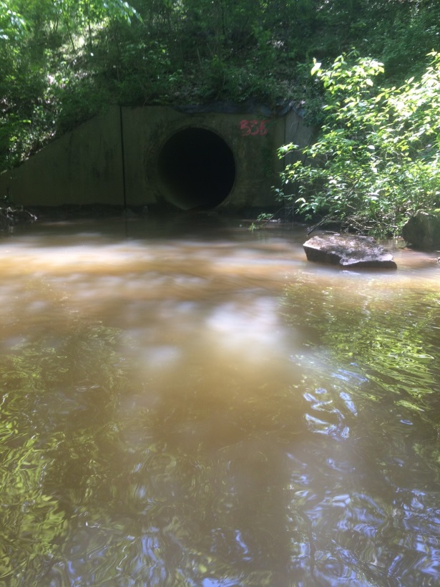
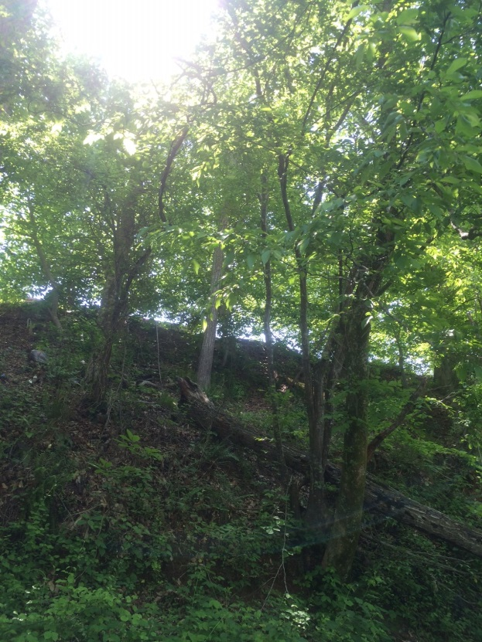
Figure 5: Trash along bank of Shopping Center Figure 6: Pipe outfall near Rt. 29.

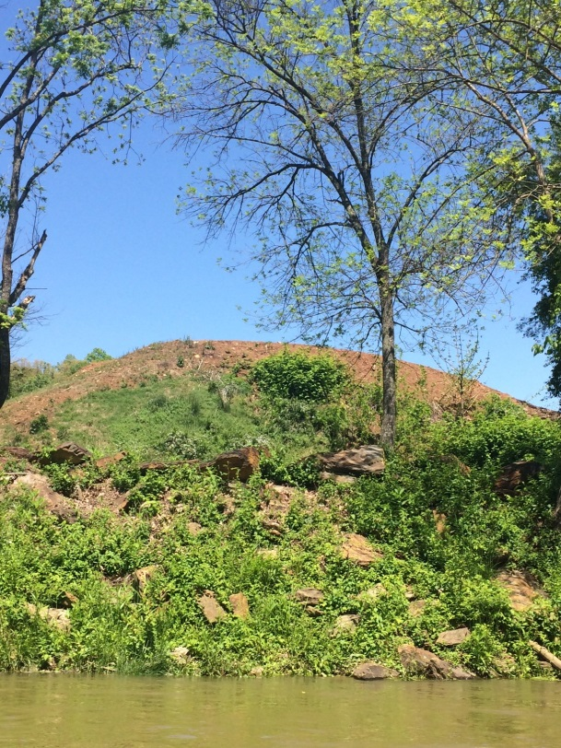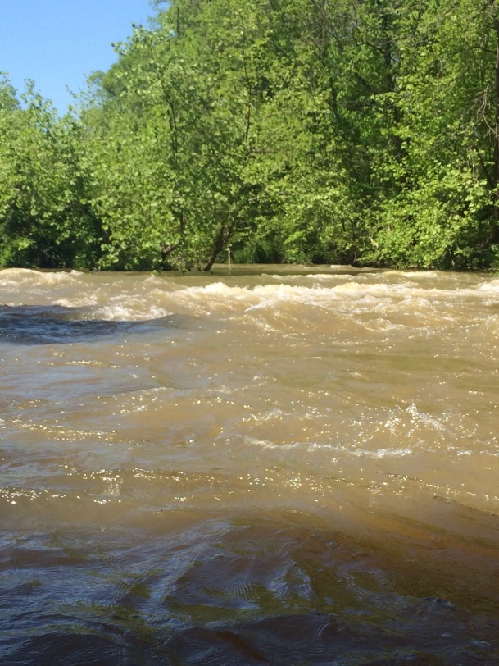
Figure 7: Large dirt pile on Private Property along River. Figure 8: Rapid area due to high water.

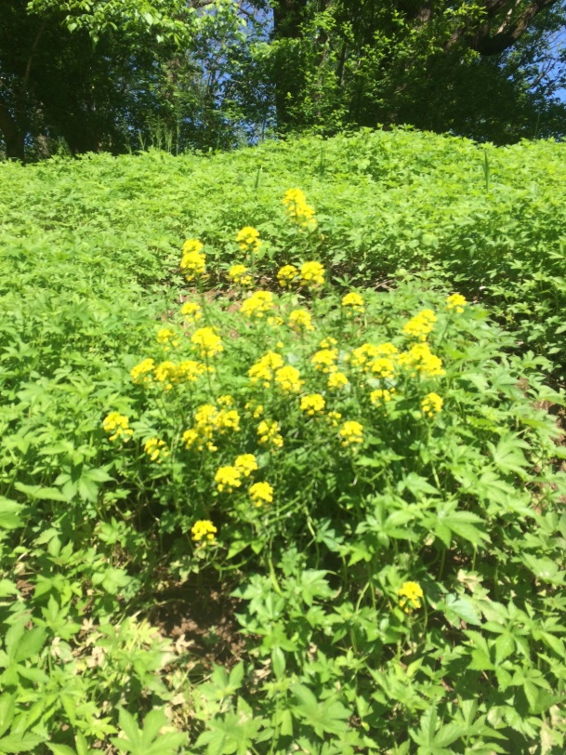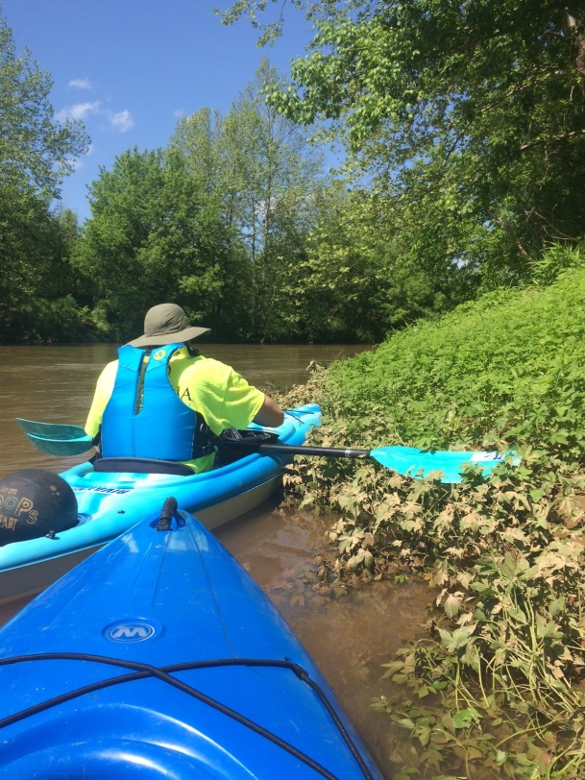
Figure 9: Plant life along River. Figure 10: Water testing at confluence.

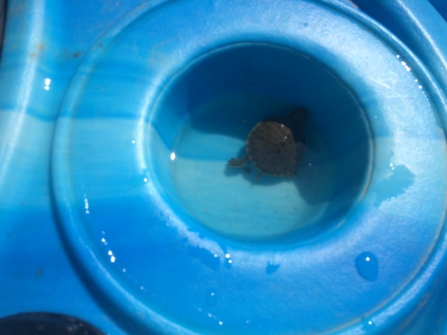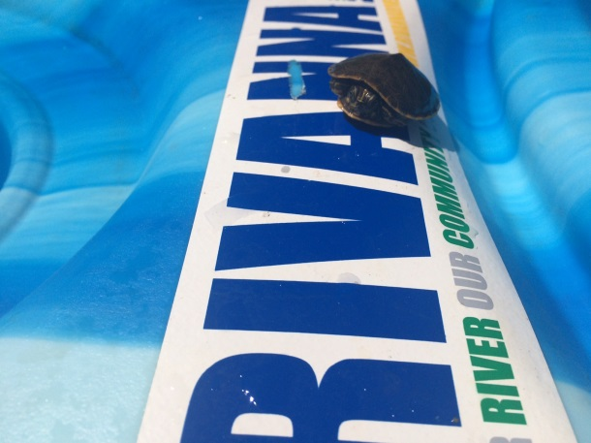
Figure 11: Baby turtle rescued from rapids. Figure 12: Baby turtle digging our RCA stickers.

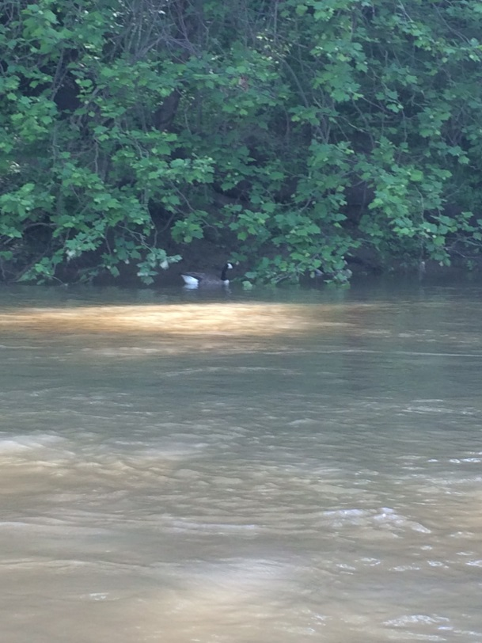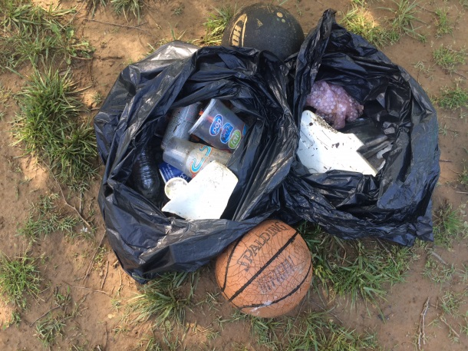
Figure 13: Geese along the River bank. Figure 14: Bags of Trash removed from River.

