RIVANNA RIVER STEWARD REPORT
River Steward Name(s): Justin Altice Date: 06-07-15
Starting Location and Time: Riverview Park 1:45 AM
Ending Location and Time: Milton 3:55 PM
Weather: Overcast with a few rays of Sun Recent Precipitation: Steady rain on Weds-Thurs of previous week
Water Flow: Mildly Rapid Water Color: A bit murky Water Odor: None
Water Temp. : 72 deg F Air Temp. : 74 deg F
DO: 3 ppm PH: 8.0 Turbidity: 40 JTU
USGS Water Gauge Reading: Palmyra 3.26 ft
Physical Location Characteristics: Where power transmission line crosses river
Land Use:
Residential development with a wooded buffer around the river that contains
the RTF then turning to more rural land uses towards Milton with train track running along side

Wildlife Sightings and Plant Life:
Lots of birds (including kingfishers, crows, red shouldered hawk, eagles, heron, ducks)

People Interactions:
Lots of people out on the Rivanna River on Sunday (8 kayakers (3 of them fishermen)

Litter and Pollution:
Not much in the way of litter, only a couple of cans and bottles mainly.

Overall Summary:
It was a great day to be on the river with low humidity and overcast skies. Witnessed an eagle in midair combat with two crows over territory near an eagles nest on large transmission power line tower. Also saw a hawk swoop down into the river and pull out a fish. Lots of people at Riverview and lots of cars at Milton.

Actions Needed – level of priority (1 highest/5 lowest)
4- Repair Milton table and put up RCS info with Plexiglas at kiosk at Milton. (I removed broken board from table and will reuse parts of board to sure up table; need to purchase two new 2x4s for repair.

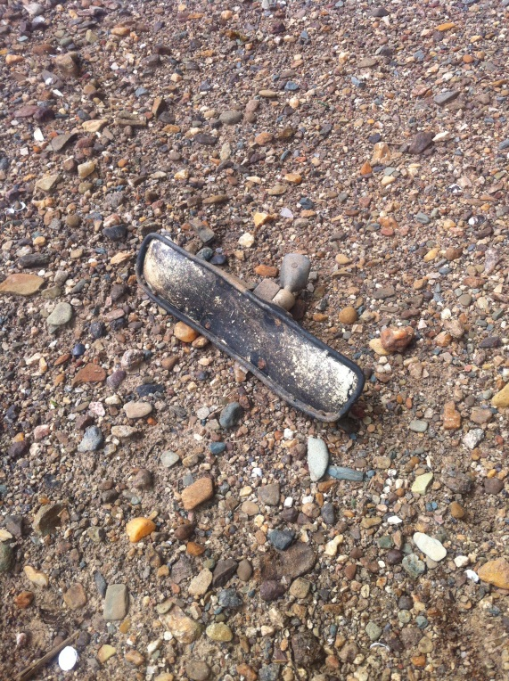
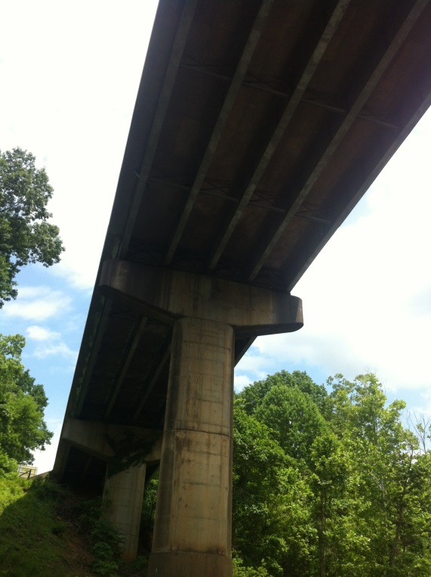
Figure 1: Interstate 64 overpass form River Figure 2: Somebody lost their rearview mirror

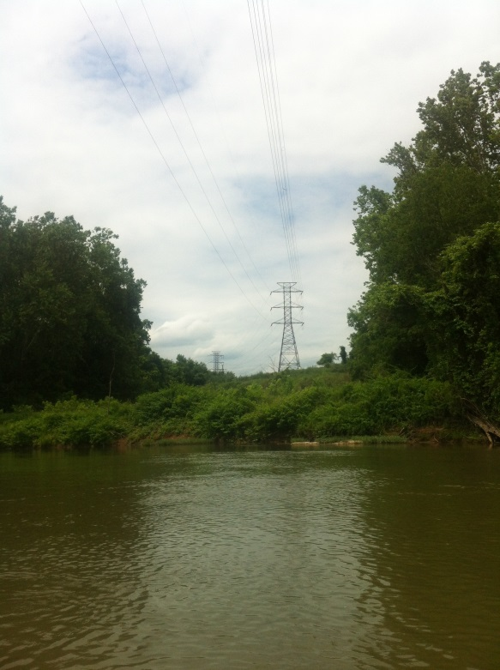
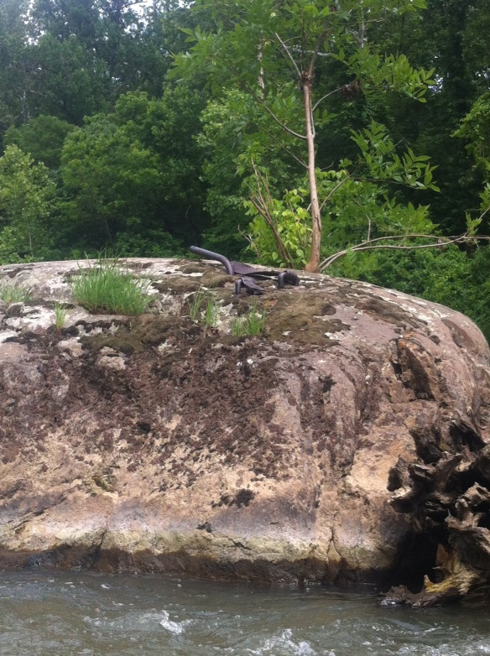

Figure 3: Old metal anchoring for historic bridge Figure 4: Large power transmission line over River

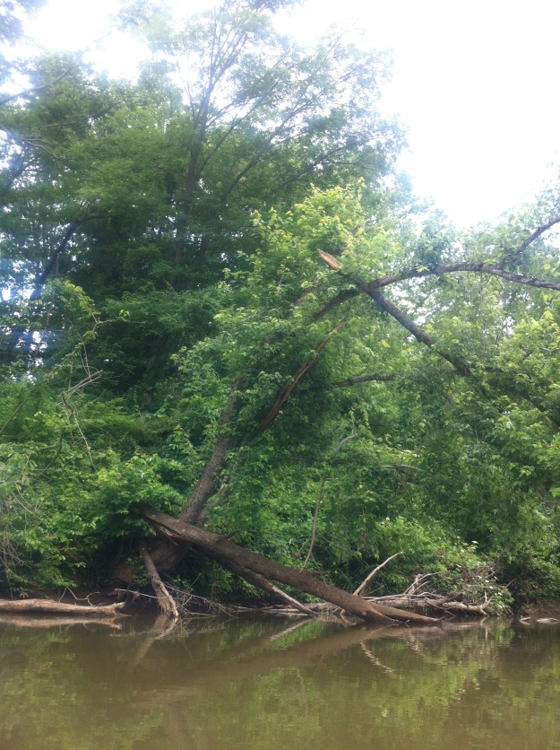
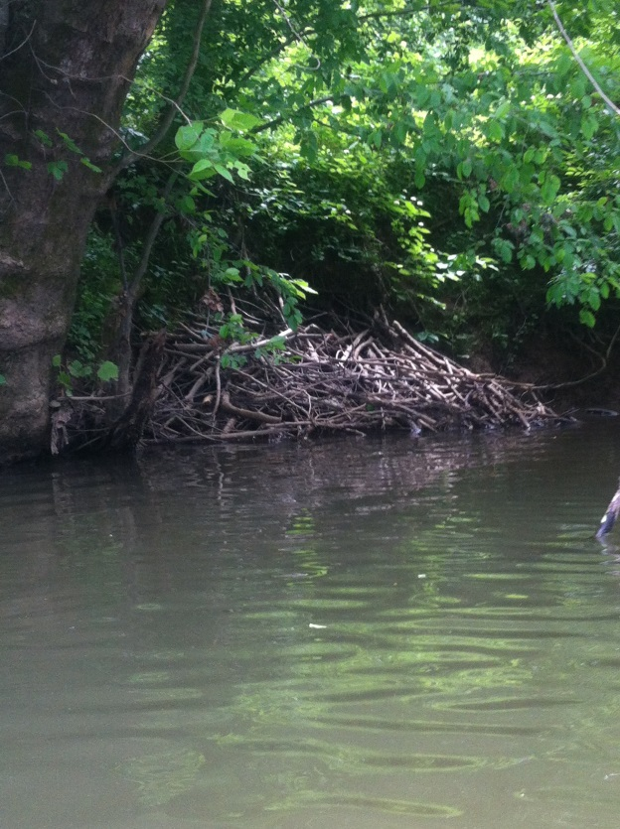
Figure 5: River habitat Figure 6: Downed trees along the River

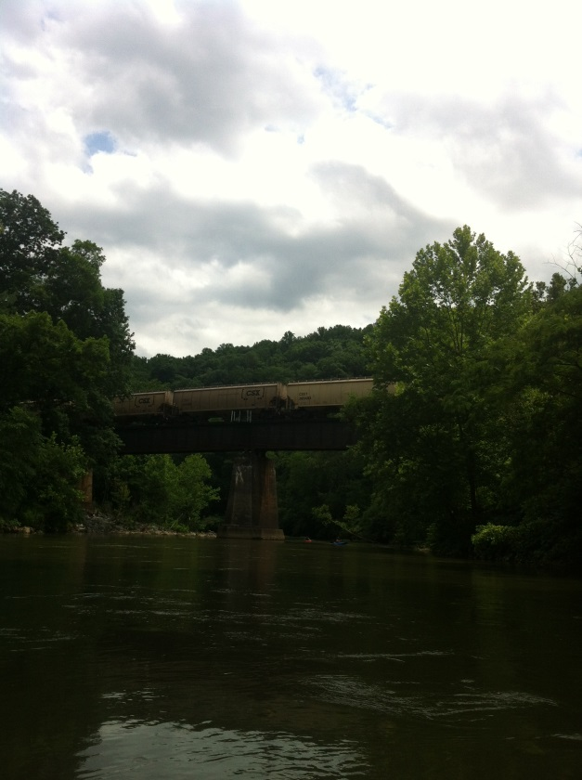
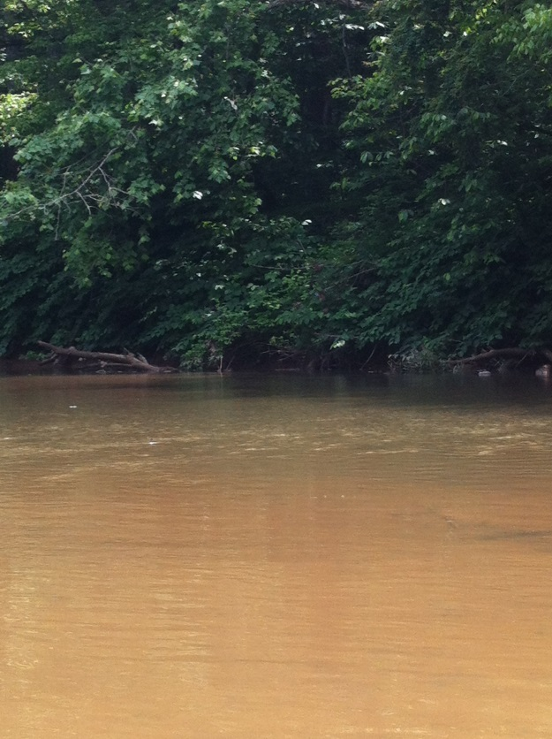
Figure 7: Murky water from rains during the week. Figure 8: CSX train traveling over the River.
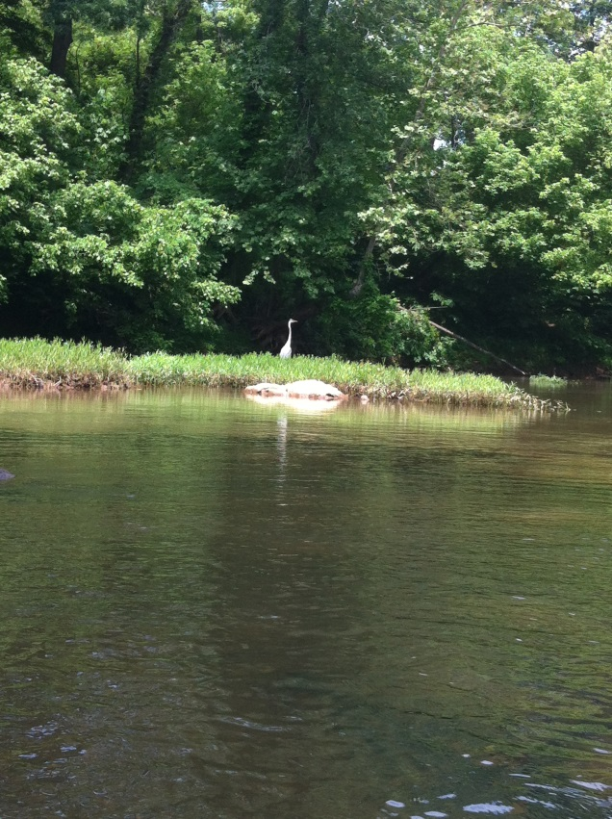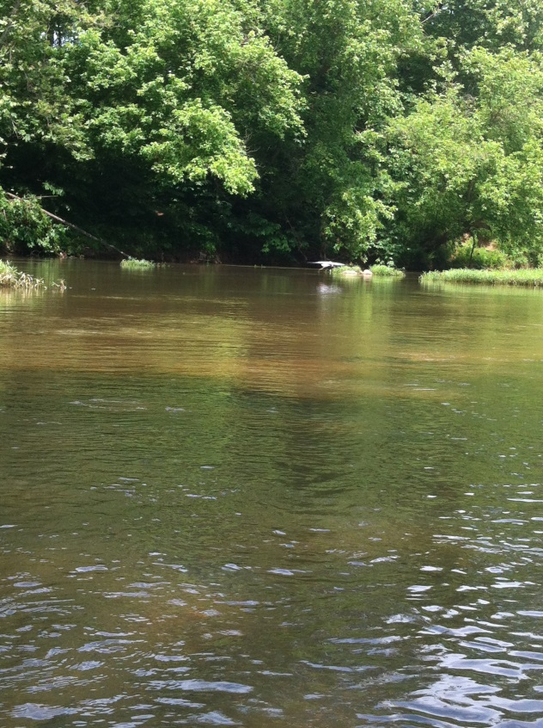
Figure 9: Heron enjoying the River. Figure 10: Shy Heron leaving after getting its picture taken.

