RIVANNA RIVER STEWARD REPORT
River Steward Names: Dan Triman & Justin Altice Date: 07-10-15
Starting Location and Time: Reas Ford Rd (5:30 PM)
Ending Location and Time: Earlysville Rd (8:00 PM)
Weather: Sunny with some Clouds Recent Precipitation: Heavy rain before trip
Water Flow: Slow Water Color: Blue (some Brown) Water Odor: None
Water Temp. : 25 deg C Air Temp. : 85 deg F
DO: 3 ppm PH: 8 Turbidity: 40 JTU
USGS Water Gauge Reading: Earlysville 1.65 ft., Palmyra 3.05 ft
Physical Location Characteristics: UVA Rowing Club Dock
Location Tested: Reservoir Right Side at Dock
---------------------------------------------------------------------------------
Land Use:
Mostly farmland and wooded areas with residential areas near the Reservoir.

Wildlife Sightings and Plant Life:
Geese (30-40), turtles, tree swallows, fish swimming under water, a beaver, 3 small deer, 2 pelicans, and 8 herons. There was also a dead baby deer floating in the water across from the Reas Ford put in (River right downstream a few hundred yards).

People Interactions:
We didn’t see any other people out on the water during the trip. There was a lot of evidence of people using the area near Reas Ford for fishing since we found a lot of Y shaped sticks in the ground for holding fishing rods, and significant amounts of litter.

Litter and Pollution:
The majority of the litter we found was near the Reas Ford put in on the River left bank in several popular fishing spots. It was mostly food and fishing bait trash. We removed about 2 trash bags worth of litter during the trip. There was also a plastic chair in the water and a dead baby deer.

Overall Summary:
Great wildlife sightings during the trip due to going out in the early evening. Good amount of trash found at fishing spots.

Actions Needed – level of priority (1 highest/5 lowest):
3 – Talk to fishers in area about pollution; 2 – Remove dead deer from water
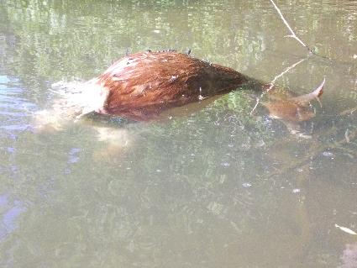
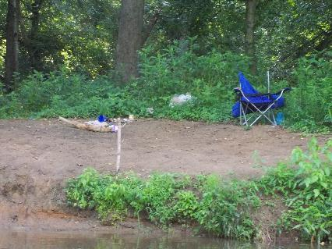
Figure 1: Trash found at Reas Ford boat put in Figure 2: Dead baby deer found floating in the River

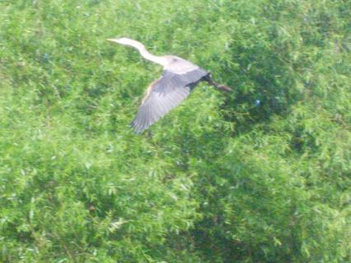
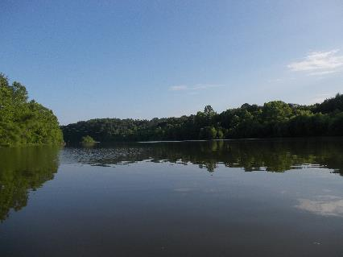
Figure 3: Scenic shot of the Rivanna Figure 4: Heron in full flight.

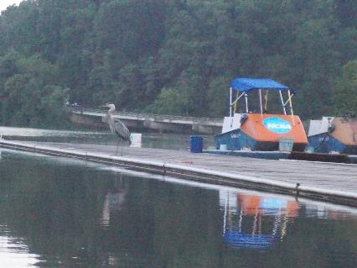
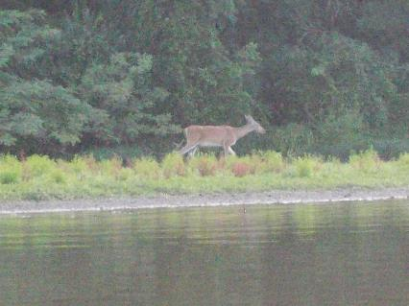

Figure 5: Young deer along the bank Figure 6: Heron standing on the UVA Rowing Club dock

