RIVANNA RIVER STEWARD REPORT
River Stewards: Justin Altice and Dan Triman Date: 07-15-16
Starting Location and Time: Riverview Park (2:30 PM)
Ending Location and Time: Milton (5:000 PM)
Weather: Clear Sky Recent Precipitation: Spotty Thunderstorms
USGS Gauges: Earlysville 1.35 ft (30 ft² / sec), Palmyra 2.95 ft (200 ft² / sec),
Water Color: Clear Water Odor: None Air Temp. : 90 deg F
DO: 4 ppm PH: 8 Turbidity: 0 JTU Water Temp. : 30.5 deg C
Water Testing Location: N. Milton Road Bridge
---------------------------------------------------------------------------------
Land Use:
The area adjacent to Riverview Park is residential, the River then passes underneath I-64 and subsequently turns more rural as with the train track running alongside. Some ag land uses occur the River approaches Milton along with sparse residential development.

Wildlife Sightings and Plant Life:
Our paddle as ripe with wildlife sightings. Geese, ducks, and turtles were seen along with a young eagle diving into the River for food. Small green herons were seen along with larger herons. A massive hawk was viewed as were many small fish jumping from the water. Lots of blooming mimosa bushes were observed along the River banks.

People Interactions:
We observed 2 young ladies in kayaks and a young couple with their dog down on the River near the Milton Road bridge.

Litter and Pollution:
Not much trash today, only a few cans and bottles. We removed 4 tires near the Milton access point.

Overall Summary:
Sunday was a hot summer day but just the right amount of cloud cover made for a wonderful paddle. The water was as clear as we have seen on the stretch of the River which opens up a whole new world to see. Lots of wildlife highlighted the trip, at one point we saw a green heron fly across the River which instigated a train reaction of a giant hawk flying the other direction followed by a young eagle flying across the River.

The rapids on this section were difficult with the lower water levels providing some dicey moments. Most novice paddlers would have difficulties on this stretch in the current conditions.

Actions Needed – level of priority (1 highest/5 lowest):
4 – Continue the planning and implementation process of improving the Riverview Park access point.
3 – Improve drainage on Milton Access Point steps.
2 – Develop a guide on which way is optimal to traverse the rapids on this section of the River

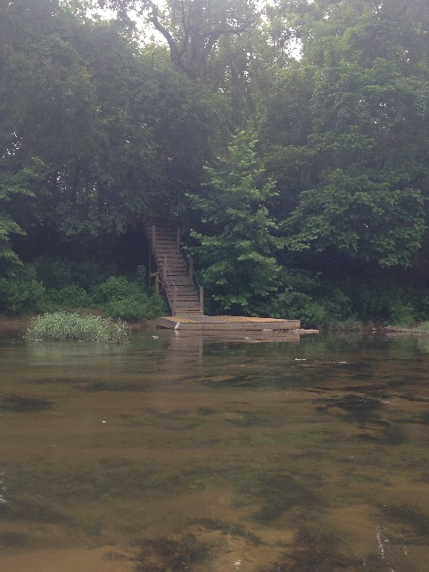
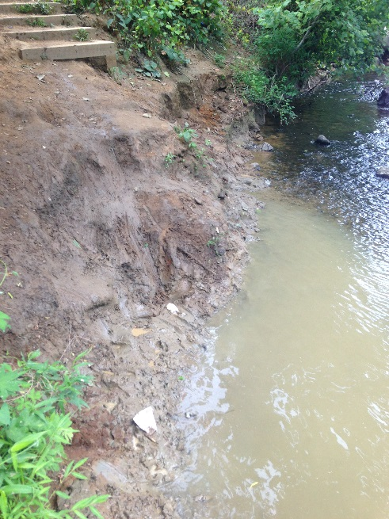
Figure 1: Eroded bank in Riverview Park. Figure 2: New dock built near old dam site.
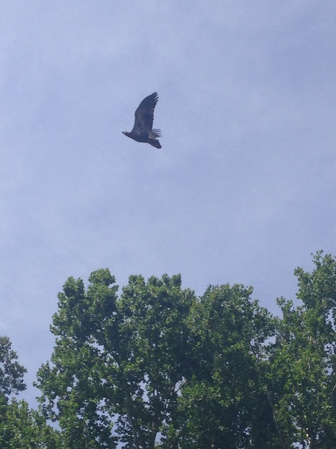
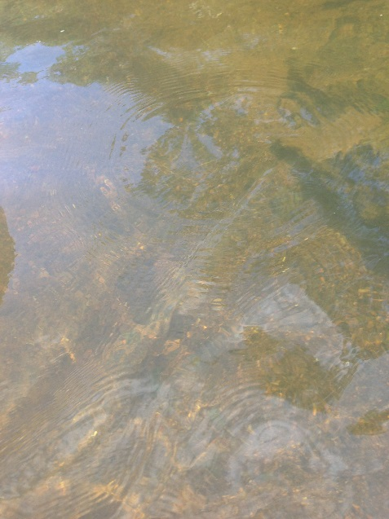
Figure 3: Clearness of water. Figure 4: Large hawk.

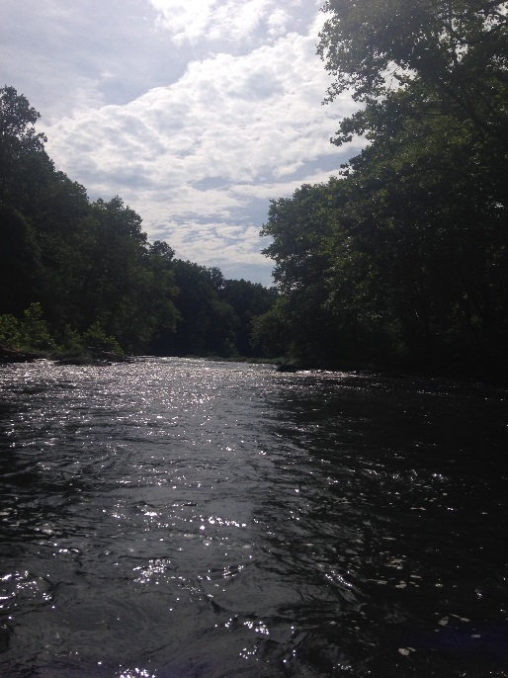
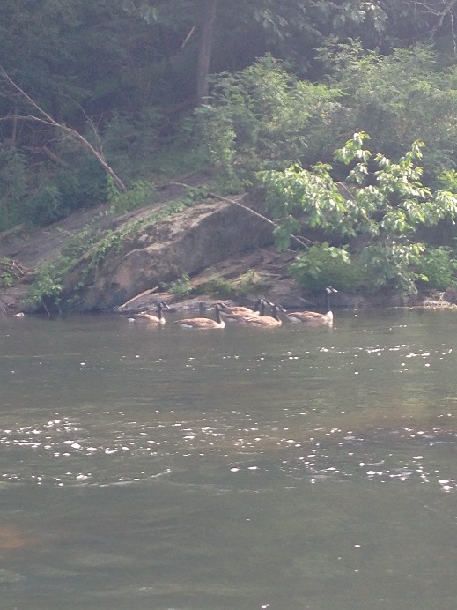
Figure 5: Flock of geese. Figure 6: View from the River.

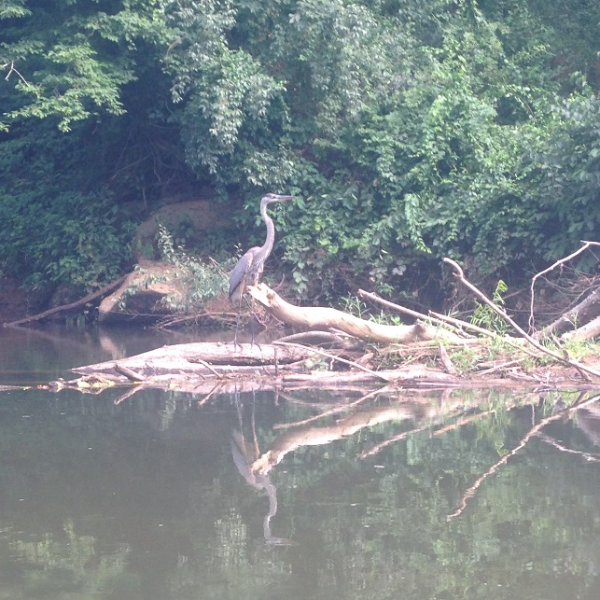
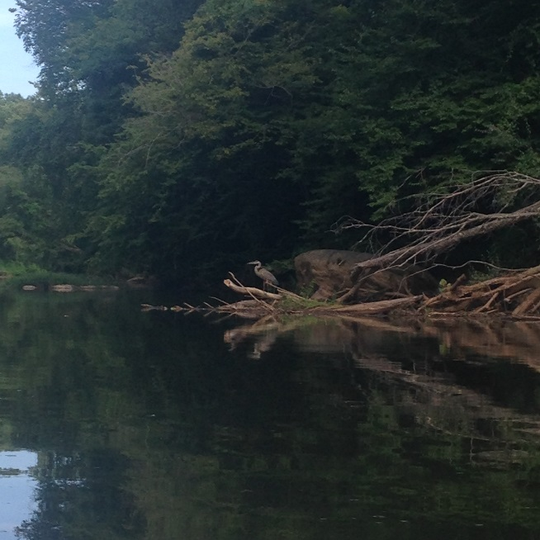
Figure 7: Posing heron. Figure 8: Closer view of heron.
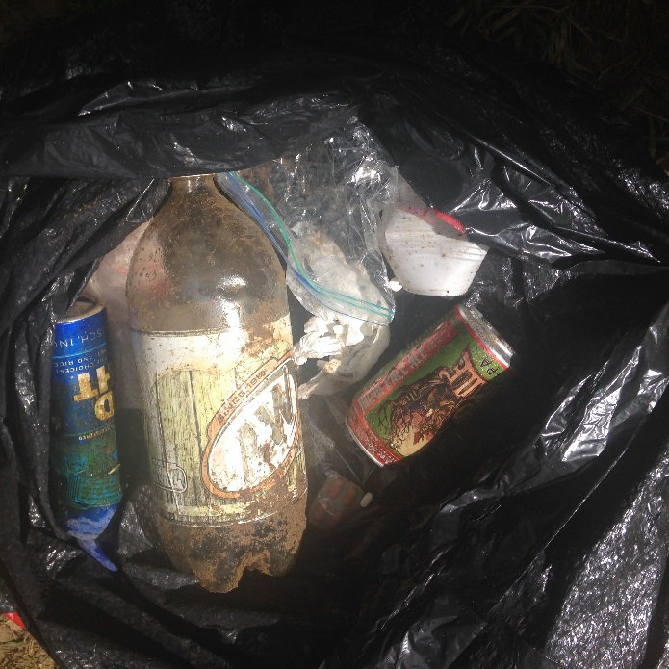
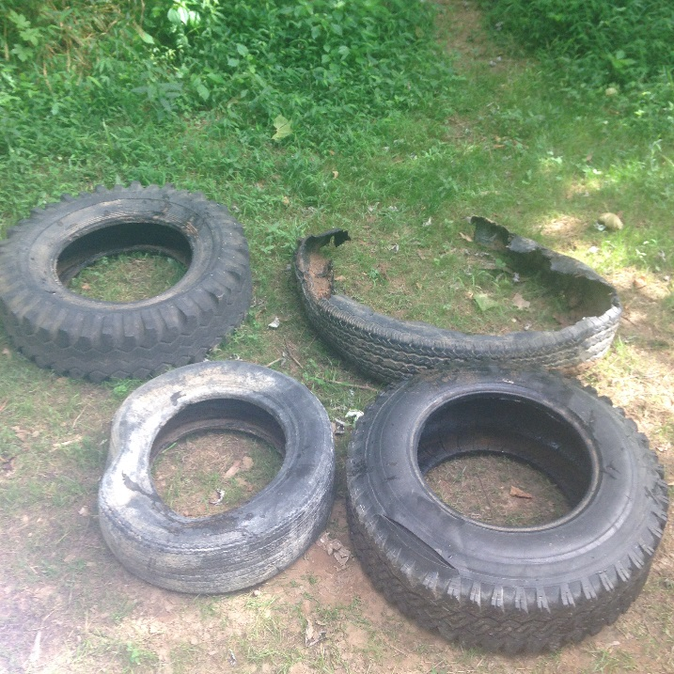
Figure 9: Tires removed near Milton. Figure 10: Trash removed from River.

