RIVANNA RIVER STEWARD REPORT
River Stewards: Dan Triman Date: 07-30-16
Starting Location and Time: Beaver Creek Reservoir (6:45 AM)
Ending Location and Time: Beaver Creek Reservoir (8:45 AM)
Weather: Overcast / Drizzly Recent Precipitation: Fairly dry
USGS Gauges: Earlysville 1.14 ft (14 ft³ / sec), Palmyra 2.65 ft (102 ft³ / sec),
Water Color: Very clear Water Odor: None Air Temp. : 75 deg F
DO: 4 ppm PH: 7 Turbidity: 10 JTU Water Temp. : 31 deg C
Water Testing Location: Northwest Corner of Reservoir
---------------------------------------------------------------------------------
Land Use:
Mostly open space and wooded areas, with some farms and residential.

Wildlife Sightings and Plant Life:
Turtles, Bass and other small minnows, Ducks, Smaller birds such as Blue Jays and Cardinal, Butterflies, Dragonflies, Spiders, and 2 Young Deer drinking at the edge of the water. Found numerous shells which appear to be mussels. Large variety of vegetation along the banks, and under water. Several large downed trees in Reservoir as well.

People Interactions:
There were about 20 other people out in boats on the Reservoir this morning. Most were fishing, with a couple rowers, kayakers, and stand up paddle boarders as well.

Litter and Pollution:
Only found 3-4 pieces of trash during the paddle, such as cans and bait boxes. 3 tires found in the Northwest corner of the Reservoir – 1 was removed, 2 are buried under water.

Overall Summary:
Turned out to be a beautiful morning for a paddle. Overall the Reservoir looked very clean and the water was very clear. There were numerous fish swimming around today. Tires found last Fall are still buried in the Reservoir. Some green algae found in the Northwest corner of the Reservoir as well.

Actions Needed – level of priority (1 highest/5 lowest):
3 – Remove 2 remaining tires from the Reservoir;
3 – Look into algae to determine if needs treatment

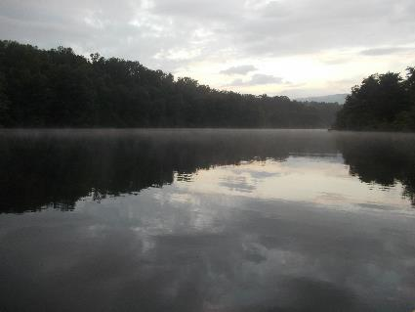
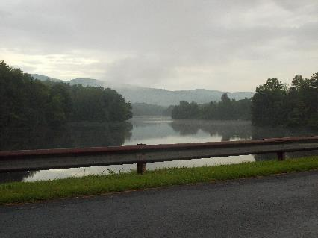
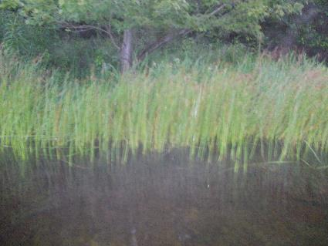
Figure 1: View of the Reservoir from the road Figure 2: View from the Reservoir facing North
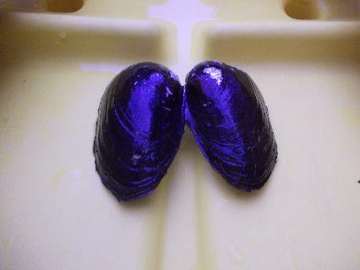
Figure 3: One of the mussel shells found in the water Figure 4: Grasses growing along the Reservoir edge
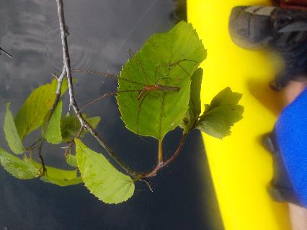
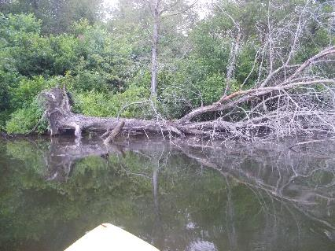
Figure 5: One of the large downed trees found Figure 6: Spider on a leaf

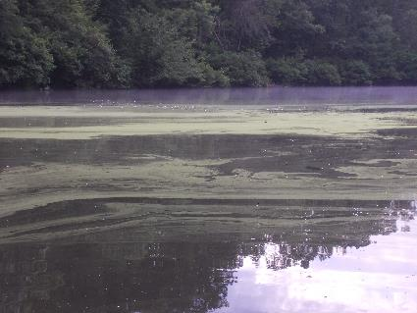
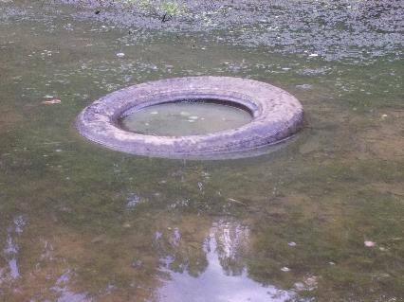
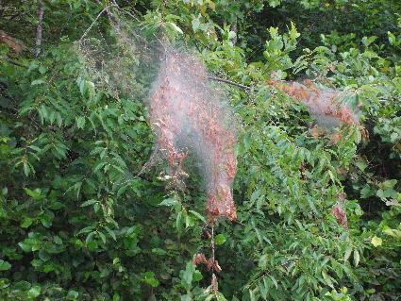
Figure 7: Tire removed from the River Figure 8: Algae growing in Northwest corner of Reservoir
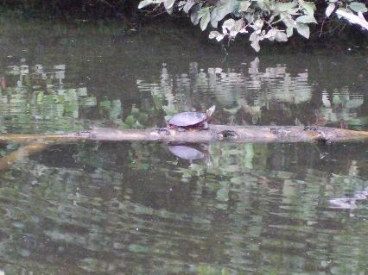
Figure 9: Turtle on a log Figure 10: One of many webs found in trees
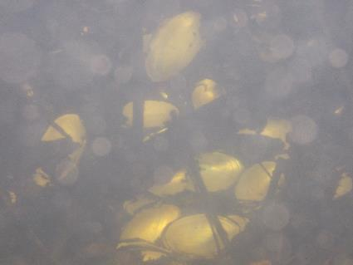
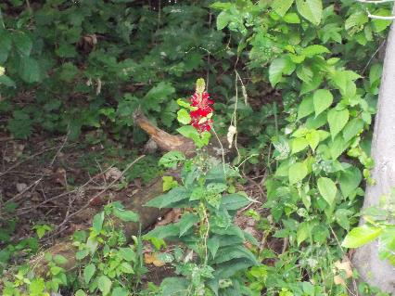
Figure 11: Cardinal flower Figure 12: One of the cluster of shells seen under water

