RIVANNA RIVER STEWARD REPORT
River Steward Names: Dan Triman & Justin Altice Date: 08-01-15
Starting Location and Time: Rivanna Reservoir – UVA Dock (10:30 AM)
Ending Location and Time: Rivanna Reservoir – UVA Dock (12:00 PM)
Weather: Sunny Recent Precipitation: Couple of rain events the past week
Water Flow: Slow Water Color: Blue w/ Green Algae on top Water Odor: None
Water Temp. : 24 deg C Air Temp. : 78 deg F
DO: 4 ppm PH: 7 Turbidity: 30 JTU
USGS Water Gauge Reading: Earlysville 1.6 ft., Palmyra 3.25 ft.
Physical Location Characteristics: UVA Boat Dock
Location Tested: Reservoir Right heading downstream
---------------------------------------------------------------------------------
Land Use:
Mostly residential, with some commercial and the water treatment plant. Generally wooded areas around the Reservoir.

Wildlife Sightings and Plant Life:
Ducks, small birds, turtles, fish, 1 eagle, and 2 blue herons

People Interactions:
There were a lot of people out using the Reservoir this afternoon. There were several groups of people out rowing around the UVA Boat Dock as well as 3 people in kayaks we saw.

Litter and Pollution:
We didn’t really find any trash during our paddle. There was a green film on the top of the water in the Reservoir near where we paddled, most likely due to algae formed during the recent heavy rains we received.

Overall Summary:
This paddle was with the Big Brothers Big Sisters local group, and we took out 5 kids and 5 adults in canoes to have them experience the Reservoir. We also had Michelle and Abby (RCS Interns) join us for the paddle today. They all had a good time and the weather was great for a paddle.

Actions Needed – level of priority (1 highest/5 lowest):
None
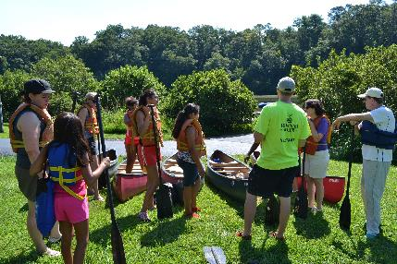
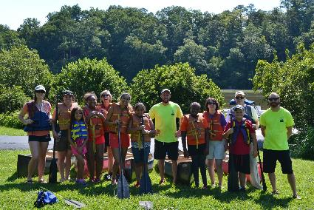
Figure 1: The group before the paddle begins Figure 2: Safety briefing before starting the paddle
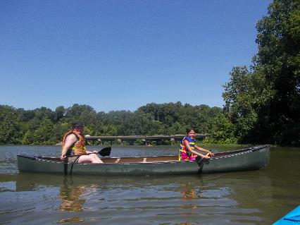
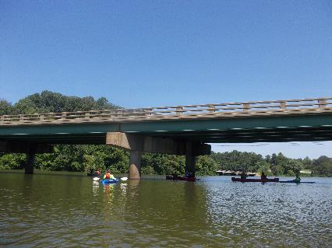

Figure 3: Enjoying a relaxing paddle in the canoe Figure 4: View of the Reservoir and bridge facing upstream

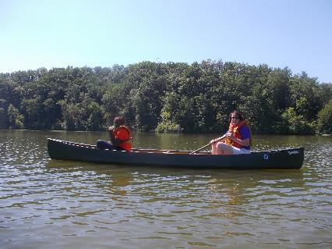
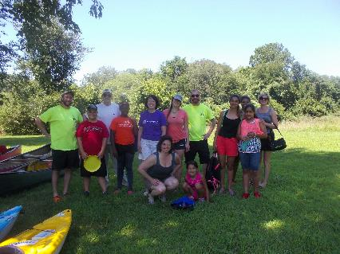

Figure 5: Taking a break from paddling Figure 6: The group after the paddle was completed

