RIVANNA RIVER STEWARD REPORT
River Steward Names: Justin Altice and Dan Triman Date: 8-09-15
Starting Location and Time: Crofton (9:30 AM)
Ending Location and Time: Palmyra (3:00 PM)
Weather: Slightly cloudy Recent Precipitation: Not much rain the past week
Water Flow: Fairly Slow Water Color: Mostly Clear / Blue Water Odor: None
Water Temp. : 26 deg C Air Temp. : 80 deg F
DO: 5 ppm PH: 7 Turbidity: 10 JTU
USGS Water Gauge Reading: Earlysville 1.42 ft, Palmyra 2.85 ft.
Physical Location Characteristics: Gravel sand bar in middle of River
Location Tested: 37°53’47”N 78°16’43”W
---------------------------------------------------------------------------------
Land Use:
Mostly open space and wooded areas, with some farms and residential.

Wildlife Sightings and Plant Life:
Turtles, fish (including 4 long nose gar), ducks, vultures, spiders, dragonflies, butterflies, and several other smaller birds.

People Interactions:
We went on this paddle with the Fluvanna County Parks and Rec as a history paddle, so we were with a group of about 14 people total. We also saw a number of people swimming in the River at Pleasant Grove and Palmyra Boat Launch. There were several other kayakers out today as well.

Litter and Pollution:
Only a few scattered pieces of trash were found (bottles and cans mostly). Noticed several buried tires still in the River.

Overall Summary:
The water level was fairly low but paddling was smooth for the most part. Trip was led by Brian from Fluvanna County Parks and Rec. We got to see the location of one of the best preserved canal locks near Crofton. Alex Searls from The Lewis and Clark Center rode in our canoe with us to take photos. Some erosion on the banks was noticed, and many downed trees.

Actions Needed – level of priority (1 highest/5 lowest):
Remove remaining tires from the water (4)

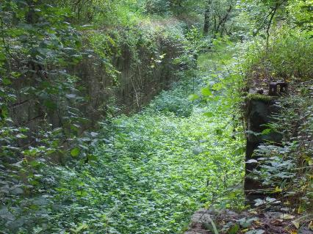
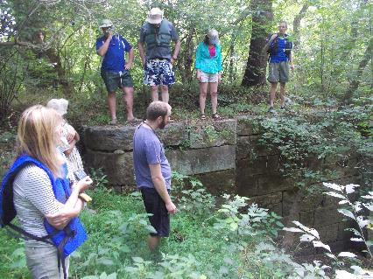
Figure 1: Talking about the canal lock near Crofton Figure 2: Another view of the canal lock
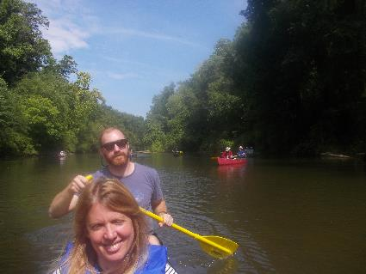
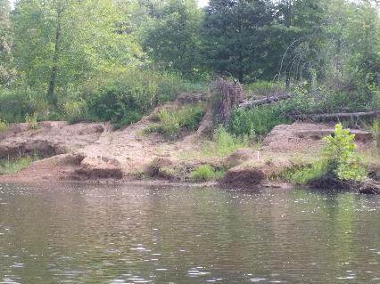
Figure 3: Erosion along the banks of the River Figure 4: Alex and Justin enjoying the padlle
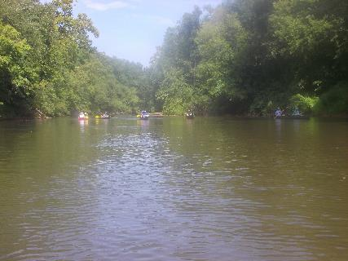
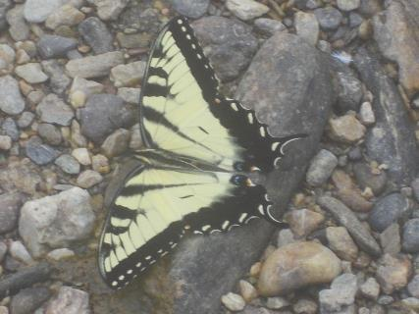

Figure 5: Butterfly perched a gravel bar Figure 6: The group paddling between Crofton and Palmyra

Photos taken by Alex Searls:
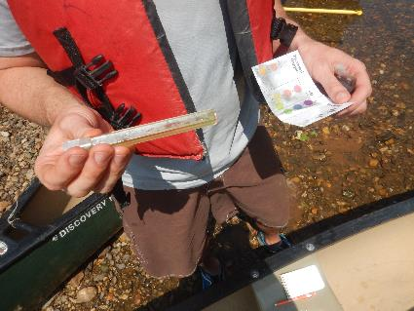
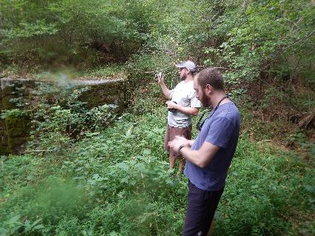
Figure 7: Dan and Justin (Stewards) looking at the lock Figure 8: Performing pH testing in the river

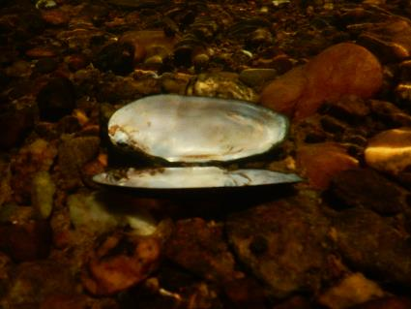
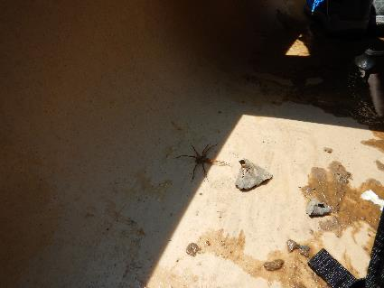
Figure 9: Brown spider catching a ride in our canoe Figure 10: Underwater shot of a shell on the river bed
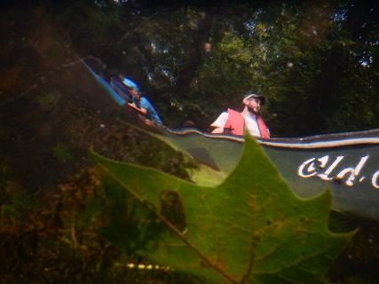
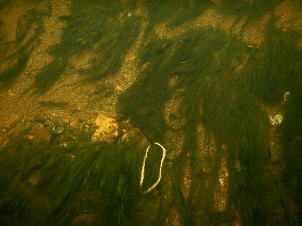

Figure 11: Underwater shot of some vegetation Figure 12: Underwater reflection of the canoe

