RIVANNA RIVER STEWARD REPORT
River Stewards: Dan Triman Date: 08-20-16
Starting Location and Time: Free Bridge (2:00 PM)
Ending Location and Time: Milton (5:15 PM)
Weather: Clear Sky Recent Precipitation: Fairly Dry
USGS Gauges: Earlysville 1.22 ft (19 ft² / sec), Palmyra 2.78 ft (175 ft² / sec),
Water Color: Clear Water Odor: None Air Temp. : 87 deg F
DO: 4 ppm PH: 8 Turbidity: 10 JTU Water Temp. : 31 deg C
Water Testing Location: Free Bridge River Right (38°00.4’N 78°24.0’W)
---------------------------------------------------------------------------------
Land Use:
Mix of residential, park, and commercial properties. Mostly wooded once you get past Woolen Mills area.

Wildlife Sightings and Plant Life:
Turtles, Fish, Geese, Butterflies, Dragonflies, 2 Osprey, 2 Green Heron, and 1 Great Blue Heron. See photos below of colorful flower blooms.

People Interactions:
Saw 25 people on the River (kayakers, canoers, fishers, and tubers). A few families swimming at Riverview and Milton, and folks on the trails. Gabe from Rivanna River Company helped me with transportation today.

Litter and Pollution:
We had several reports of a lot of trash in this section of the Rivanna, and we were able to remove 2 large trash bags worth of small litter (cans, bottles, food trash), as well as 1 tire from the River today.

Overall Summary:
Water levels are slightly down again. We looked for a tree down that was reported as a strainer, but didn’t see anything too unsafe. Still some trash remaining in this section of the River, and a few tires as well. Work has begun on the new boat access area at Riverview Park, and there is a lot of erosion and mud at Milton where vehicles have started driving recently.

Actions Needed – level of priority (1 highest/5 lowest):
2 – Complete Riverview work; 2 – Fix erosion problem at Milton; 4 – Remove remaining tires from this section of the River; 4 – Look into wasp issues at Milton kiosk

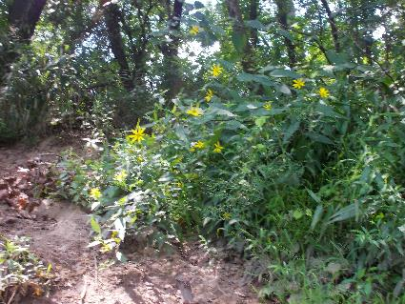
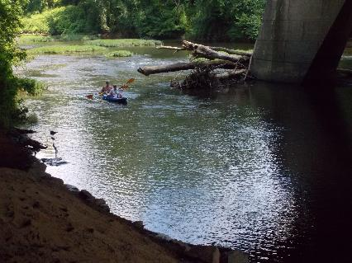
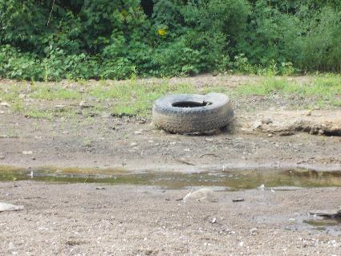
Figure 1: 2 Kayakers arriving at Free Bridge Figure 2: Yellow flowers along the bank
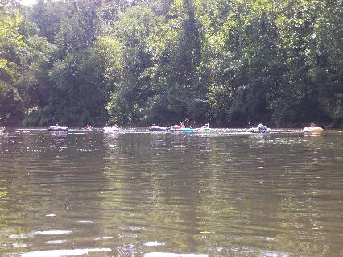
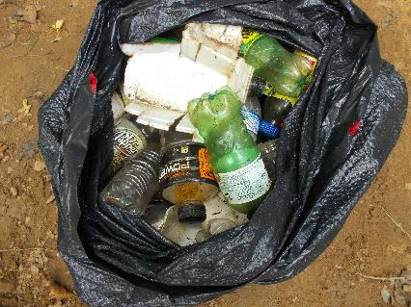
Figure 3: Group of tubers enjoying the Rivanna Figure 4: One of the tires seen during the paddle
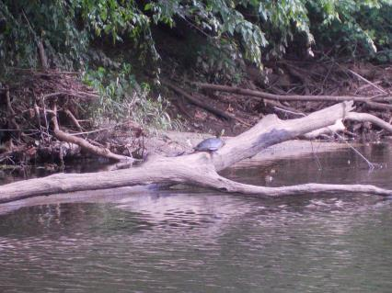
Figure 5: Turtle on a log Figure 6: One of the bags of trash removed from the River

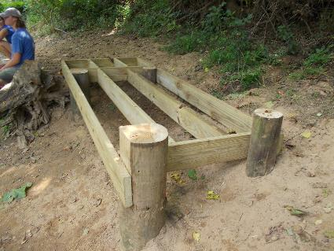
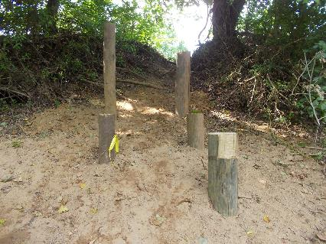
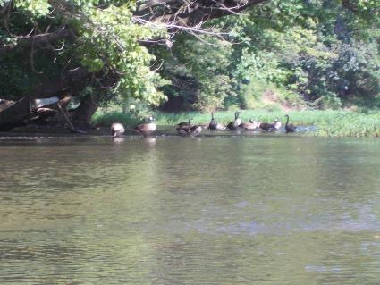
Figure 7: Start of new boat access at Riverview Park Figure 8: Riverview Park platform being constructed
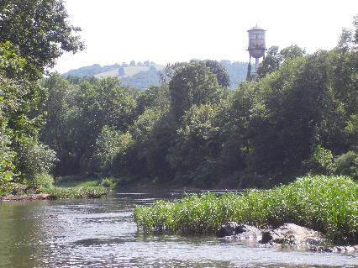
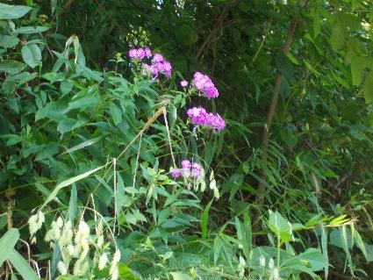
Figure 9: View of the Rivanna looking down river Figure 10: Geese feeding in one of the rapids
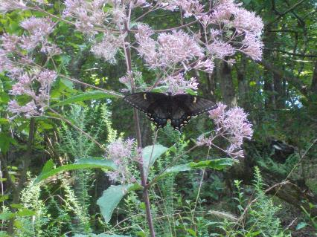
Figure 11: Butterfly on a plant on the bank Figure 12: Purple flowers along the bank

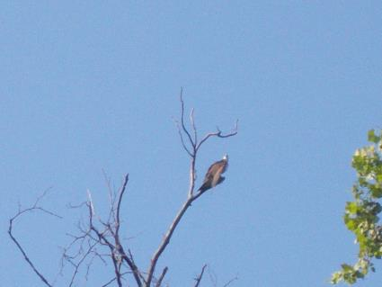
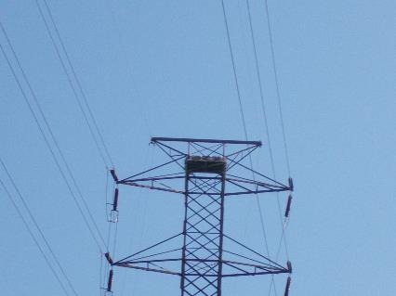
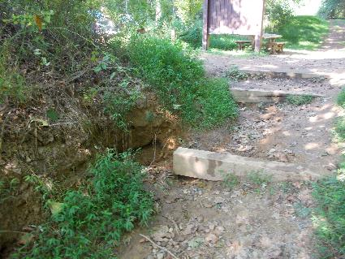
Figure 13: Eagle nest on power line tower Figure 14: Osprey perched atop a tree
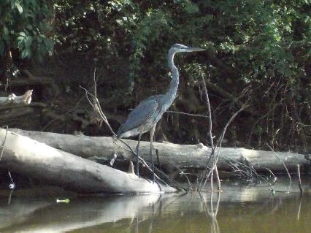
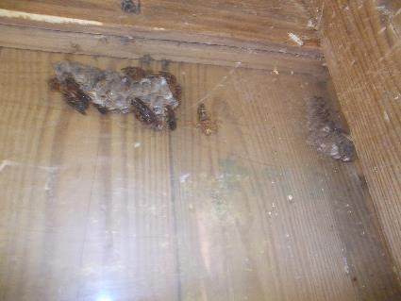
Figure 15: Great Blue Heron Figure 16: Erosion at Milton steps
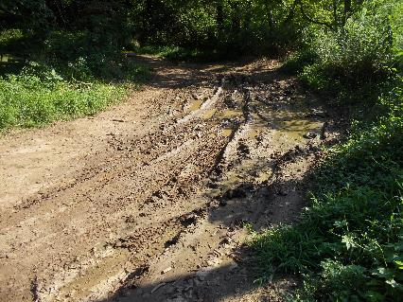
Figure 15: Area above Milton steps causing erosion Figure 16: Wasp nest in RCA Kiosk at Milton

