RIVANNA RIVER STEWARD REPORT
River Stewards: Dan Triman and Justin Altice Date: 09-05-16
Starting Location and Time: Darden Towe (10:45 AM)
Ending Location and Time: Riverview Park (12:30 AM)
Weather: Clear Skies Recent Precipitation: Not much rain recently
USGS Gauges: Earlysville 1.01 ft (7 ft³ / sec), Palmyra 2.48 ft (88 ft³ / sec),
Water Color: Clear Water Odor: None Air Temp. : 80 deg F
DO: 4 ppm PH: 8 Turbidity: 0 JTU Water Temp. : 24.5 deg C
Water Testing Location: Riverview Park below the steps at River Right
---------------------------------------------------------------------------------
Land Use:
Residential mainly, with some commercial use and park property

Wildlife Sightings and Plant Life:
Turtles, Fish, Geese, smaller birds, and 1 Great Blue Heron. Some invasives noticed on the banks (such as bamboo), but also some native flowering plants. Lower water levels exposed a lot more underwater vegetation than we have seen recently.

People Interactions:
We saw a good number of people out today on the Rive (fishing, swimming, kayaking, and tubing). There were also a lot of folks out at both Darden and Riverview parks using the trails and play areas.

Litter and Pollution:
We removed about 1 bag of trash from the Rivanna today, mostly bottles and cans. We also removed a few sports ball, a tire rim, and a milk carton. There was a kids bicycle on one of the banks that looked like it came out of the River, and we also saw a few tires along the way.

Overall Summary:
Water levels are extremely low right now. We did this paddle to scout things out for our paddle later this week for a local conference. Due to Labor Day, there was a lot of people on the River. The new boat access at Riverview Park is still in progress, but coming along (see photos below).

Actions Needed – level of priority (1 highest/5 lowest):
3 – Finish building new Riverview steps; 4 – Remove bicycle and tires

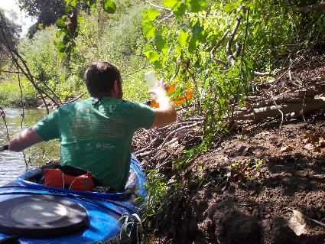
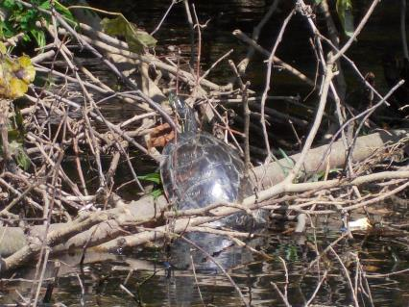
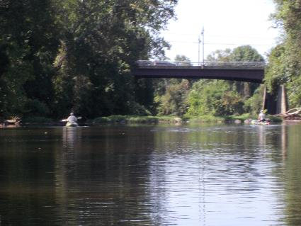
Figure 1: Turtle on a log near Darden Towe park Figure 2: Justin picking up a plastic bottle
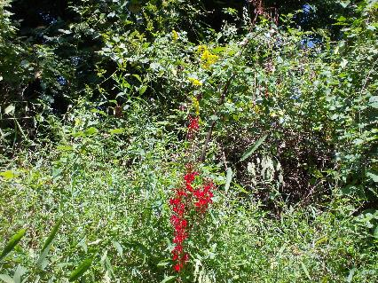
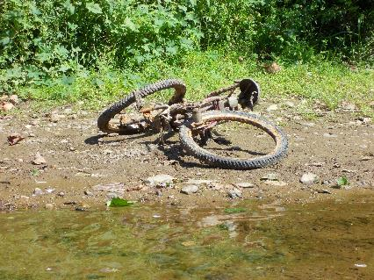
Figure 3: Some of the flowering colors on the bansk Figure 4: View of 2 kayakers in front of Free Bridge
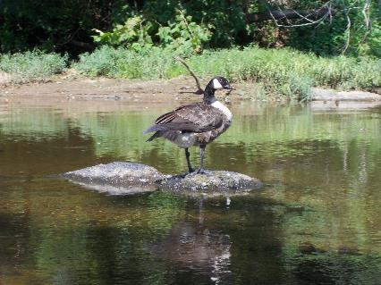
Figure 5: Goose posing for a photo on a rock Figure 6: Kids Bicycle found on one of the banks

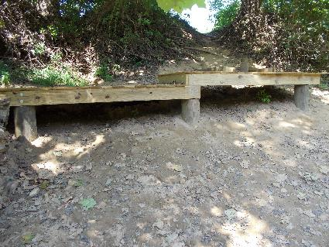
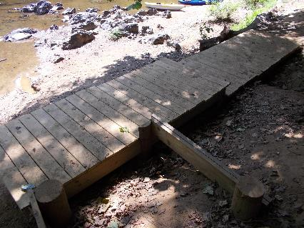
Figure 7: New Riverview Park boat access Figure 8: Another view of the Riverview steps
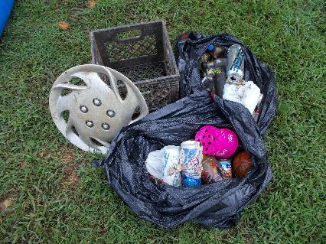
Figure 9: Trash removed from River today

