RIVANNA RIVER STEWARD REPORT
River Stewards: Dan Triman and Justin Altice Date: 09-09-16
Starting Location and Time: Rivanna Resrvoir @ Dam (1:00 PM)
Ending Location and Time: Rivanna Reservoir @ UVA Boat Ramp (2:45 PM)
Weather: Clear Skies Recent Precipitation: Very dry recently
USGS Gauges: Earlysville 1.04 ft (8 ft³ / sec), Palmyra 2.47 ft (85 ft³ / sec),
Water Color: Brown-Green Water Odor: None Air Temp. : 95 deg F
DO: 4 ppm PH: 8 Turbidity: 20 JTU Water Temp. : 32 deg C
Water Testing Location: At UVA Boathouse Dock - Reservoir Right
---------------------------------------------------------------------------------
Land Use:
Mix of residential and park property surrounds the Reservoir.

Wildlife Sightings and Plant Life:
Turtles, Fish, smaller birds, and 1 Great Blue Heron. Nothing out of the ordinary on the vegetation side of things – everything still looks pretty green and healthy even with the long dry periods we have had recently.

People Interactions:
We took a group of about 12 people from the Virginia Conservation Network conference, out for a paddle on the Reservoir today. We partnered with Gabe Silver from Rivanna River Company for this event. The UVA Boathouse let us use their dock for our take out location for the boats. We also saw two people fishing at the Woodlands Rd bridge.

Litter and Pollution:
We removed a few loose plastic bags, cans, and bottles from the Reservoir, but overall there wasn’t much trash found.

Overall Summary:
Very hot today, but everyone enjoyed the paddle on the Reservoir. There was a mix of folks from Charlottesville and other areas across the state of Virginia, on the paddle with us. The water was not very clear and had a brownish-greenish color to it. There are still a few areas of algae near the Woodlands Rd bridge. We also found a young deer dead in the water just below the bottom edge of the field at the UVA Boathouse property.

Actions Needed – level of priority (1 highest/5 lowest):
2 – Remove the dead deer from the Reservoir

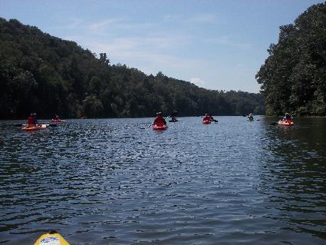
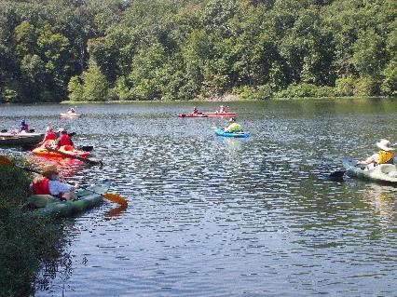
Figure 1: The group leaving the put in above the Dam Figure 2: View of the Reservoir heading up river
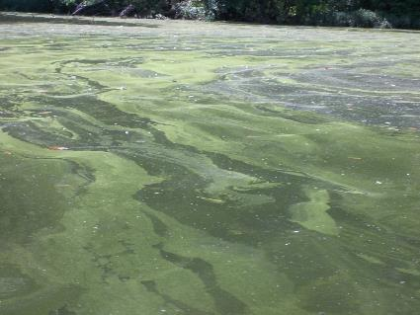
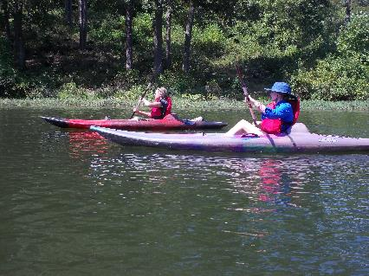
Figure 3: Couple of paddlers on the trip Figure 4: Example of some of the algae on the surface
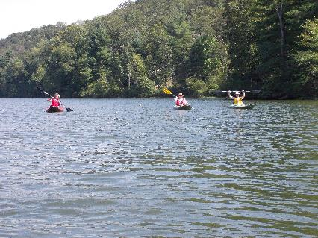
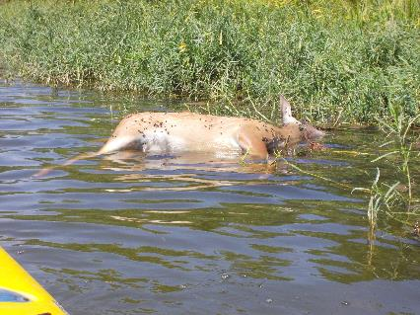
Figure 5: Dead deer found in the water Figure 6: Paddlers having a good time

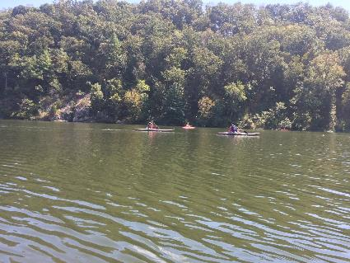
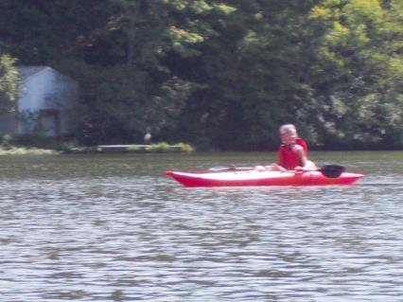
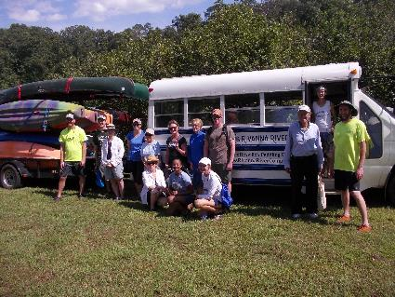
Figure 7: Blue Heron on the dock in the background Figure 8: Another photo of the paddlers
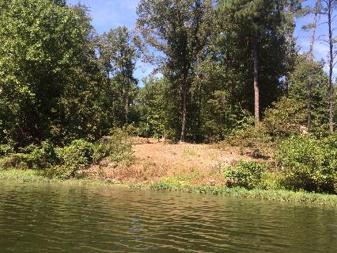
Figure 9: Bank along the Reservoir Figure 10: Group photo of the paddlers

