RIVANNA RIVER STEWARD REPORT
River Steward Name(s): Dan Triman and Justin Altice Date: 09-16-15
Starting Location and Time: Milton 2:30 PM
Ending Location and Time: Crofton 7:00 PM
Weather: Sunny and Clear Skies Recent Precipitation: Very dry lately
Water Flow: Slow Water Color: Very Clear Water Odor: None
Water Temp. : 24 deg C Air Temp. : 75 deg F
DO: 3 ppm PH: 8.0 Turbidity: 10 JTU
USGS Water Gauge Reading: Palmyra 2.58 ft, Earlysville 1.13 ft
Physical Location Characteristics: Crofton Boat Ramp
Specific Location Testing Performed: River left
Land Use:
Mostly rural farms and wooded land, with some residential areas in Keswick and Lake Monticello.

Wildlife Sightings and Plant Life:
Several turtles (including some of largest we have ever seen), a few smaller fish, 2 bald eagles (including the largest one we have ever seen), 3 blue herons, 1 green heron, 2 ospreys, butterflies, dragonflies, and several smaller birds. Lots of greenery on the river banks with some of the exposed banks from previous trips being well grown in with vegetation now.

People Interactions:
Didn’t see any people, but saw one car parked at Milton with a kayak rack.

Litter and Pollution:
Significant litter and trash was found during the trip, most likely from the recent heavy rain storm last week. We collected and removed 2 trash bags worth of bottles, cans, other plastic containers, fishing bait supplies, and sporting equipment. There were also about 30 or so tires we saw along the way either buried in the river or on the banks.

Overall Summary:
The weather was great, but the water levels were pretty low, so paddling was slow going. Water was pretty clear for the most part. More trash found in this stretch than usual, and many tires that need to be removed. Good amount of downed trees along the way as well, but no impassable spots.

Actions Needed – level of priority (1 highest/5 lowest)
4 – Remove Tires, 4 – Remove remaining trash and litter, 2 – Check into erosion and sedimentation controls for the power line project at Milton
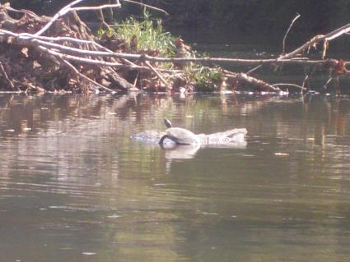
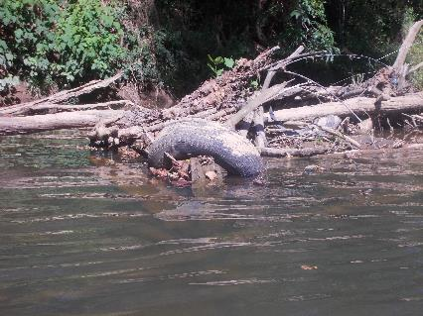
Figure 1: Example of buried tire in the River Figure 2: Turtle sitting on a rock

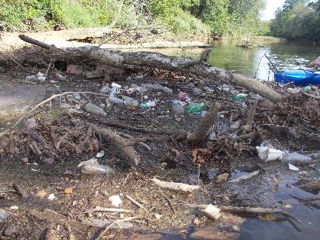
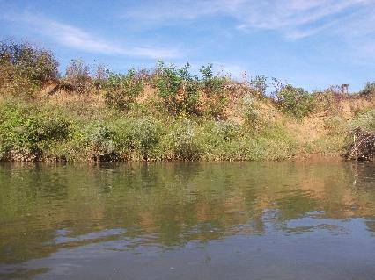
Figure 3: Previously exposed banks now with vegetation Figure 4: Worst trash area piled up in front of a downed tree

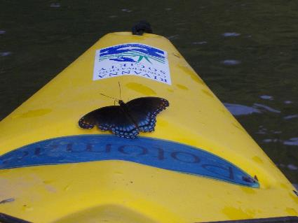
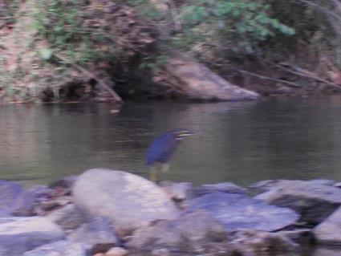

Figure 5: Green Heron along some rocks Figure 6: Butterfly catching a ride on our kayak

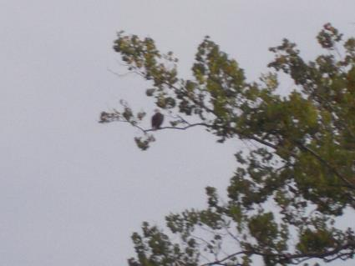
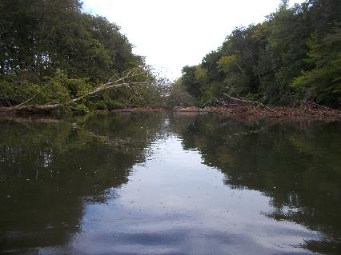
Figure 7: Examples of downed trees in the river Figure 8: Bald Eagle sitting up high in a tree

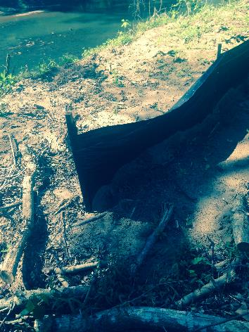
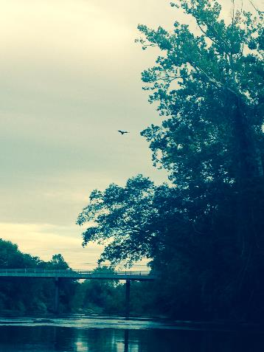
Figure 9: Bald Eagle flying away Figure 10: Silt Fence at Milton boat ramp

