RIVANNA RIVER STEWARD REPORT
River Stewards: Dan Triman (and Dave Smith - RCA Board) Date: 09-17-16
Starting Location and Time: Rivanna Resrvoir @ UVA Boat Ramp (10:15 AM)
Ending Location and Time: Rivanna Reservoir @ UVA Boat Ramp (12:00 PM)
Weather: Overcast Recent Precipitation: Very dry recently
USGS Gauges: Earlysville 0.88 ft (2 ft³ / sec), Palmyra 2.37 ft (65 ft³ / sec),
Water Color: Brownish Water Odor: None Air Temp. : 75 deg F
DO: 4 ppm PH: 7 Turbidity: 20 JTU Water Temp. : 28 deg C
Water Testing Location: At UVA Boathouse Dock - Reservoir Right
---------------------------------------------------------------------------------
Land Use:
Mix of residential and park property surrounds the Reservoir.

Wildlife Sightings and Plant Life:
Fish, Ducks, Geese, smaller birds, 1 Kingfisher, and 3 Great Blue Heron. Vegetation is still doing well despite the recent dry periods.

People Interactions:
We took 12 people (6 children ages 8-11, and 6 adults) from Big Brothers Big Sisters, for a paddle on the Reservoir today. The UVA Boathouse let us use their dock for our put in and take out location. There were a lot of people on the Reservoir this morning (rowers, kayakers, and people fishing, as well as the UVA Men’s and Women’s Rowing Teams practicing).

Litter and Pollution:
We removed a few loose plastic bags, cans, and bottles from the Reservoir, but overall there wasn’t much trash found.

Overall Summary:
Everyone from the Big Brothers Big Sisters had a great time. Many of the children had never been in a boat before. They all enjoyed watching the UVA Women’s Rowing Team practicing during our paddle. They also helped us do our Water Quality Testing at the UVA Boat Dock. The water levels in the Reservoir are extremely low with several areas having only a couple inches of water above the bottom of the Reservoir. The water was a little clearer than last week and most of the algae was gone. This was our third paddle with the Big Brothers Big Sisters group over the past two years.

Actions Needed – level of priority (1 highest/5 lowest):
None

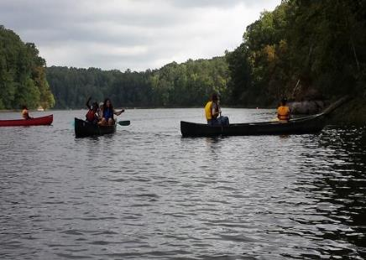
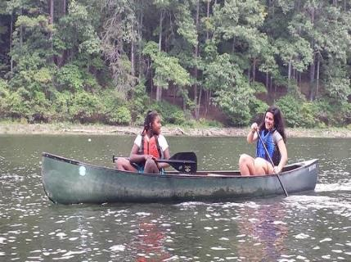
Figure 1: Having a good time paddling Figure 2: Nice view of the Reservoir
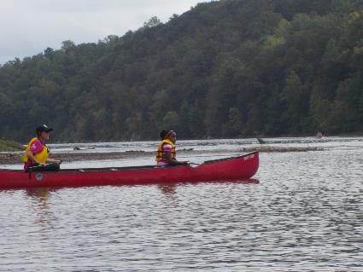
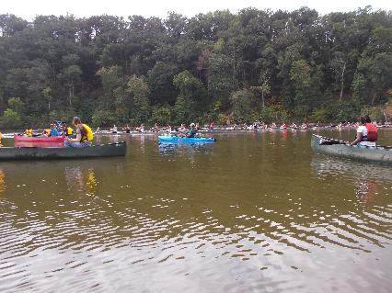
Figure 3: Up close look at the UVA Women’s Rowing Team Figure 4: Stopping to see the Blue Heron in the background
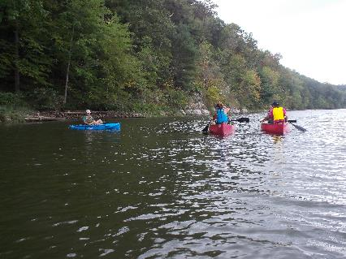
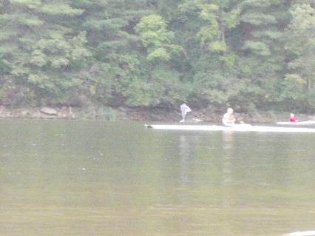
Figure 5: Blue Heron flying past us Figure 6: Dave with a few of our paddlers after turning around

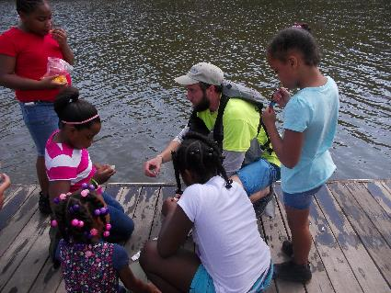
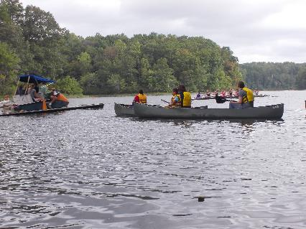
Figure 7: Cheering on the UVA Women’s Rowing Team Figure 8: Teaching the children about water quality testing
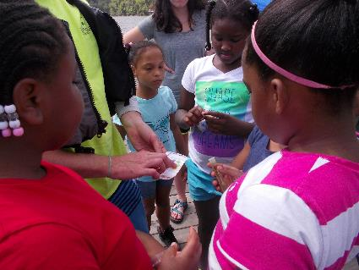
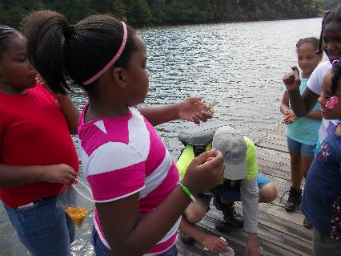
Figure 9: Performing the DO and pH testing on the Dock Figure 10: Determining the DO and pH values from the card

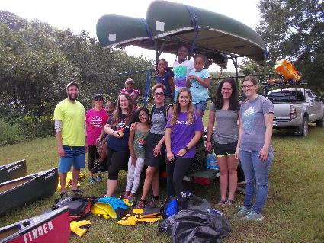
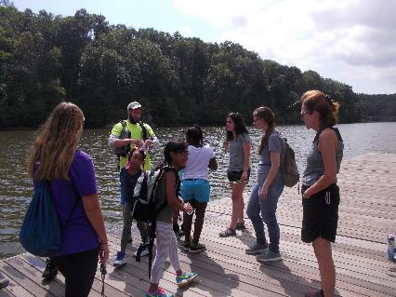
Figure 11: Packing up and getting ready to leave Figure 12: Group photo of our paddlers

