RIVANNA RIVER STEWARD REPORT
River Steward Names: Dan Triman & Justin Altice Date: 09-19-15
Starting Location and Time: Rivanna Reservoir – UVA Dock (11:15 AM)
Ending Location and Time: Rivanna Reservoir – UVA Dock (1:00 PM)
Weather: Sunny Recent Precipitation: Not much rain lately
Water Flow: Slow Water Color: Blue w/ Some Green Algae Water Odor: None
Water Temp. : 24 deg C Air Temp. : 80 deg F
DO: 4 ppm PH: 8 Turbidity: 20 JTU
USGS Water Gauge Reading: Earlysville 1.1 ft., Palmyra 2.5 ft.
Physical Location Characteristics: UVA Boat Dock
Location Tested: Reservoir Right heading downstream
---------------------------------------------------------------------------------
Land Use:
Mostly residential, with some commercial and the water treatment plant. Generally wooded areas around the Reservoir.

Wildlife Sightings and Plant Life:
Ducks, small birds, turtles, fish

People Interactions:
There were a lot of people out using the Reservoir this afternoon. The UVA crew teams were practicing, as well as some other people rowing and kayaking.

Litter and Pollution:
We didn’t really find much trash during our paddle, just a couple of small pieces of trash. There was still some green film / algae on the top of the water in the Reservoir, but not as much as last time we were here.

Overall Summary:
This paddle was with the Big Brothers Big Sisters local group, and we took out 5 kids and 5 adults in canoes to have them experience the Reservoir. We also had Michelle from RCS join us for the paddle today. We paddled downstream towards the Dam, and then turned around and came back to the dock. Everyone had a good time and the weather was great.

Actions Needed – level of priority (1 highest/5 lowest):
None
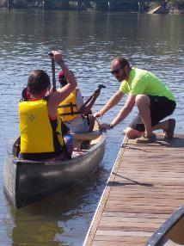
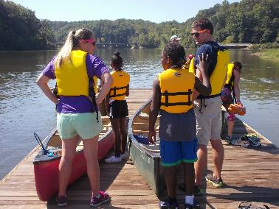
Figure 1: Getting ready for the paddle on the dock Figure 2: Justin helping people into their canoe
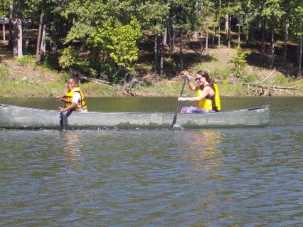
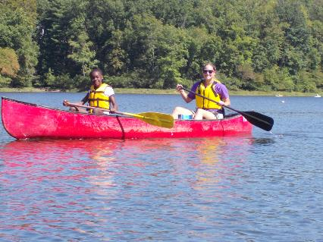

Figure 3: Paddling on the Reservoir Figure 4: Another of the BBBS matches having a good time

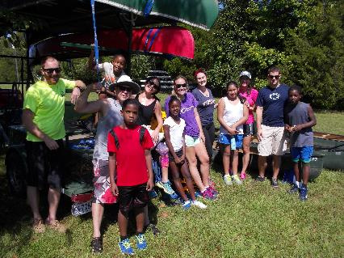
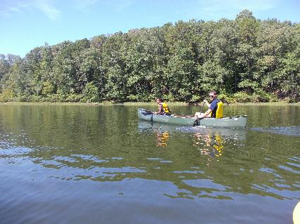

Figure 5: A beautiful day for a paddle on the Reservoir Figure 6: The group after the paddle was completed

