RIVANNA RIVER STEWARD REPORT
River Steward Names: Dan Triman and Justin Altice Date: 10-08-14
Starting Location and Time: Darden Towe Park (5:30 PM)
Ending Location and Time: Riverview Park (7:00 PM)
Weather: Sunny Recent Precipitation: Very heavy rain last night
Water Flow: Moderate Water Color: Brown / Murky Water Odor: None
Water Temp. : 20 deg C Air Temp. : 78 deg F
DO: 4 ppm PH: 7 Turbidity: 20 JTU
USGS Water Gauge Reading: Earlysville 1.23 ft.
Physical Location Characteristics: Sand bar at River Left
Location Tested: N 38˚01’ W 78˚27’
---------------------------------------------------------------------------------
Land Use:
Residential mainly, with some commercial use

Wildlife Sightings and Plant Life:
2 Heron, 1 Kingfisher, several turtles, 1 hawk, 1 bat, 1 squirrel trying to eat something in the water, 1 spider, various birds, small fish

People Interactions:
Saw one person fishing near Riverview Park, lots of people using the RTF trails, and several people with their dogs down by the water at Riverview.

Litter and Pollution:
Removed ½ a trash bag of litter from the river including drink bottles and cans (metal, glass, plastic), a few pieces of Styrofoam, a Frisbee, a baseball, and a head of cabbage. While there were fewer trash items noticed than usual, this was the first time we found trash floating out in the middle of the river, rather than being trapped up against something on the sides.

Overall Summary:
Saw various wildlife, as well as a few people at Riverview Park. Water levels rose significantly after the rain last night, with some sections of the River a little browner and murkier than usual from sedimentation. Picked up some trash along the way. One large downed tree at River right just before boat ramp at Riverview Park. Some bank erosion noticed as well.

Actions Needed – level of priority (1 highest/5 lowest):
4 – Look into the pipe in the water near Darden Towe

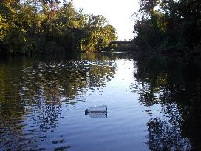
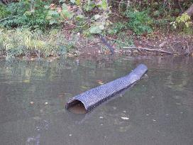
Figure 1: Pipe found in the water near Darden Towe. Figure 2: Example of floating plastic bottles found.
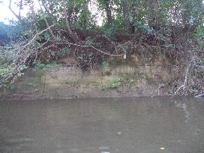
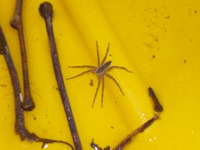
Figure 3: Spider found on the back of our kayak Figure 4: Example of bank erosion closer to Riverview.

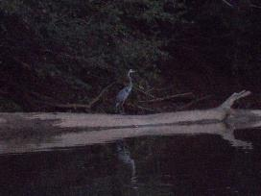
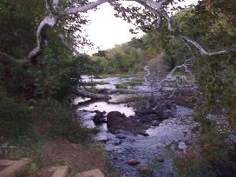

Figure 5: Downed tree near Riverview Park Figure 6: Heron standing on a fallen log in River.

