RIVANNA RIVER STEWARD REPORT
River Stewards: Dan Triman Date: 10-16-16
Starting Location and Time: Milton (10:15 AM)
Ending Location and Time: Crofton (3:15 PM)
Weather: Clear Blue Skies Recent Precipitation: Fairly dry this past week
USGS Gauges: Earlysville 1.24 ft (20 ft³ / sec), Palmyra 2.63 ft (125 ft³ / sec),
Water Color: Very Clear Water Odor: None Air Temp. : 70 deg F
DO: 4 ppm PH: 7 Turbidity: 0 JTU Water Temp. : 20 deg C

Water Testing Location: Buck Island River Left (37°57'16.4"N 78°22'21.8"W)
---------------------------------------------------------------------------------
Land Use:
Mostly farms and wooded land; residential in Keswick and Lake Monticello.

Wildlife Sightings and Plant Life:
Turtles, Fish (including Gar), 1 Osprey, 1 Bald Eagle, 1 Kingfisher, Smaller birds such as Blue Jays, Crows, Vultures, Hawks. Several sections of river closer to Crofton with extremely thick mats of underwater vegetation. Significant amount of large trees down in the River as well.

People Interactions:
This was our Fall Sojourn and had a group of 18 people on the trip. We saw a couple of people at Milton and Crofton, but not other people on the water. Met 2 property owners who own the land at the Canal Lock near Milton. Niemann Pest from RCA helped today, and Gabe from Rivanna River Company provided the boats and shuttling for our paddlers.

Litter and Pollution:
Removed 2 bags worth of trash from Rivanna today, mostly bottles and cans. Also saw 30+ tires in this stretch, several of which were very large. The steps at Milton are in need of repair, and there were hay bales in the River next to a farm a few miles from Crofton at River Left.

Overall Summary:
Water levels were just high enough to paddle today, with a few spots requiring getting out of the boats due to low water levels. The weather was great, and everyone had a good time on the paddle today.

Actions Needed – level of priority (1 highest/5 lowest):
4 – Remove tires; 2 – repair stairs and erosion at Milton; 3 - Look into hale bales in the River a few miles from Crofton

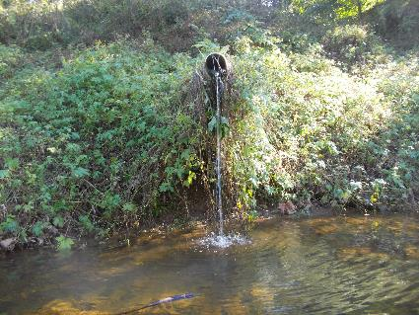
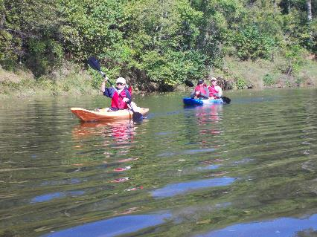
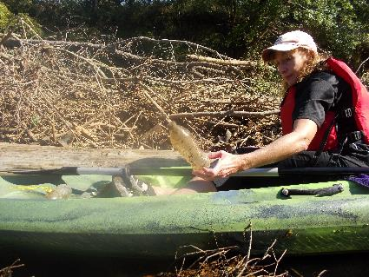
Figure 1: Starting the paddle at Milton Figure 2: Pipe from Glenmore into the Rivanna River
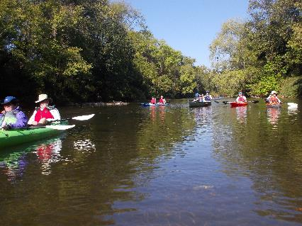
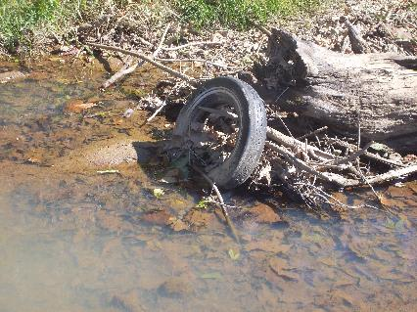
Figure 3: Some of our Sojourn paddlers Figure 4: Removing bottles from the River
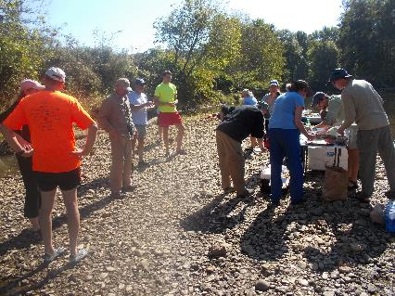
Figure 5: Lunch near Buck Island Figure 6: One of the many tires found on the paddle

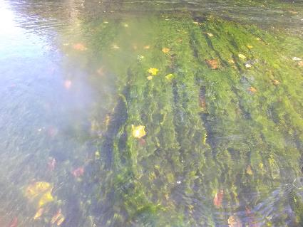
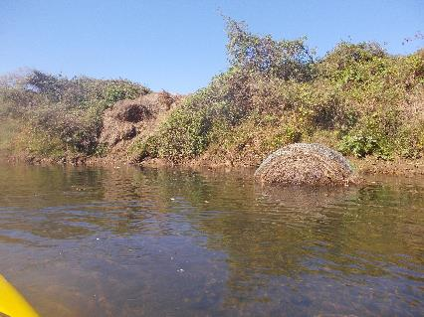
Figure 7: Hey bales coming down hill and in the River Figure 8: Thick green vegetation under the water
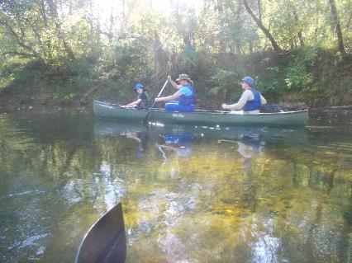
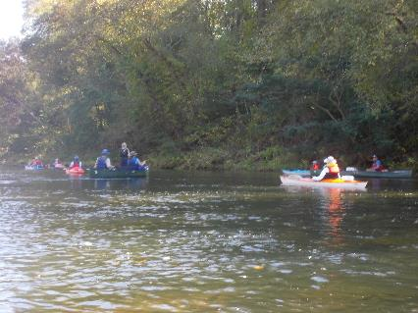
Figure 9: Finishing up the paddle near Crofton Figure 10: Family paddling in a canoe

