RIVANNA RIVER STEWARD REPORT
River Steward Name(s): Dan Triman and Justin Altice Date: 10-19-14
Starting Location and Time: Milton 9:45 AM
Ending Location and Time: Crofton 2:00 PM
Weather: Sunny and Clear Skies Recent Precipitation: One heavy rain recently
Water Flow: Moderate Water Color: Mostly clear Water Odor: None
Water Temp. : 18 deg C Air Temp. : 50-60 deg F
DO: 4 ppm PH: 7.0 Turbidity: 20 JTU
USGS Water Gauge Reading: Palmyra 3.00 ft
Physical Location Characteristics: Crofton boat launch
Specific Location Testing Performed: River left near boat launch
Land Use:
Mostly rural farms and wooded land, with some residential areas in Keswick and Lake Monticello.

Wildlife Sightings and Plant Life:
turtles, several birds (including kingfishers, 1 osprey, crows, and hawks), and several fish.

People Interactions:
This trip was the Fall 2014 Sojourn, so we went with a group of about 20 people total including RCS and BRMS staff.

Litter and Pollution:
About 12 tires spotted throughout the paddle. Several of the paddlers helped remove trash during the paddle. In all we collected about 3 trash bags worth of plastic and glass bottles, sports equipment (balls, Frisbees, etc.), and other general trash. There is still a piece of farm equipment on one of the river banks (about a mile or two from Crofton), as well as a table up high on the right side of the river in a tree near Crofton.

Overall Summary:
It turned out to be great weather and great water levels for the Sojourn. Everyone had a great time. There were some tires we will try to remove in the Spring, and lots of large downed trees blocking parts of the river. Severe erosion on banks near Keswick.

Actions Needed – level of priority (1 highest/5 lowest)
A lot of tires that need to be removed from the water (3), erosion control (3).
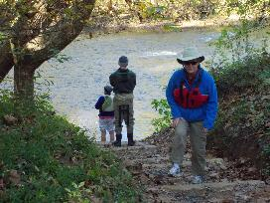
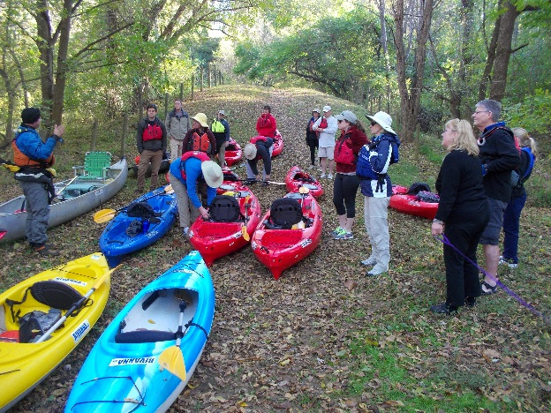
Figure 1: Safety Briefing at Milton put in. Figure 2: Checking out the water levels before the trip.

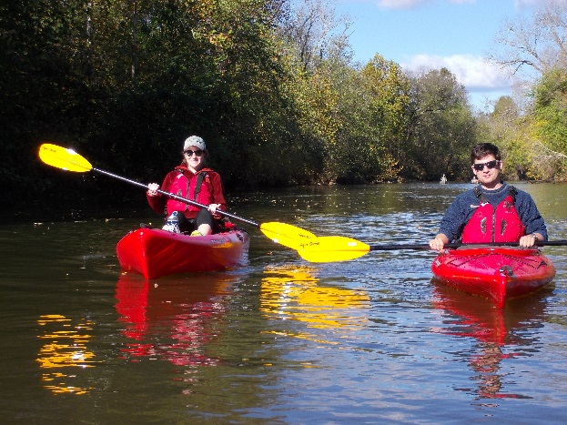
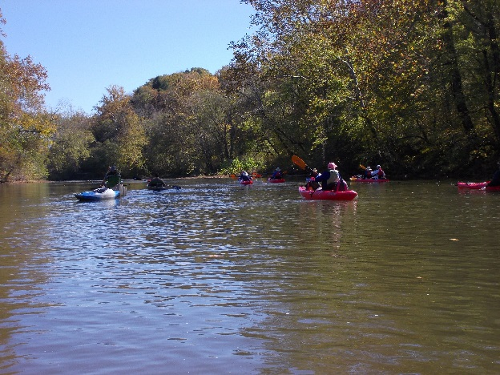
Figure 3: The group paddling near Milton. Figure 4: Sarah and Joe paddling on the River.

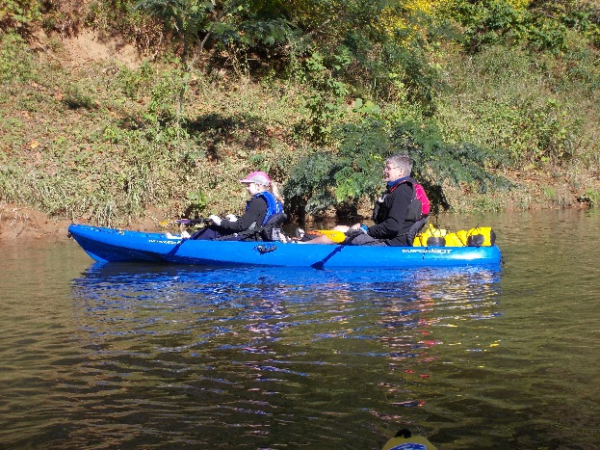
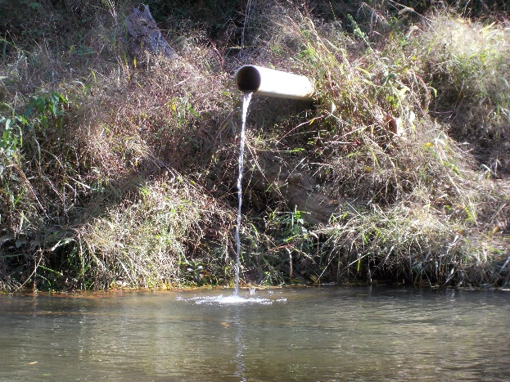

Figure 5: Wes from BRMS and his daughter paddling. Figure 6: Pipe outfall near Glenmore.

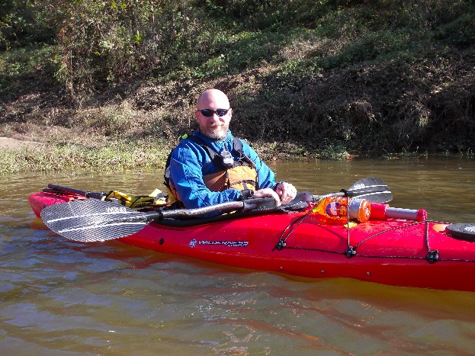
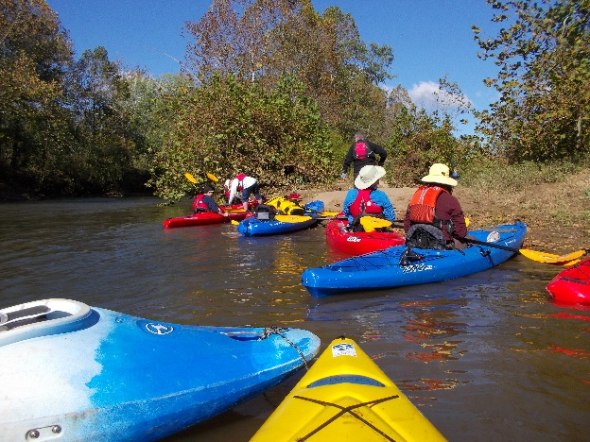
Figure 7: Stopping for a break on one of the sand banks. Figure 8: Aaron from BRMS.

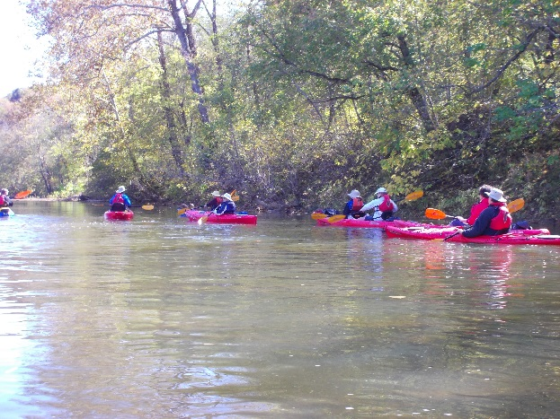
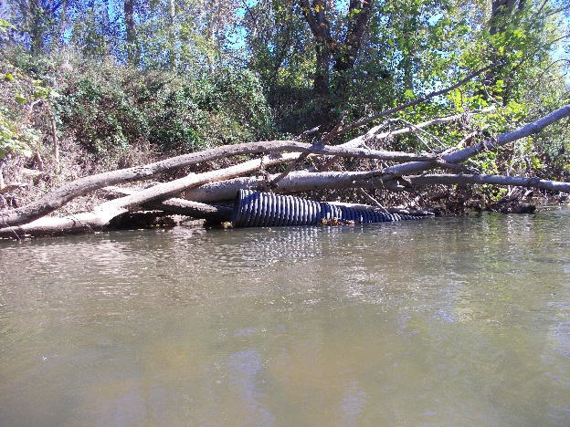
Figure 9: Black corrugated pipe floating in the River. Figure 10: Another group paddling shot.
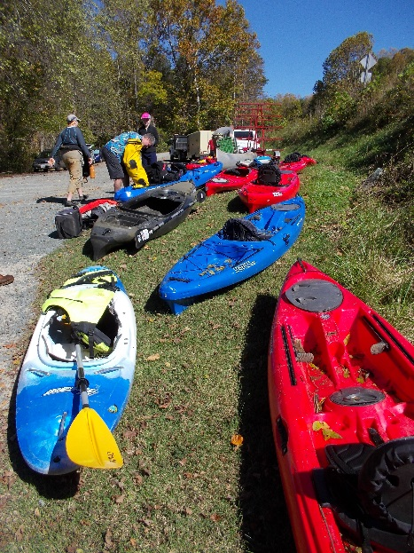

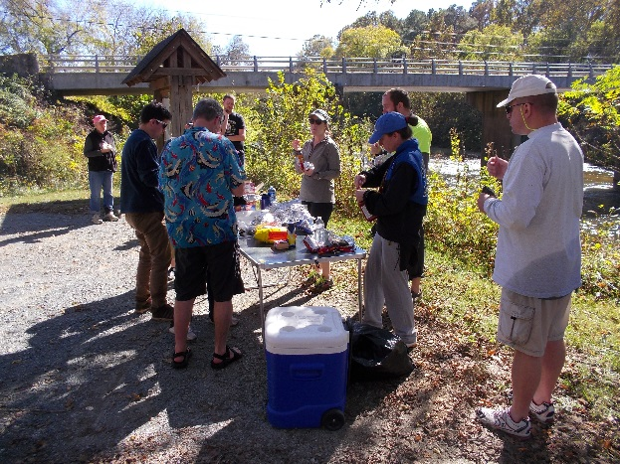

Figure 12: Everyone enjoying the food at Crofton.
Figure 11: Getting the boats ready to pack up.

