RIVANNA RIVER STEWARD REPORT
River Steward Names: Dan Triman and Justin Altice Date: 10-28-14
Starting Location and Time: Darden Towe Park (2:30 PM)
Ending Location and Time: Riverview Park (4:00 PM)
Weather: Sunny and Windy Recent Precipitation: Very little rain recently
Water Flow: Fairly Slow Water Color: Clear / Blue Water Odor: None
Water Temp. : 16 deg C Air Temp. : 80 deg F
DO: 7 ppm PH: 7 Turbidity: 0 JTU
USGS Water Gauge Readings: Earlysville 1.30 ft, Palmyra 2.65 ft
Physical Location Characteristics: Riverview Park
Location Tested: At boat ramp put in River Right
---------------------------------------------------------------------------------
Land Use:
Residential mainly, with some commercial use

Wildlife Sightings and Plant Life:
2 Heron, 2 Kingfishers, 5 turtles, 1 water snake. A lot of fallen leaves from nearby trees were in the River.

People Interactions:
Saw one person fishing in a kayak near Riverview Park, and lots of people using the RTF trails. At Riverview Park we had 2 young children who were with their mom help us do the water quality test, and they really enjoyed it.

Litter and Pollution:
There wasn’t a whole lot of trash along this stretch of the River. We picked up a couple of beer cans, Styrofoam cups, plastic bags, and plastic beverage containers, as well as a basketball and plastic kids bowling ball.

Overall Summary:
Water levels were still high enough that our boats weren’t scraping the bottom too much except for a couple of spots. The River looked very clean (water was clear and not much trash found). Saw various wildlife, as well as a few people at Riverview Park. The one large downed tree at River Right just before boat ramp at Riverview Park has split but is still blocking part of the River. Some bank erosion noticed as well in various places.

Actions Needed – level of priority (1 highest/5 lowest):
4 – Try to remove manhole cover near Darden Towe (River Left past the put in) and blue barrel near Riverview Park.
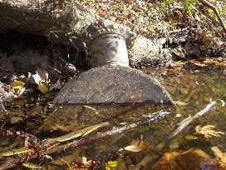
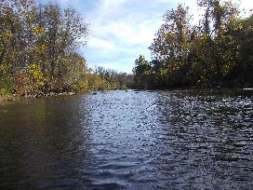
Figure 1: View looking down river from Darden Towe. Figure 2: Manhole cover buried near Darden Towe
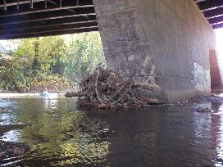
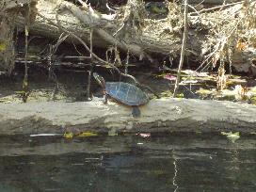
Figure 3: Turtle on a log Figure 4: Debris piled up under Free Bridge

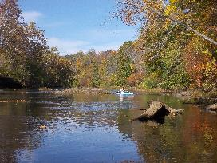
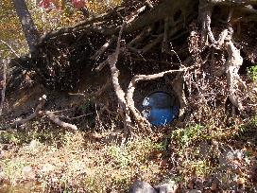

Figure 5: Blue barrel at River Left before Riverview Park Figure 6: View up river just before Riverview Park.

