RIVANNA RIVER STEWARD REPORT
River Steward Name(s): Dan Triman Date: 11-01-15
Starting Location and Time: Riverview Park 1:45 PM
Ending Location and Time: Milton 3:45 PM
Weather: Cloudy with some sun Recent Precipitation: Rain shower earlier in day
Water Flow: Fast Water Color: Mostly Clear Water Odor: None
Water Temp. : 14 deg C Air Temp. : 60 deg F
DO: 6 ppm PH: 8 Turbidity: 20 JTU
USGS Water Gauge Reading: Earlysville 2.20 ft, Palmyra 3.80 ft
Physical Location Characteristics: Milton Rd Bridge
Location Tested: Just past bridge at sand bank River Left
----------------------------------------------------------------------------------------
Land Use:
Mix of residential, park, and commercial properties. Mostly wooded once you get past Woolen Mills area.

Wildlife Sightings and Plant Life:
Geese, crows, 1 bald eagle and nest in power line tower, 1 blue heron, 1 osprey, turtles, squirrels on the banks, small fish, small birds. Most leaves had fallen off the trees during the recent storms, the remaining foliage still had good fall colors. Several trees down along the banks of the River.

People Interactions:
Saw a few people at Riverview Park, but no other people out on the River.

Litter and Pollution:
There wasn’t much litter found during the paddle, just a couple of smaller pieces of trash, and sports balls. Saw several tires and hub caps as well.

Overall Summary:
Water was moving pretty fast today, but looked fairly clean. Good wildlife sightings, including larger birds today. Found one dead animal (maybe a water fowl?) in a pile of debris (see photo below). Was joined on this paddle by Dave Smith (RCS Board) and Jenna Reilly (Western Albemarle High School student doing a community environmental project).

Actions Needed – level of priority (1 highest/5 lowest):
4 – Remove tires and hub cabs
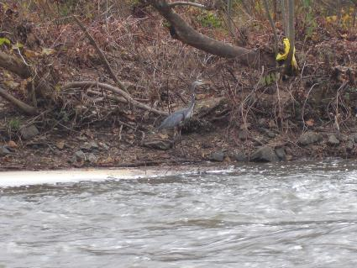
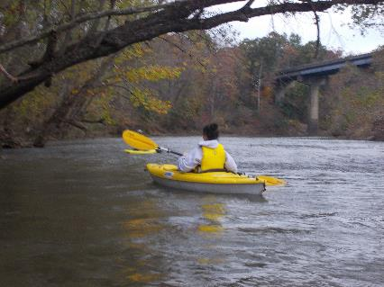
Figure 1: Jenna paddling in her kayak Figure 2: Heron along the bank
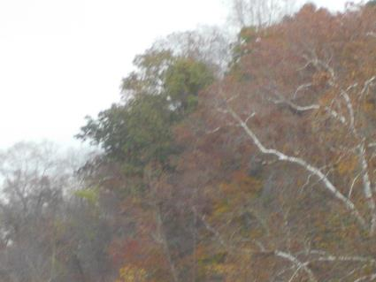
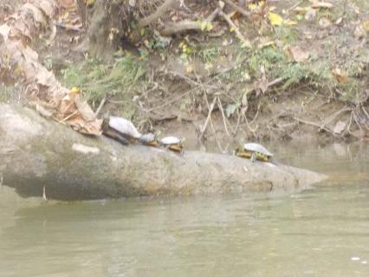
Eagle (white head and white tail showing (back facing camera)
Figure 3: Turtles on a log Figure 4: Eagle sitting up high in a tree

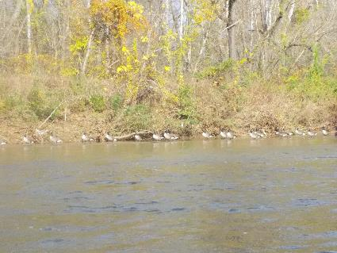
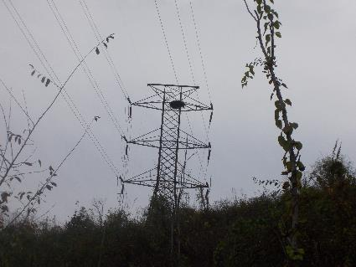

Figure 5: Eagle nest on top of power line tower Figure 6: Lots of geese

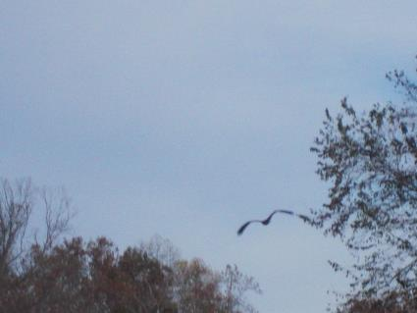
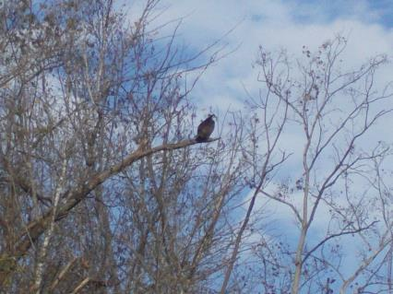
Figure 7: Osprey sitting in a tree Figure 8: Osprey flying away from us
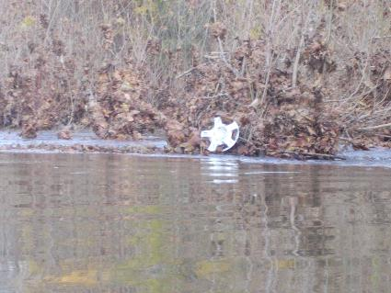
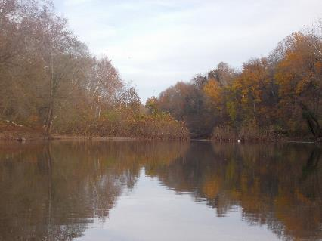
Figure 9: View of the fall colors and reflection on the water Figure 10: One of the hub caps in the River

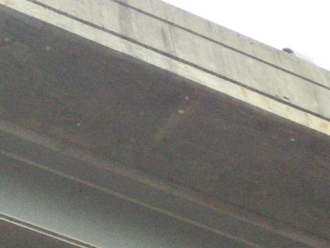
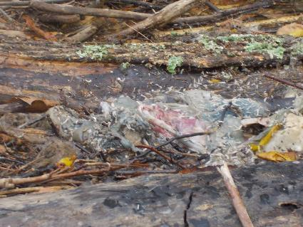

White circles are the eggs

Figure 11: Unidentified dead animal in the water Figure 12: Hellgrammite eggs underneath Milton Bridge

