RIVANNA RIVER STEWARD REPORT
River Steward Names: Dan Triman & Justin Altice Date: 11-12-14
Starting Location and Time: Reas Ford Rd (2:30 PM)
Ending Location and Time: Earlysville Rd (4:30 PM)
Weather: Very Sunny Recent Precipitation: Not much rain recently
Water Flow: Slow Water Color: Blue Water Odor: None
Water Temp. : 14 deg C Air Temp. : 65 deg F
DO: 4 ppm PH: 7 Turbidity: 10 JTU
USGS Water Gauge Reading: Earlysville 1.27 ft., Palmyra 2.65 ft
Physical Location Characteristics: Boat launch at Woodlands Rd / Reservoir
Location Tested: Middle of River between Woodlands Rd Bridge and Boat launch
---------------------------------------------------------------------------------
Land Use:
Mostly farmland and wooded areas with some residential areas closer to the Reservoir.

Wildlife Sightings and Plant Life:
Ducks, small birds, lots of geese (30-40), turtles, and 3 herons. We also heard a number of frogs. Most trees had lost their leaves, but a few still had some leaves showing fall colors. More wetland type grasses & plants than other sections of River.

People Interactions:
We saw 4 kayakers, several people fishing in motorized boats, and a couple of rowers (all near the Reservoir). There was a lot of evidence of people using the area near Reas Ford for fishing since we found a lot of Y shaped sticks in the ground for holding fishing rods, and fishing bait litter.

Litter and Pollution:
We found a few pieces of scattered trash during the paddle (such as bait boxes, cans, and bottles), but overall there wasn’t a whole lot of trash.

Overall Summary:
It was a beautiful day to be on the River, and this was our last paddle for the year as the weather will be getting colder this week. The water levels were good for a smooth paddle and we saw a good amount of wildlife.

Actions Needed – level of priority (1 highest/5 lowest):
None
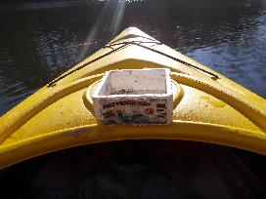
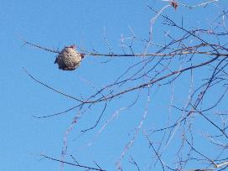
Figure 1: Wasp nest in a tree (we saw a couple of these) Figure 2: Example of bait box trash found in the River

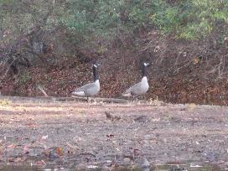
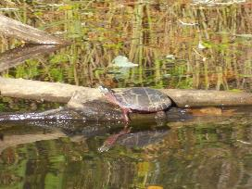
Figure 3: Turtle sunning on a log Figure 4: 2 of the many geese we saw today.

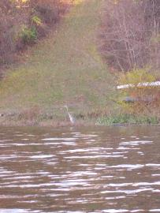
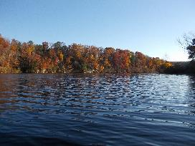

Figure 5: Some of the trees showing fall colors

Figure 6: Heron standing on the River bank

