RIVANNA RIVER STEWARD REPORT
River Steward Names: Dan Triman Date: 5-25-15
Starting Location and Time: Rio Mills (1:30 PM)
Ending Location and Time: Riverview Park (6:00 PM)
Weather: Sunny / Clear Recent Precipitation: Not much rain recently
Water Flow: Slow Water Color: Mostly Clear Water Odor: None
Water Temp. : 26 deg C Air Temp. : 80 deg F
DO: 4 ppm PH: 8 Turbidity: 10 JTU
USGS Water Gauge Reading: Earlysville 1.47 ft, Palmyra 2.94 ft
Physical Location Characteristics: Just below where North / South Forks meet
Location Tested: River right (38°04'23.2"N 78°26'22.0"W)
---------------------------------------------------------------------------------
Land Use:
Starts as commercial at beginning of trip, transitioning to open or wooded space, with some residential mixed in along the way.

Wildlife Sightings and Plant Life:
Ducks, small birds (lots of swallows), turtles, frogs, fish (including 2 long nose gar, and bass), 1 blue herons, 1 deer, turkey vultures, crows, and 1 hawk.

People Interactions:
There were a lot of people out on the beaches and swimming in the Rivanna today (likely because it was Memorial Day). Several other people out boating and fishing as well. Probably saw around 50 people total on the water during the trip.

Litter and Pollution:
We picked up about 1 ½ large trash bags worth of trash during the trip (mostly cans and bottles, bait boxes, and Styrofoam containers)

Overall Summary:
The water levels were fairly low but high enough to paddle. Some trash noticed along the way, as well as several downed trees. The biggest of which is just below where the South and North Forks meet and is blocking the entire River. Saw a lot of people today and a good amount of wildlife as well.

Actions Needed – level of priority (1 highest/5 lowest):
2 – Remove large tree blocking River at approx. 38°04'21.7"N 78°26'22.6"W
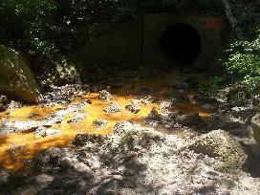
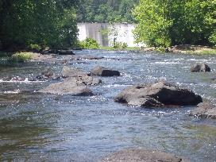
Figure 1: View of Reservoir Dam from below Figure 2: Pipe just below 29 bridge near Rio Mills
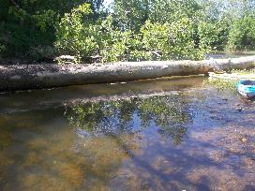
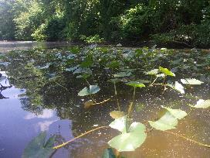
Figure 3: Vegetation growing out of the water. Figure 4: This is the large tree down blocking the River

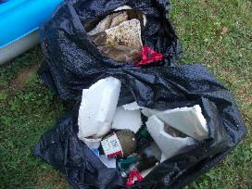
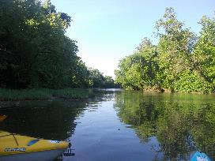

Figure 5: View upstream near Darden Towe Figure 6: Some of the trash collected during the trip

