RIVANNA RIVER STEWARD REPORT
River Steward Names: Justin Altice Date: 5-30-14
Starting Location and Time: Darden Towe Park (12:30 PM)
Ending Location and Time: Milton (3:30 PM)
Weather: Overcast Recent Precipitation: A few evening rains in previous 2 days
Water Flow: Moderate Water Color: Brownish Water Odor: None
Water Temp. : 22 deg C Air Temp. : 68 deg F
DO: 2.5-3 ppm PH: 7.5-8 Turbidity: 40 JTU
USGS Water Gauge Reading: Fluvanna 3.81 ft.
Physical Location Characteristics: Same as above
Location Tested: Under 64 Overpass just past Riverview Park
---------------------------------------------------------------------------------
Land Use:
Some Residential, train tracks adjacent, trails, open space

Wildlife Sightings and Plant Life:
Ducks, Lots of Geese, various small birds, turtle, fish jumping from river

People Interactions:
Saw several people using RTF trail near Charlottesville

Litter and Pollution:
Removed 3/4 a trash bag worth of litter from the river. Pulled 2 tires from River 0.4 miles from Free Bridge in shallow sand bar in bend in river.

Overall Summary:
Water was a little murky with sediment, and saw litter at various points along the river. Pull-out point in Milton is not well marked at all, also the condition of that pull out is very poor.

Actions Needed – level of priority (1 highest/5 lowest):
Remove the shopping cart (located adjacent to Free Bridge) (3) Contact Albemarle County Parks and Rec about condition of Milton Access Point (3)

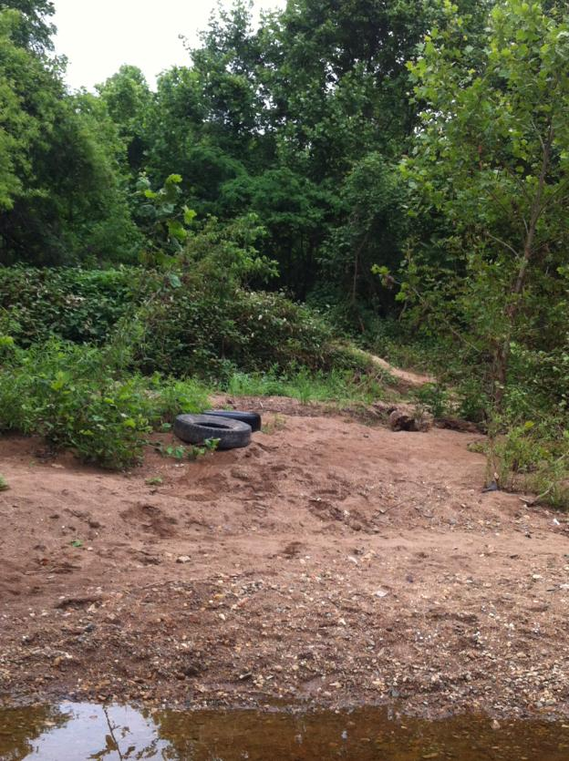
Figure 1: Two Tires Pulled Out of River Near Free Bridge

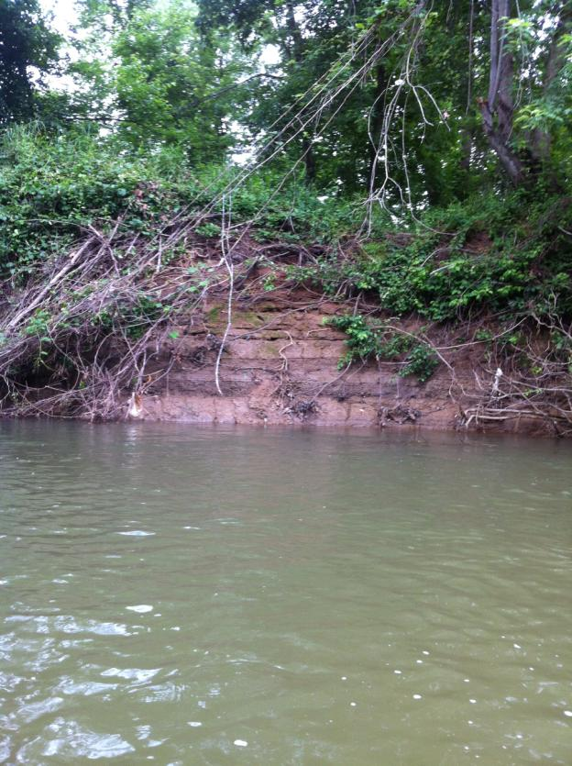
Figure 2: Severe bank erosion

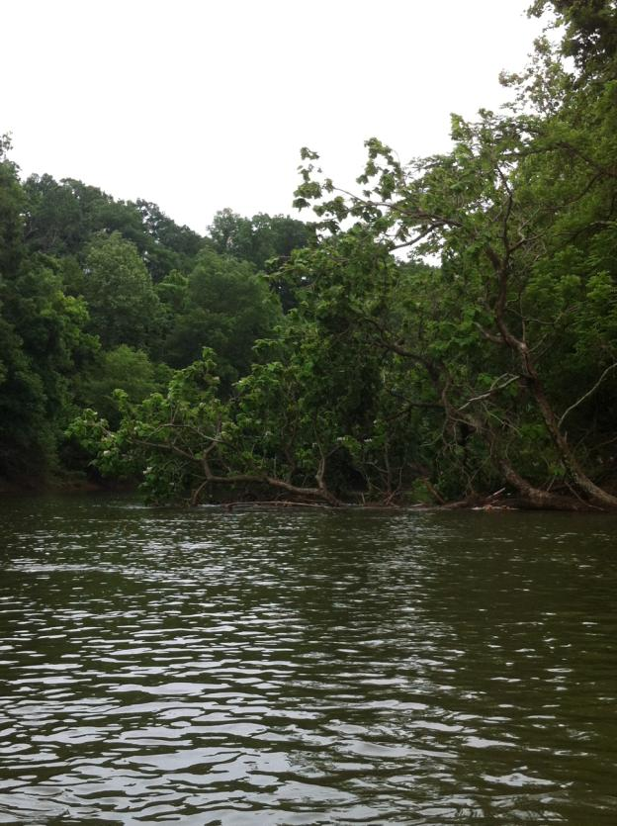
Figure 3: Tree Fallen before Riverview Park that is block half the River
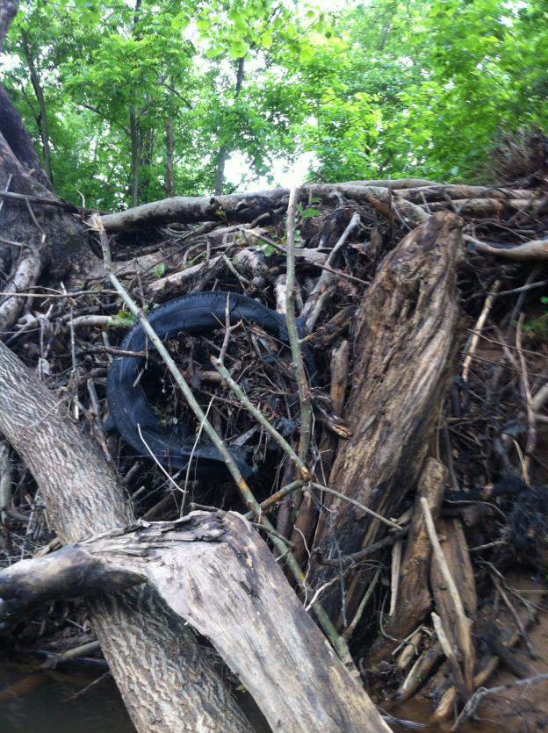
Figure 4: Tire lodged in debris on RTF near Riverview Park
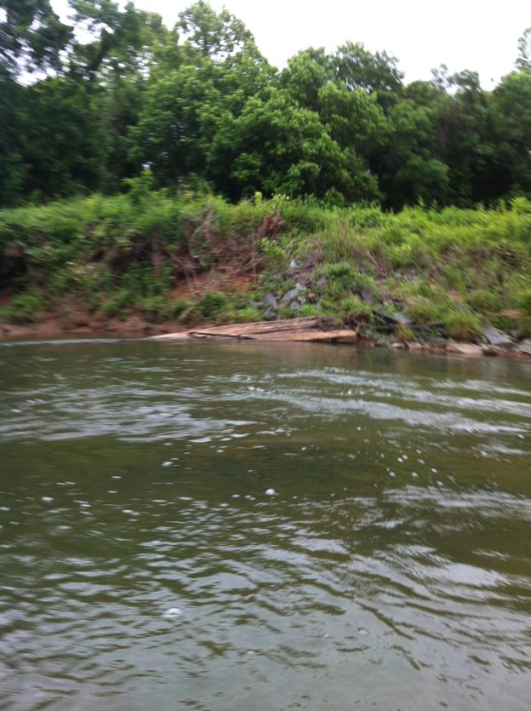
Figure 5: Piece of Boat Launch originally at Darden Towe Park, washed down river during torrential rains last month

