RIVANNA RIVER STEWARD REPORT
River Steward Names: Justin Altice Date: 6-15-14
Starting Location and Time: Rio Mills (4:15 PM)
Ending Location and Time: Palmyra (6:45 PM)
Weather: Clear Recent Precipitation: Heavy afternoon rains several days prior
Water Flow: Moderate Water Color: Brownish Water Odor: None
Water Temp. : 26 deg C Air Temp. : 83 deg F
DO: 1 ppm PH: 8 Turbidity: 40 JTU
USGS Water Gauge Reading: Fluvanna 3.6 ft.
Physical Location Characteristics: Same as above
Location Tested: Railroad Bridge underpass.
---------------------------------------------------------------------------------
Land Use:
Some open space and wooded areas, along with a great deal of residential and some commercial at beginning of trip

Wildlife Sightings and Plant Life:
Ducks, various small birds, turtles, frogs, otter, and fish

People Interactions:
Spoke with a few ladies putting in at same location as me, they often use the River for recreation on warm weekends. Saw a large number of people utilizing the River in Darden Towe Park, spoke with some that considered the access of the Rivanna at Darden a great asset for them and their children.

Litter and Pollution:
Low amount of trash encountered along route

Overall Summary:
Beautiful day to be out on river, lots of residential lots adjacent to the river along this route, level of river perfect for uninterrupted float, nice to see otter up close and see many frogs “running” on top of River, large amount of people enjoying river at Darden Towe Park

Actions Needed – level of priority (1 highest/5 lowest):
3 – Spotted old piece of car on edge of river near Darden Towe Park, 5 – Saw a few Trails leading to River from unknown properties that could provide excellent access points, would need to speak with private land owners most likely
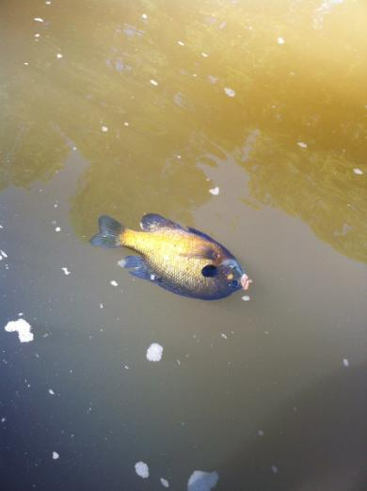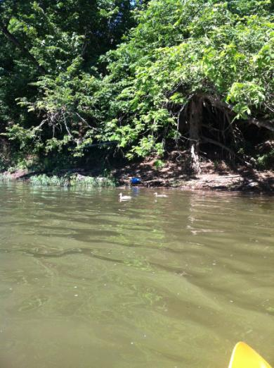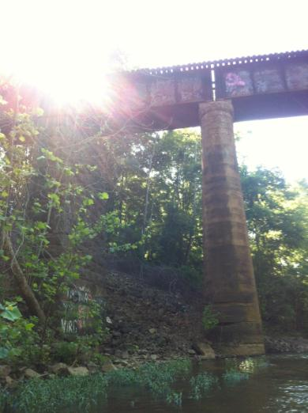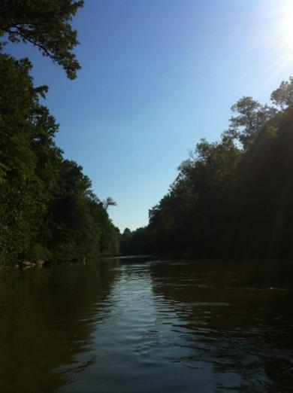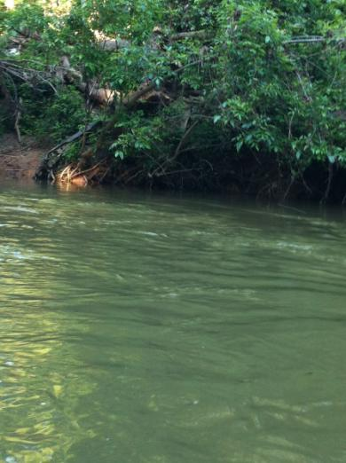
Dead Fish found near 29 Business Area.
Ducks on River.
Railroad Bridge, site of water testing.
Piece of Car spotted near Darden Towe Park.

