RIVANNA RIVER STEWARD REPORT
River Steward Names: Justin Altice and Dan Triman Date: 6-25-14
Starting Location and Time: Crofton (11:00 PM)
Ending Location and Time: Palmyra (1:30 PM)
Weather: Overcast, Breezy Recent Precipitation: Not much rain this week
Water Flow: Slow Water Color: Clear Water Odor: None
Water Temp. : 24 deg C Air Temp. : 80 deg F
DO: 2 ppm PH: 8 Turbidity: 20 JTU
USGS Water Gauge Reading: Palmyra 3.26 ft.
Physical Location Characteristics: Near bank at river left.
Location Tested: Between 2-3 miles downstream of Crofton at confluence of stream entering Rivanna at river left.
---------------------------------------------------------------------------------
Land Use:
Mostly open space and wooded areas, with some farms and residential.

Wildlife Sightings and Plant Life:
Lots of turtles, several fish including a long nose gar, several birds

People Interactions:
Spoke with a man at Crofton who had some questions about kayaking, saw 2 guys finishing a kayak float at Crofton, and saw several people along the beach at Pleasant Grove and at the Palmyra take out point.

Litter and Pollution:
Only a few scattered pieces of trash were found. The only other item of note was that in the last mile or so stretch of the river before Palmyra there were about 40-50 tires buried in the riverbed.

Overall Summary:
In general this stretch of the Rivanna looked in good condition. There were a couple of spots with a good amount of erosion along the banks and downed trees. There were a lot of tires found in the water though, many of which we weren’t able to remove during this trip.

Actions Needed – level of priority (1 highest/5 lowest):
Remove all of the tires in the water near Palmyra (4)

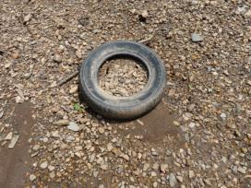
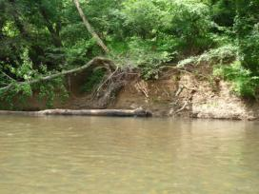
Figure 1: Example of erosion along the river bank Figure 2: One of the tires found (this one was removed)

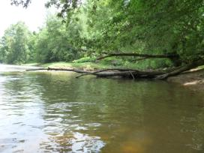
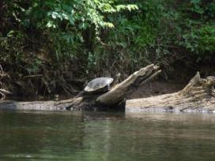
Figure 3: Large turtle sunning on a log Figure 4: Location of water quality testing performed
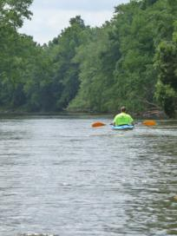
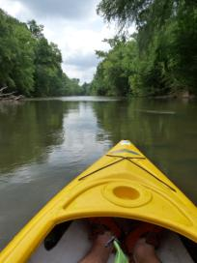

Figure 5: View from the kayak down river Figure 6: Justin paddling down the river

