RIVANNA RIVER STEWARD REPORT
River Steward Names: Justin Altice and Dan Triman Date: 8-13-14
Starting Location and Time: Crofton (12:00 PM)
Ending Location and Time: Palmyra (3:00 PM)
Weather: Overcast, Breezy Recent Precipitation: One heavy rain this week
Water Flow: Fairly slow Water Color: Mostly Clear Water Odor: None
Water Temp. : 24 deg C Air Temp. : 82 deg F
DO: 2 ppm PH: 8 Turbidity: 20 JTU
USGS Water Gauge Reading: Palmyra 2.97 ft.
Physical Location Characteristics: Beach (N 37º 53.616’ W 078º 27.522’)
Location Tested: Beach at River Left
---------------------------------------------------------------------------------
Land Use:
Mostly open space and wooded areas, with some farms and residential.

Wildlife Sightings and Plant Life:
Lots of turtles, several fish including a long nose gar, several birds including 3 bald eagles, a hawk, and several kingfishers.

People Interactions:
We saw several people fishing and swimming in the River near the Pleasant Grove beach and spoke to one fisherman at the Palmyra take out point.

Litter and Pollution:
Only a few scattered pieces of trash were found (bottles and cans mostly). We also found a kids playschool vehicle in the water as well. The only other item of note was that in the last mile or so stretch of the river before Palmyra there were about 40-50 tires buried in the riverbed.

Overall Summary:
Things were in good condition today for this stretch of the River. The rain we got earlier this week helped with the water depth and flow making it easier to paddle than last week. Not much trash was found. Some erosion on the banks near Crofton, and a lot of buried tires to be removed near Palmyra.

Actions Needed – level of priority (1 highest/5 lowest):
Remove all of the tires in the water near Palmyra (4)

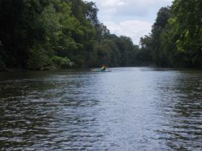
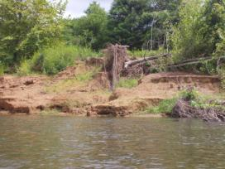
Figure 1: Example of erosion on bank near Crofton Figure 2: View down river near Crofton

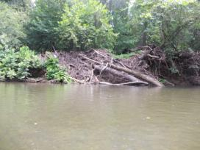
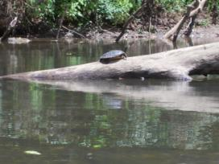
Figure 3: Turtle sunning on a log Figure 4: Another example of erosion along the banks
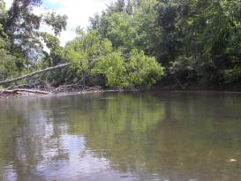
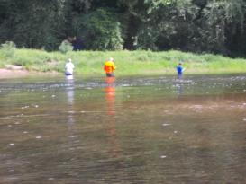

Figure 5: Large tree down across the River Figure 6: People fishing in the River near Pleasant Grove

