RIVANNA RIVER STEWARD REPORT
River Steward Names: Justin Altice and Dan Triman Date: 8-20-14
Starting Location and Time: Crofton (9:30 AM)
Ending Location and Time: Palmyra (4:00 PM)
Weather: Overcast, Breezy Recent Precipitation: Not much rain recently
Water Flow: Slow Water Color: Mostly Clear Water Odor: None
Water Temp. : 26 deg C Air Temp. : 85 deg F
DO: 2 ppm PH: 8 Turbidity: 40 JTU
USGS Water Gauge Reading: Palmyra 2.61 ft.
Physical Location Characteristics: Palmyra Boat Launch
Location Tested: Near boat ramp
---------------------------------------------------------------------------------
Land Use:
Mostly open space and wooded areas, with some farms and residential.

Wildlife Sightings and Plant Life:
Turtles, long nose gar and other fish, frogs, geese, 1 deer drinking in the river, 1 bald eagle and several other smaller birds, 2 copperhead snakes and 1 water snake.

People Interactions:
We spoke with a canoe group of about 20 people from Camp Friendship, as well as a few people at the Palmyra boat launch.

Litter and Pollution:
Only a few scattered pieces of trash were found (bottles and cans mostly). We were focused on removing tires from the river on this paddle, and managed to remove a total of 60 tires today.

Overall Summary:
The water level was very low and paddling was a little slow today. We went out with 4 volunteers (Dave, Pat, Chris, and John) to remove buried tires. We managed to get 60 tires out of the water, which we towed behind us in canoes, and will be taken to a recycling facility later in the week. There are still a good amount of tires to remove from Camp Friendship to Palmyra.

Actions Needed – level of priority (1 highest/5 lowest):
Remove the rest of the tires in the water near Palmyra (4)

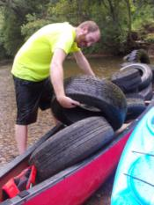
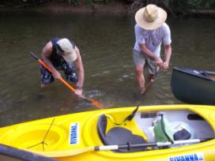
Figure 1: Chris and John working to remove a buried tire.
Figure 2: Justin putting a tire in one of the canoes

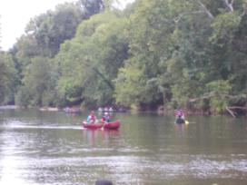
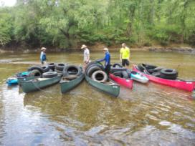
Figure 3: Dave, Chris, Pat, and Justin with the tires Figure 4: Camp Friendship canoe group loaded in the boats
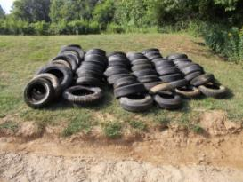
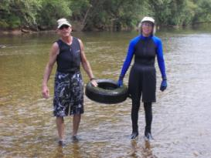

Figure 5: John and Pat removing a tire Figure 6: The 60 tires we removed from the river

