RIVANNA RIVER STEWARD REPORT
River Steward Names: Dan Triman Date: 8-21-15
Starting Location and Time: Darden Towe (10:30 AM)
Ending Location and Time: Milton (2:00 PM)
Weather: Clear Recent Precipitation: Some heavy afternoon storms this week
Water Flow: Moderate Water Color: Brownish Water Odor: None
Water Temp. : 26 deg C Air Temp. : 75 deg F
DO: 5 ppm PH: 8 Turbidity: 40 JTU
USGS Water Gauge Reading: Earlysville 1.3 ft., Palmyra 2.85 ft.
Physical Location Characteristics: At I-64 Underpass
Location Tested: At Railroad Bridge underpass at River left.
---------------------------------------------------------------------------------
Land Use:
Development with a wooded buffer around the river that contains the RTF
then turning to more rural land uses towards Milton

Wildlife Sightings and Plant Life:
Birds (1 eagle, 1 osprey, several Blue and Green Heron, sand pipers, and other small birds), turtles, small fish. Lots of cardinal flowers and other blooms along the river. Patch of dense bamboo growing near Darden Towe.

People Interactions:
Saw people on Rivanna trail, but nobody else out on the water today.

Litter and Pollution:
There were the usual plastic bottles and metal cans found in the river, along with some sports equipment (Frisbee, bike helmet, football, and softball). Also noticed several buried tires in the water.

Overall Summary:
Turned out to be a great day for a paddle, the water levels were just up high enough from the recent rain we got, and the weather was ideal. Water was somewhat brown with sediment from recent rain, and some trash found. At Milton it was noticed that new power poles were put up next to the boat ramp and it appears they clear cut all the way down to the River bank (see photos below).

Actions Needed – level of priority (1 highest/5 lowest):
2 – Have County Inspectors look at power pole clear cutting

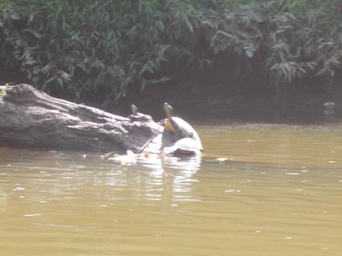
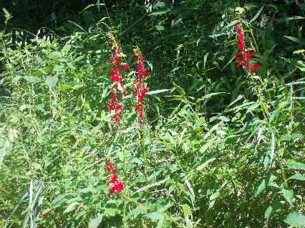
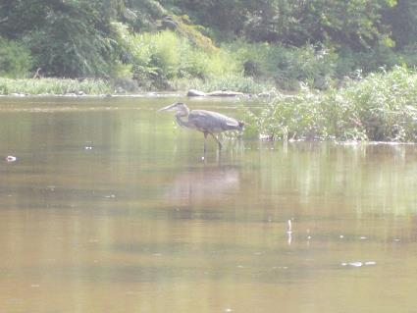
Figure 1: Cardinal flowers near Darden Towe Park Figure 2: Turtles sunning on a log
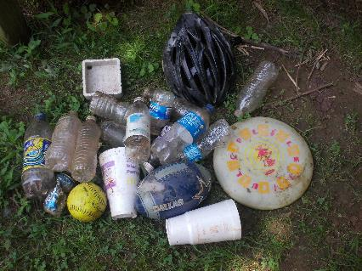
Figure 3: Examples of the trash found in the River Figure 4: Heron looking for food in the water

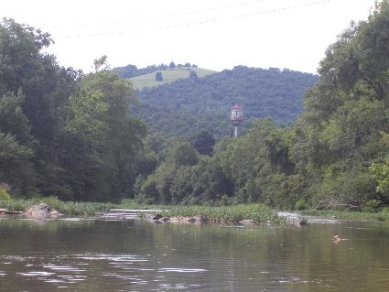
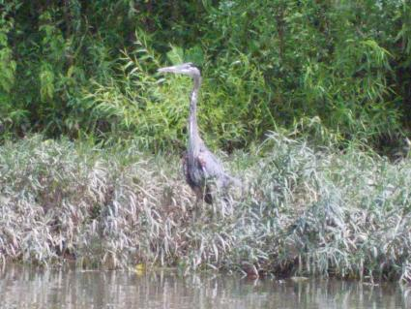

Figure 5: Another Heron along spotted on the trip Figure 6: View near Woolen Mills from the River

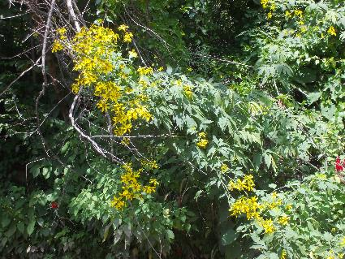
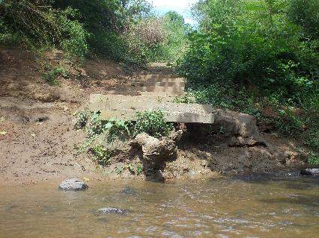
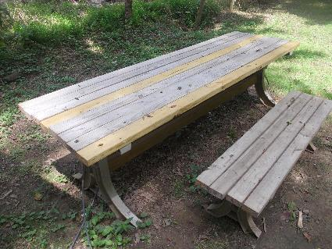
Figure 7: Riverview Park steps showing erosion Figure 8: Yellow flowers in full bloom
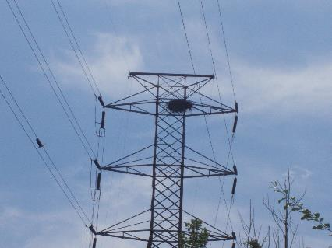
Figure 9: Eagles nest on power line tower, and eagle flying Figure 10: Table at Milton Justin recently repaired
away at the left of the photo between power lines

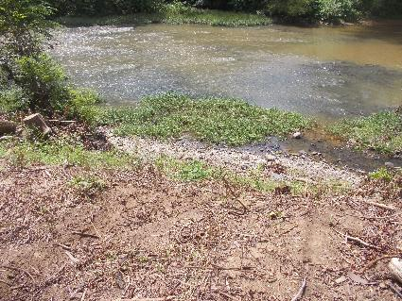
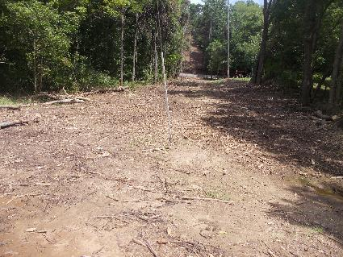

Figure 11: Power line work at Milton looking uphill Figure 12: Clear cut at Milton looking towards River

