RIVANNA RIVER STEWARD REPORT
River Steward Names: Justin Altice and Dan Triman Date: 8-8-14
Starting Location and Time: Darden Towe (9:00 AM)
Ending Location and Time: Milton (2:00 PM)
Weather: Cloudy Recent Precipitation: Very little rain lately
Water Flow: Very Slow Water Color: Clear Water Odor: None
Water Temp. : 24 deg C Air Temp. : 75 deg F
DO: 1 ppm PH: 7 Turbidity: 0 JTU
USGS Water Gauge Reading: Earlysville 1.21 ft.
Physical Location Characteristics: Same as above
Location Tested: just after I-64 Bridge underpass at River left.
---------------------------------------------------------------------------------
Land Use:
Development with a wooded buffer around the river that contains the RTF
then turning to more rural land uses towards Milton

Wildlife Sightings and Plant Life:
Birds (2 eagles, 2 osprey, several Heron, several king fishers, geese, and other birds), turtles, toads, fish (10 long nose gar), beavers, otters, deer

People Interactions:
Saw people on Rivanna trail, spoke to one woman at Riverview Park, 1 fisherman near Milton, and 1 man along bank just after Riverview Park.

Litter and Pollution:
We focused on trash clean up during this paddle, and removed about 7 trash bags worth of bottles, cans, bags, and misc trash. We also removed 4 tires from the River, a large metal sign, a few soccer and tennis balls, and several large plastic items.

Overall Summary:
Aaron from Blue Ridge Mountain Sports came with us on this paddle trip and helped us with trash removal. The weather was great with cooler temperatures throughout the day. The water levels were extremely low due to lack of rain lately, so paddling was tough in some stretches. The weather was iffy at start of day but turned into pretty nice day. Saw a few people on the trip, and lots of wildlife.

Actions Needed – level of priority (1 highest/5 lowest):
4 – Remove more tires, shopping cart and table from River

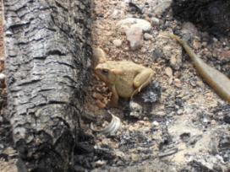
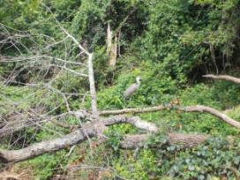
Figure 1: Heron perched on a log Figure 2: Toad spotted along one of the beaches
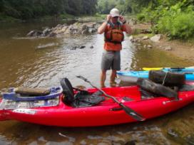
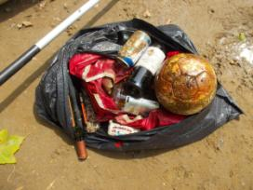
Figure 3: Examples of the trash removed from the River Figure 4: Tires and large objects removed from River

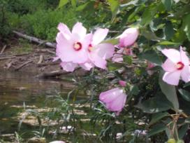
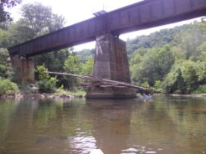

Figure 5: Location of water testing at I-64 bridge Figure 6: Example of flowering plants along the River

