RIVANNA RIVER STEWARD REPORT
River Steward Names: Dan Triman & Justin Altice Date: 9-14-14
Starting Location and Time: Rio Mills (5:00 PM)
Ending Location and Time: Darden Towe Park (8:00 PM)
Weather: Overcast Recent Precipitation: Pretty dry – not much rain recently
Water Flow: Slow Water Color: Brownish Water Odor: None
Water Temp. : 24 deg C Air Temp. : 68 deg F
DO: 3 ppm PH: 7 Turbidity: 60 JTU
USGS Water Gauge Reading: Earlysville 1.06 ft.
Physical Location Characteristics: Near 29 bridge just past Rio Mills
Location Tested: River right at outfall pipe discharging brownish liquid
---------------------------------------------------------------------------------
Land Use:
Starts as commercial at beginning of trip, transitioning to open or wooded space, with some residential mixed in along the way.

Wildlife Sightings and Plant Life:
Ducks, small birds, turtles, frogs, fish (including 1 long nose gar, and bass), 2 bald eagles, 1 osprey, 3 blue herons, several kingfishers, and 3 deer.

People Interactions:
Only saw 1 guy along the way, who was fishing in his kayak near Rio Mills.

Litter and Pollution:
Very little trash spotted along the way, just a few cans and bottles. We spotted about 4 tires buried under the water on the route.

Overall Summary:
The water levels were extremely low making for a difficult paddle; we had to get out of the kayaks and walk them along in the water many times. The water near Rio Mills was very brown and murky, with lots of vegetation growing under the water in thick mats. Saw a lot of wildlife, but not a lot of people. Spotted 2 dead fish in the water (each in different location). A lot of brown liquid is being discharged from the pipe at River right near the 29 bridge just past Rio Mills. Some erosion noticed on river banks, as well as a good number of downed trees in the water.

Actions Needed – level of priority (1 highest/5 lowest):
4 – Remove tires; 2 – look into origin of brown liquid discharge
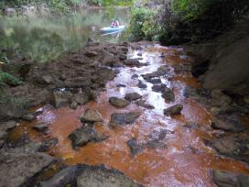
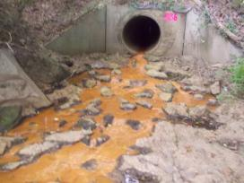
Figure 1: View of brownish liquid coming out of pipe near Figure 2: Another view of what is coming out of same pipe.
29 bridge just past Rio Mills.

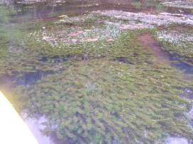
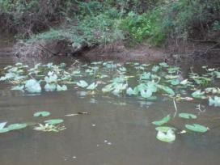
Figure 3: Vegetation growing out of the water. Figure 4: This is the thick vegetation we saw a significant
amount of growing under the water

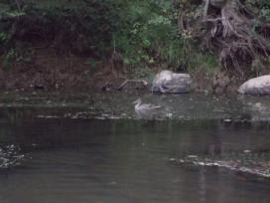

Figure 5: One of the ducks spotted on the river.

