RIVANNA RIVER STEWARD REPORT
River Steward Names: Justin Altice and Dan Triman Date: 9-24-14
Starting Location and Time: Camp Friendship (9:30 AM)
Ending Location and Time: Palmyra (1:30 PM)
Weather: Overcast, Breezy Recent Precipitation: No rain recently
Water Flow: Slow Water Color: Mostly Clear Water Odor: None
Water Temp. : 18 deg C Air Temp. : 64 deg F
DO: 5 ppm PH: 8 Turbidity: 10 JTU
USGS Water Gauge Reading: Palmyra 2.27 ft.
Physical Location Characteristics: Near Camp Friendship
Location Tested: River left (N 37˚52’ W 78 ˚16’)
---------------------------------------------------------------------------------
Land Use:
Mostly open space and wooded areas, with some farms and residential.

Wildlife Sightings and Plant Life:
Turtles, small fish, frogs, geese, several smaller birds

People Interactions:
We didn’t see any other people on the river, but did talk with a lot of the staff at Camp Friendship where we launched our boats.

Litter and Pollution:
Only a few scattered pieces of trash were found (bottles and cans mostly). We were focused on removing tires from the river on this paddle, and managed to remove a total of 60 tires today.

Overall Summary:
The water level was very low and paddling was a little slow today. We went out with 4 volunteers (Ellis, Pat, Tom, and John) to remove buried tires. We managed to get 60 tires out of the water, which we towed behind us in canoes, and will be taken to a recycling facility later in the week. This latest effort should have removed the majority of the tires near Palmyra.

Actions Needed – level of priority (1 highest/5 lowest):
Remove the 2 large tractor tires in the stretch of the river (4)

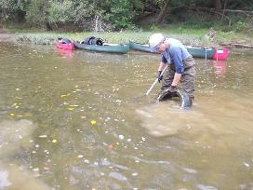
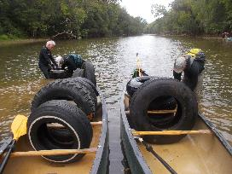
Figure 1: John, Pat, and Ellis removing tires from river Figure 2: Tom removing a tire from the river
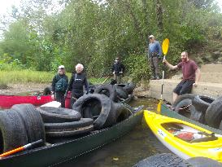
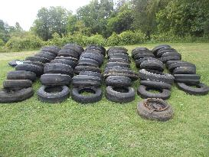

Figure 3: The crew at the Palmyra take out Figure 4: The 60 tires we removed from the river

