RIVANNA RIVER STEWARD MONTHLY REPORT
Date: August 2014
River Steward Name(s): Dan Triman and Justin Altice

River Sections Paddled this Month:
- Darden Towe Park To Riverview Park (2 times)
- Riverview Park to Milton (1 time)
- Crofton to Palmyra (2 times)
Total River Miles Paddled this Month: 21.5 miles
General Weather Conditions: 75 – 85 deg F, Sunny with some clouds and breeze
General Precipitation: very dry month with only a couple of rain events
General Water Characteristics (Flow, Color, Odor, Depth, Temp):
Slow flow most of the month, with very low water levels. Color was mostly clear, with minor occurrences of murkier water after rain events. Depth of water was in the 2.6 – 3.0 ft range in Fluvanna County and the 1.2 – 1.3 ft range near Charlottesville. Water temps were in the 24-26 deg C range. No odor in water.
Water Testing Summary:
4 water quality tests performed. 1) At I-64 underpass at River left btw Riverview and Milton (DO: 1 ppm, PH: 7.0, Turbidity: 0 JTU), 2) Beach (N 37º 53.616’ W 078º 27.522’) at River left btw Crofton and Palmyra (DO: 2 ppm, PH: 8.0 , Turbidity: 20 JTU), 3) Palmyra Boat Ramp (DO: 2 ppm, PH: 8.0 , Turbidity: 40 JTU), 4) At power lines near Riverview (DO: 2 ppm, PH: 8.0, Turbidity: 60 JTU)
Major Findings:
We saw birds (6 bald eagles, 2 osprey, 3 blue heron, 1 hawk, numerous kingfishers, numerous geese, other small birds), numerous turtles, toads and frogs, fish (15 long nose gar, and other small fish), 2 beavers, 1 otter, 2 copperhead snakes, 1 water snake, and 2 deer. During the month we spoke with several people including: a canoe group of about 20 people from Camp Friendship, several people at the Palmyra boat launch, fisherman near Milton and Riverview Park, people swimming near Pleasant Grove, and we saw many people out using the RTF trails. We were joined on some of our paddle trips this month by Blue Ridge Mountain Sports and several RCS River Guardians. We removed a lot of litter and trash from the River (10 trash bags, 64 tires, and several large metal, plastic, and rubber items). Some bank erosion was noticed, as well as many downed trees.

Future actions include the following:
- Talk to City and County about creating better signage at access points.
- Remove a few more tires found in the River (especially from Camp Friendship to Palmyra)
- Repair damaged Milton RCS Kiosk.

Photo Highlights:

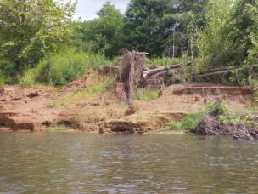
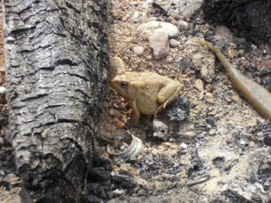

Photo 1: Toad found on one of the beaches
Photo 2: Example of bank erosion along the River

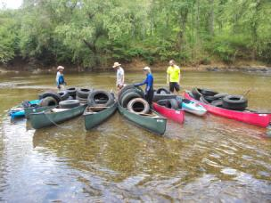
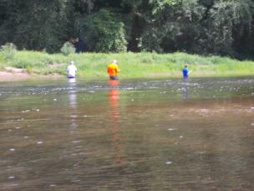

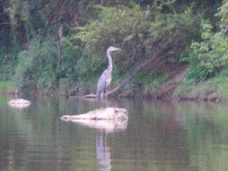
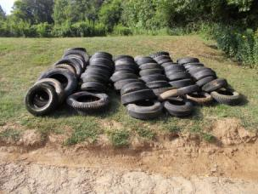
Photo 3: People fishing in the River
Photo 5: 60 tires removed from River between Crofton and Palmyra.
Photo 6: Heron on a rock in the middle of the River
Photo 4: Removing tires from the River

