RIVANNA RIVER STEWARD MONTHLY REPORT
Date: June 2014
River Steward Name(s): Dan Triman and Justin Altice

River Sections Paddled this Month:
- Rio Mills to Darden Towe Park (1 time)
- Darden Towe Park To Riverview Park (1 time)
- Milton to Crofton (1 time)
- Crofton to Palmyra (2 times)
Total River Miles Paddled this Month: 33 miles
General Weather Conditions: upper 70’s – lower 90’s, mostly sunny
General Precipitation: some rain early in month, drier later in month
General Water Characteristics (Flow, Color, Odor, Depth, Temp):
Slower flow rates most of the month, with less rainfall. Color was clear most of the time, with minor occurrences of murkier water. Depth of water was typically in the 3-3.5 foot range in Fluvanna County and the 2 foot range closer to Charlottesville. Water temperatures were in the 24-28 deg C range. No odor noticed in water.
Water Testing Summary:
5 water quality tests were completed. 1) 2 miles past Crofton access point, at shallow rock bar in middle of river (DO: 2 ppm, PH: 8, Turbidity: 20 JTU), 2) 2 miles past Milton access point near Keswick Golf Club (DO: 3 ppm, PH: 8.0 , Turbidity: 10 JTU), 3) Railroad Bridge underpass between Rio Mills & Darden (DO: 1 ppm, PH: 8.0 , Turbidity: 40 JTU), 4) At overhead power lines between Free Bridge and Riverview (DO: 2 ppm, PH: 7.0 , Turbidity: 20 JTU), and 5) 2-3 miles past Crofton at stream entering river on left (DO: 2 ppm, PH: 8.0 , Turbidity: 20 JTU).
Major Findings:
We saw turtles, birds (ducks, geese, a bald eagle, and kingfishers), snakes, an otter, frogs, and fish (including long nose gar). We saw other kayakers, fishers, people enjoying beach areas, and hikers along the trails. We removed litter (plastic, food trash, tires, etc.) from the River. There are a lot of tires in the River in the last mile before Palmyra. We found a piece of farm equipment on the bank (near Crofton), a piece of a car on the bank (near Darden Towe) and a table stuck up in a tree (near Crofton). The River closer to Charlottesville had more litter than the River in more rural areas. Some bank erosion was noticed, as well as many downed trees.

Future actions include the following:
- Talk to City and County about creating better signage at access points.
- Remove a few more tires found in the River.

Photo Highlights:

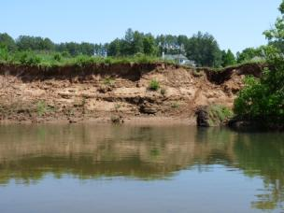
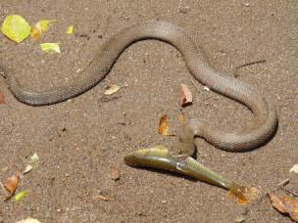

Photo 1: A snake eating a fish on a sand bar.
Photo 2: Example of erosion along the river bank near Keswick

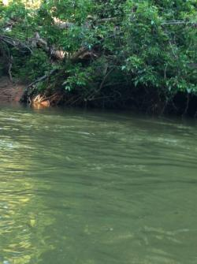
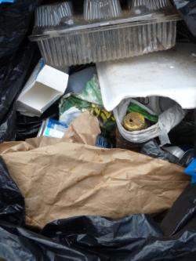

Photo 3: Piece of a car found near Darden Towe Park
Photo 4: Some of the trash removed from the River

