RIVANNA RIVER STEWARD MONTHLY REPORT
Date: November 2014
River Steward Name(s): Dan Triman and Justin Altice

River Sections Paddled this Month:
- Reas Ford Rd to Earlysville Rd – South Fork (1 time)
- Riverview Park to Milton (1 time)
Total River Miles Paddled this Month: 8 miles
General Weather Conditions: 60’s deg F, Sunny / Windy / Clear
General Precipitation: Mostly dry month without much rain
General Water Characteristics (Flow, Color, Odor, Depth, Temp):
It has been a pretty dry month, so there have been very slow River flows. The water was mostly clear, and the depth of water was in the 2.6 – 2.7 ft range near Palmyra and the 1.2 – 1.3 ft range near Earlysville. Water temps were about 14 deg C which was much colder than last month. No odor in water.
Water Testing Summary:
2 water quality tests performed: 1) Just before Milton bridge at River right (DO: 4 ppm, PH: 8.0, Turbidity: 10 JTU), 2) Near Earlysville Rd boat launch - N 38˚01’ W 78˚27’ (DO: 4 ppm, PH: 7.0, Turbidity: 10 JTU).
Major Findings:
The River water levels have been low most of the month, making it difficult to paddle many of the sections of the River. Also due to the dropping air temperatures and water temperatures, we weren’t able to spend as much time paddling this month as previous months. During our paddles we saw 1 hawk, 1 kingfisher, crows, geese, ducks, several smaller birds, turtles, 1 deer, 1 beaver, 1 otter, 3 herons, and wild turkeys along the bank. We also saw 2 adult bald eagles and 1 younger bald eagle as well as a nest located on a power line tower at approx. 38°00'31.7"N 78°25'26.0"W. We also spotted 1 eagle flying near the Reservoir. Lastly, we heard many frogs in the River. During our time on the River, we talked to a couple of people at Riverview Park and Earlysville Rd. We saw several people kayaking, rowing, and in motorized boats near the Reservoir. During the month, most of the trees dropped their leaves, but there are still some left with fall colors showing. We removed about 1 bag of litter from the River this month (items like beverage container and cans, plastic bags, and fishing bait boxes). Some bank erosion was noticed, as well as several downed trees.

Future actions include the following:
- Talk to City and County about creating better signage at access points.
- Repair damaged Milton RCS Kiosk.
- Continue tire and other large object removal efforts.

Photo Highlights:

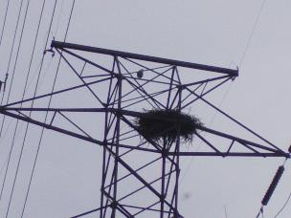
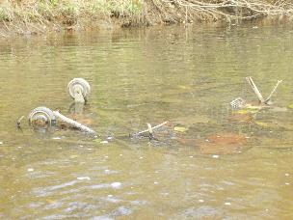

Photo 1: Buried shopping cart near Woolen Mills
Photo 2: Young eagle and nest in power line tower
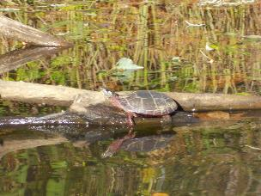
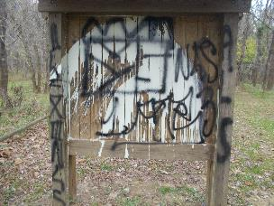

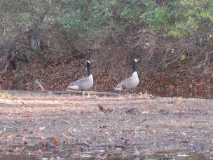
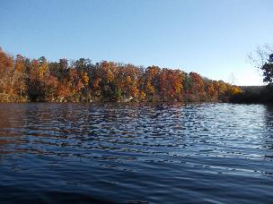
Photo 4: Turtle laying on a log
Photo 3: Damaged Milton kiosk
Photo 5: Fall colors in the trees along the River
Photo 6: 2 Gees walking along a bank

