RIVANNA RIVER STEWARD MONTHLY REPORT
Date: October 2014
River Steward Name(s): Dan Triman and Justin Altice

River Sections Paddled this Month:
- Reas Ford Rd to Earlysville Rd – South Fork (1 time)
- Earlysville Rd to Rio Mills Dam – Reservoir (1 time)
- Darden Towe to Riverview Park (2 times)
- Crofton to Milton (1 time)
Total River Miles Paddled this Month: 20 miles
General Weather Conditions: 50 - 80 deg F, Sunny / Windy / Clear
General Precipitation: Mostly dry month with a few heavy rains
General Water Characteristics (Flow, Color, Odor, Depth, Temp):
Slow flows most of month, with faster flows after the rain storms. River mostly clear, with some areas of murkier water after storms. Depth of water was in the 2.3 – 3.1 ft range in Fluvanna County (large spike to 7.0 ft in middle of the month) and the 1.0 - 1.5 ft range near Earlysville (large spike in middle of month to 5.0 ft). Water temps were in the 16 - 20 deg C range. No odor in water.
Water Testing Summary:
5 water quality tests performed: 1) Just before Rio Mills Dam in middle of Reservoir (DO: 4 ppm, PH: 6.0, Turbidity: 30 JTU), 2) Sand Bar at River Left - N 38˚01’ W 78˚27’ (DO: 4 ppm, PH: 7.0, Turbidity: 20 JTU), 3) Crofton boat launch at River left (DO: 4 ppm, PH: 7.0 , Turbidity: 20 JTU), 4) Small island across from Green Meadows Ln (DO: 4 ppm, PH: 8.0 , Turbidity: 50 JTU), 5) Riverview Park at boat put in – River right (DO: 7 ppm, PH: 7.0 , Turbidity: 0 JTU).
Major Findings:
The River water levels have been low most of the month, making it difficult to paddle many of the sections of the River. We were lucky enough to have higher water levels for our Fall Sojourn trip on October 19th with BRMS. During our paddles we saw ducks, geese, squirrels, spiders, small birds, turtles, fish, 1 bat, 2 osprey, 5 kingfisher, 1 hawk, crows, and 12 blue herons. During our time on the River, we saw people using the RTF trails, about 10 kayakers, several fishers, several rowers (including the UVA Rowing team), and several people down by the water at Riverview Park. Towards the end of the month the fall colors on the trees were out in full. We removed about 6 bags of litter from the River this month (items like beverage container and cans, plastic bags, sporting equipment, fishing bait boxes, and food). Some bank erosion was noticed, as well as several downed trees.

Future actions include the following:
- Talk to City and County about creating better signage at access points.
- Remove tires, table in tree, farm equipment, blue barrel, manhole cover.
- Do a paddle from Palmyra to Columbia.
- Repair damaged Milton RCS Kiosk.

Photo Highlights:

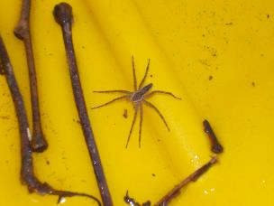
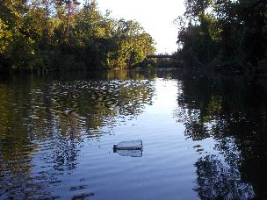

Photo 1: Plastic bottle floating in the River.
Photo 2: Spider on one of our kayaks
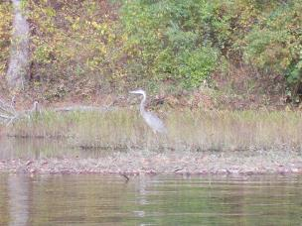
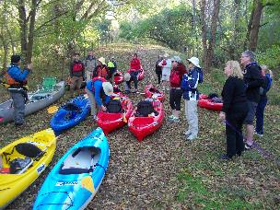

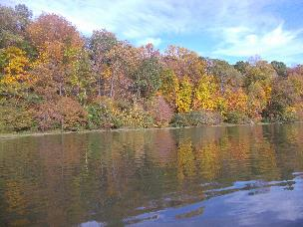
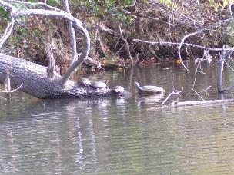
Photo 4: Heron on the River bank
Photo 3: Safety briefing before Fall Sojourn
Photo 5: Turtles on a log
Photo 6: Fall colors along the River

