RIVANNA RIVER STEWARD MONTHLY REPORT
Date: September 2014
River Steward Name(s): Dan Triman and Justin Altice

River Sections Paddled this Month:
- Rio Mills to Darden Towe Park (1 time)
- Riverview Park to Milton (1 time)
- Camp Friendship to Palmyra (1 time)
Total River Miles Paddled this Month: 12 miles
General Weather Conditions: Lower 60’s – upper 80’s deg F, Sunny / Overcast
General Precipitation: Very dry month with barely any rain
General Water Characteristics (Flow, Color, Odor, Depth, Temp):
Extremely slow flow the entire month, with very low water levels. Color was mostly clear, with minor occurrences of murkier water near Rio Mills. Depth of water was in the 2.0 – 2.3 ft range in Fluvanna County and the 1.0 - 1.1 ft range near Charlottesville. Water temps were in the 18-30 deg C range. No odor in water.
Water Testing Summary:
3 water quality tests performed. 1) At Milton Boat Launch River left (DO: 2 ppm, PH: 8.0, Turbidity: 30 JTU), 2) Near 29 bridge just past Rio Mills River right where there is a pipe outfall and brownish liquid being discharged (DO: 3 ppm, PH: 7.0 , Turbidity: 60 JTU), 3) Just past Camp Friendship River left (N 37˚52’ W 78 ˚16’) (DO: 5 ppm, PH: 8.0 , Turbidity: 10 JTU)
Major Findings:
The water levels in the Rivanna River have been extremely low all month, making it difficult to paddle any of the sections without our boats scraping the bottom of the River or having to get out of the boats and walk. However, the low water levels did allow us to remove another 60 tires from the section of the River between Camp Friendship and Palmyra. During our paddles we saw birds (2 bald eagles, 2 osprey, 1 kingfisher, 3 blue herons, ducks, geese, and other small birds), turtles, frogs, fish (including 1 long nose gar and several bass), and 3 deer. Our only encounters with other people on the River this month were we saw 1 person fishing just past Riverview, 2 people kayaking near Milton, and 1 person fishing near Rio Mills. We were joined on one of our paddle trips this month by several RCS River Guardians and other volunteers. We removed a few bags of litter from the River this month in addition to the tires mentioned above. Some bank erosion was noticed, as well as several downed trees.

Future actions include the following:
- Talk to City and County about creating better signage at access points.
- Continue tire removal efforts.
- Do a paddle from Palmyra to Columbia.
- Repair damaged Milton RCS Kiosk.
- Look into brown discharge at outfall pictured below near Rio Mills

Photo Highlights:

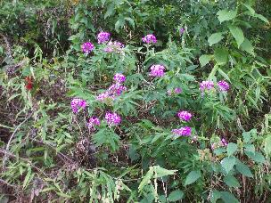
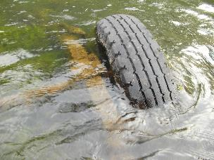

Photo 1: Tire and axle between Riverview and Milton
Photo 2: Example of flora along the River
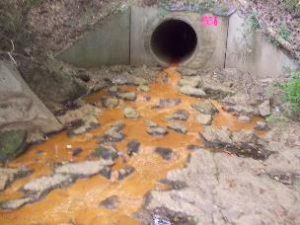
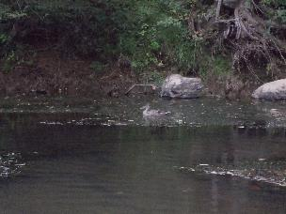

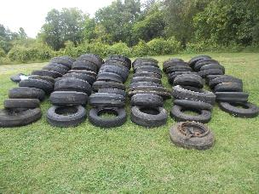
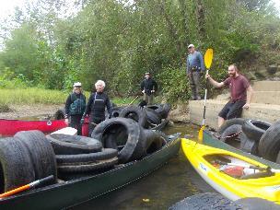
Photo 4: Duck seen in the River
Photo 3: Brown discharge at outfall near Rio Mills
Photo 5: Volunteer crew who removed 60 tires
Photo 6: 60 tires take out at Palmyra boat ramp

