RIVANNA RIVER STEWARD REPORT
River Steward Names: Dan Triman and Justin Altice Date: 6-20-14
Starting Location and Time: Darden Towe Park (12:00 PM)
Ending Location and Time: Riverview Park (1:30 PM)
Weather: Overcast Recent Precipitation: Not much rain lately
Water Flow: Fairly Slow Water Color: Clear Water Odor: None
Water Temp. : 26 deg C Air Temp. : 80-85 deg F
DO: 2 ppm PH: 7 Turbidity: 20 JTU
USGS Water Gauge Reading: Earlysville 1.8 ft.
Physical Location Characteristics: Residential area with sand bank
Location Tested: Under overhead power lines between Free Bridge and Riverview
---------------------------------------------------------------------------------
Land Use:
Residential mainly, with some commercial use

Wildlife Sightings and Plant Life:
Several turtles sunning on logs, various birds, fish

People Interactions:
Saw one person fishing along the River, a couple of people canoeing, and a couple of people walking along the Rivanna Trail. Talked with Chris Gensic from Charlottesville Parks and Rec about putting up a marker to indicate take out point for Riverview Park.

Litter and Pollution:
Removed half a trash bag worth of litter from the river including plastic bags, plastic bottles and containers. The shopping cart just past Free Bridge on west side of river we noticed before had been removed.

Overall Summary:
Water was fairly clear with only a little sediment, and saw litter at various points along the river. Otherwise, no major issues of note.

Actions Needed – level of priority (1 highest/5 lowest):
None

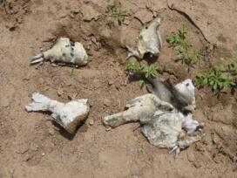
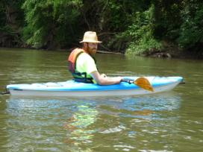
Figure 1: Justin paddling in the river Figure 2: Pieces of fish found along a river bank

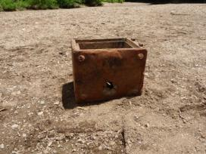
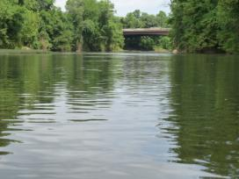
Figure 3: Looking up river at Free Bridge Figure 4: Appliance found along a river bank
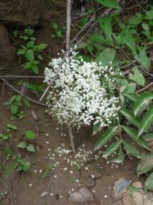
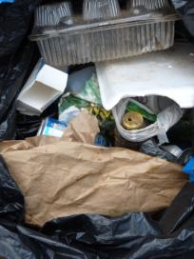

Figure 5: Some of the trash removed from the Figure 6: Queen Anne’s Lace
water during the trip

