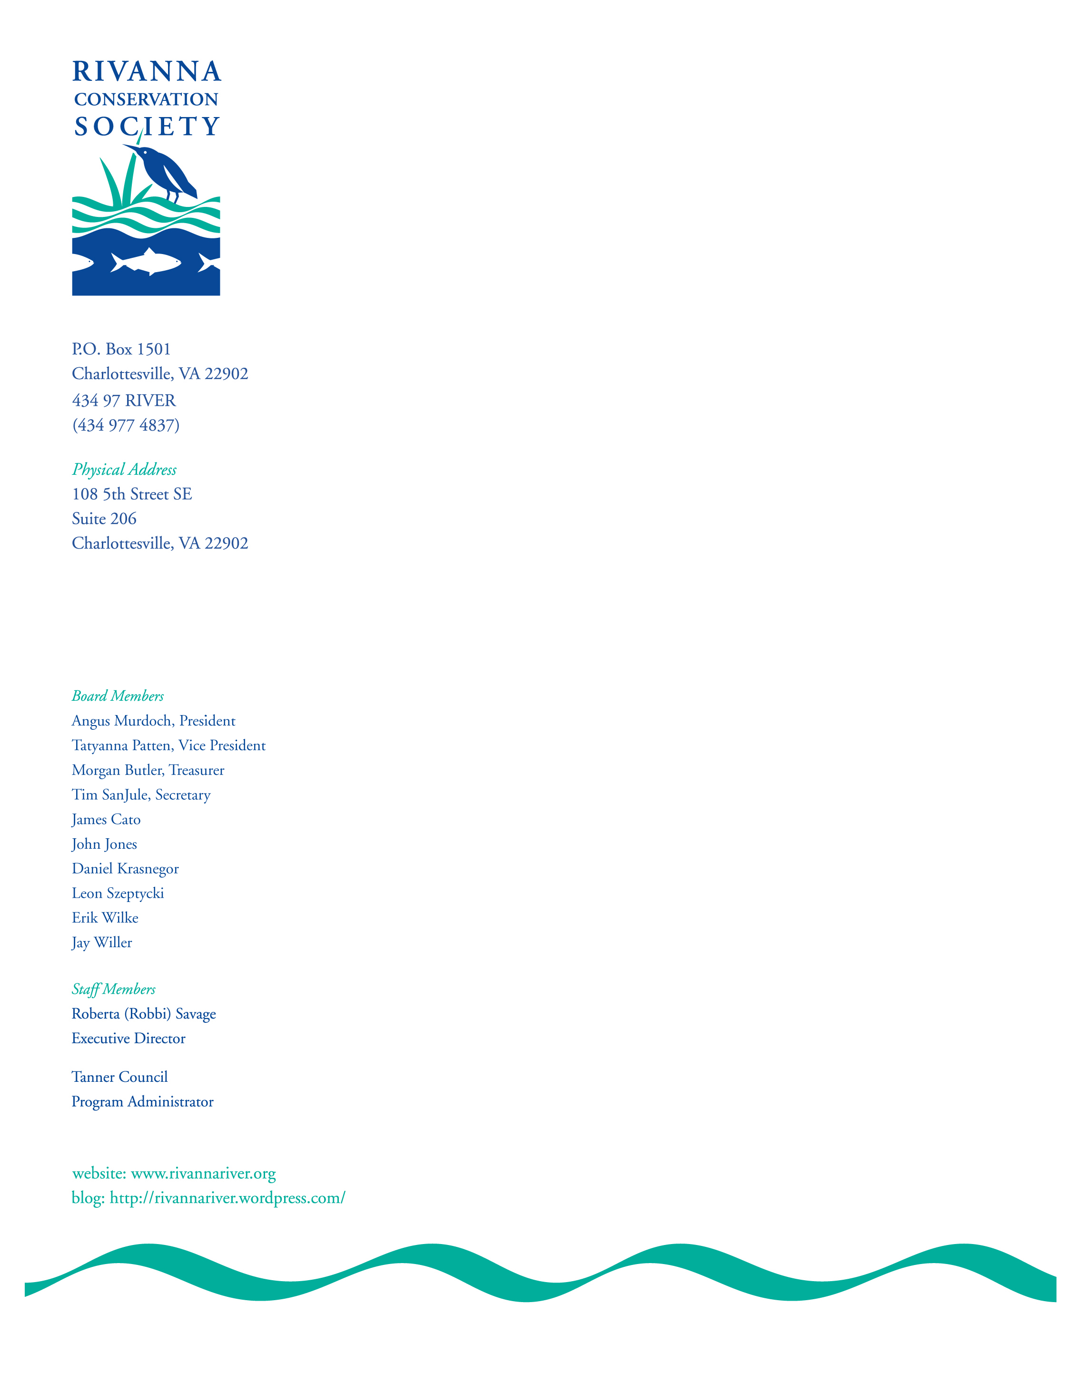

Mr. Chairman and Members of the Board of Supervisors

My name is Roberta Savage and I am here representing the Rivanna Conservation Society (RCS).

RCS is a nonprofit organization created 1990 to care for and protect the Rivanna River and its watershed.

I have had the pleasure of coming before you on several occasions to discuss the results of the Water Protection Code and Ordinance Project conducted by RCS, the Southern Environmental Law Center, with the support from the UVA Environmental Law and Conservation Clinic.

This 2 ½ year project began with an in-depth analysis of different section of the County’s codes and relevant polices. Based on this analysis, we developed a series of recommendations designed to reduce damage from polluted runoff.

Our recommendations were submitted to the Board more than a year ago and at that time you asked us to work with your professional staff to draft ordinance amendments for your consideration. We come to you now with the first recommendation that has resulted from our efforts and we are hopeful that you will approve the staff proposal by day’s end.

If approved, the proposal will require the major grading work on a construction site to be completed within nine months of the date the grading work begins. At the end of that time, any denuded areas of the site that are not covered by an active building permit would have to be stabilized with permanent vegetation or another surface that is equally effective in preventing erosion.

It is our understanding that some concerns have been raised about this proposal and we have attempted to address these objections by including extension provisions. The flexibility that has been incorporated seems to us to be fair and appropriate given the tremendous damage being done to our waterways.

We are also aware that there is some concern about the potential for increasing construction costs for certain projects. From where we sit, this objection pales in comparison to the cost to the public and to the environment. As others here will testify, the costs associated with the cleanup of the Forest Lakes community will exceed $1 million. Add to this figure the costs associated with the damage to individual homes and property, the decrease in property values, the cost of diminished community aesthetics, the loss of aquatic life and of course the cost in terms of general public frustration and irritation.

Our goal is to assure pollution prevention rather than remediation because the costs associated with stopping a problem before it begins is far more cost effective than trying to repair environmental damage that could have been avoided.

Mr. Chairman, stormwater runoff is one of the most significant water quality threats to the Rivanna River Watershed and we ask that you adopt the ordinance placed before you today.

Thank you.

