RIVANNA RIVER STEWARD REPORT
River Stewards: Dan Triman and Justin Altice Date: 03-27-16
Starting Location and Time: Lewis and Clark Center @ Darden Towe (12:00 PM)
Ending Location and Time: Riverview Park (2:00 PM)
Weather: Cloudy Recent Precipitation: Fairly dry this week
USGS Gauges: Earlysville 1.87 ft (89 ft² / sec), Palmyra 3.58 ft (571 ft² / sec),
Water Color: Mostly Clear Water Odor: None Air Temp. : 55 deg F
DO: 4 ppm PH: 8 Turbidity: 20 JTU Water Temp. : 11 deg C
Water Testing Location: Just past Free Bridge, middle of River at sand bank.
---------------------------------------------------------------------------------
Land Use:
Residential mainly, with some commercial use and park property

Wildlife Sightings and Plant Life:
Turtles, Crows, Cardinals, Fish, Geese, and a Ladybug.
Vegetation is starting to come back after the Winter. Saw some redbuds, and other flowering plants. Several patches of dense bamboo near Darden.

People Interactions:
We saw a number of people at both Darden Towe Park and Riverview Park. A couple of people were fishing, some were walking dogs, and a lot were walking, biking, jogging on the trails. One man near Free Bridge asked us how far we paddle and said it looked like fun paddling the River.

Litter and Pollution:
We removed ½ a bag of trash from the River. It was mostly cans and bottles, food containers, fish bait boxes, plastic bags, and a soccer ball.

Overall Summary:
Water levels were lower with not much rain lately. There is still a decent amount of sediment on the Darden Towe boat ramp (see photo below). The Riverview Park steps need attention as the soil has eroded at the bottom (see photo below). There was also a pipe that is just hanging out of the water near Darden Towe Park (River Left – see photo below). Saw a few turtles and birds mostly, and a lot of people out using the trails.

Actions Needed – level of priority (1 highest/5 lowest):
4 – Clean sediment off Darden Towe boat ramp and Riverview steps;
4 – Determine if the pipe near Darden Towe needs to be fixed; 3 – fix Riverview Park steps for safety issues

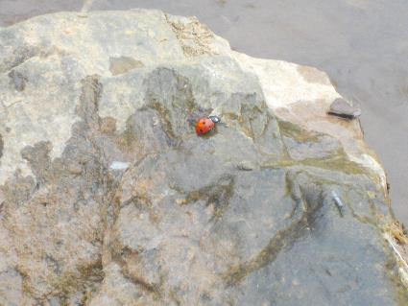
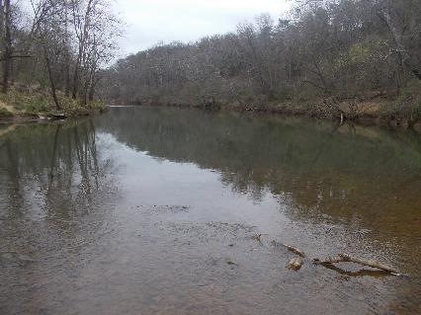
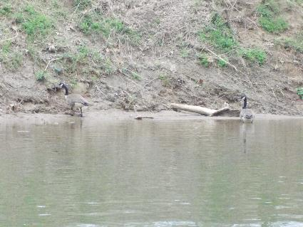
Figure 1: Looking up river from Lewis and Clark Center Figure 2: Ladybug on a rock
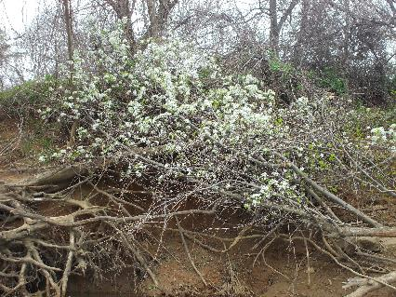
Figure 3: White flowers along the River Figure 4: Geese floating at the edge of the water
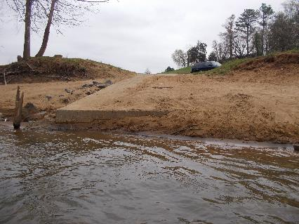
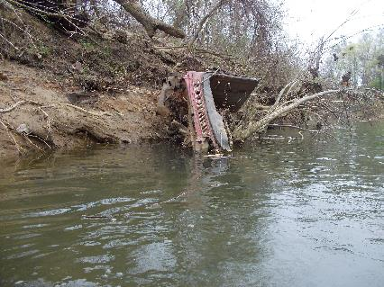
Figure 5: Piece of a car still on bank just above Darden Figure 6: Sediment on Darden Towe Boat Ramp

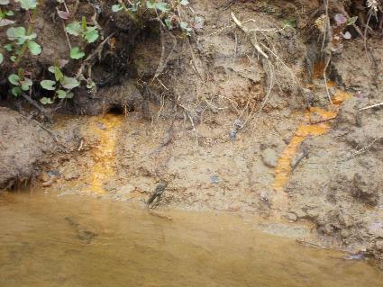
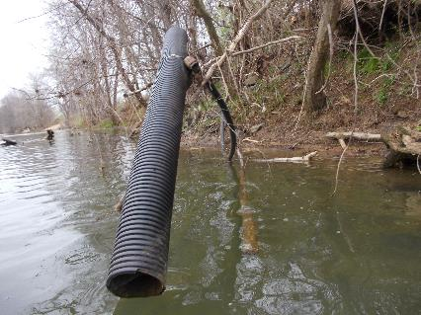
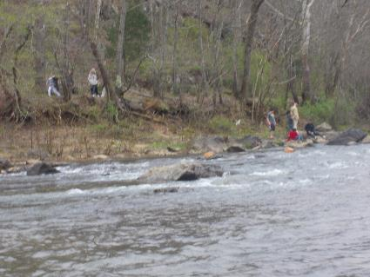
Figure 7: Pipe hanging just below Darden boat ramp Figure 8: Orange sediment entering River just below Darden
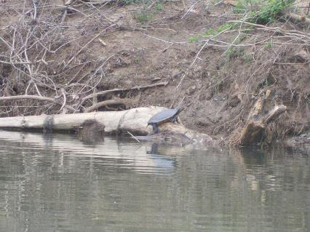
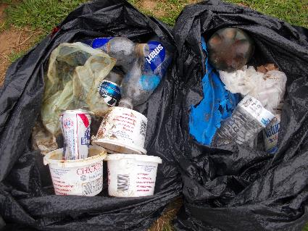
Figure 9: Turtle on a log Figure 10: People along the Rivanna Trails
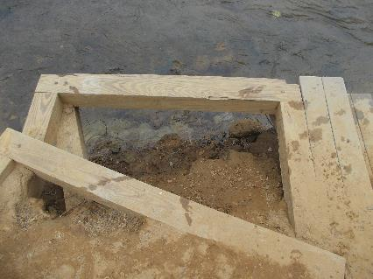
Figure 11: Repairs needed to Riverview Park steps Figure 12: Trash collected during the paddle

