RIVANNA RIVER STEWARD REPORT
River Steward Names: Dan Triman & Justin Altice Date: 04-12-15
Starting Location and Time: Earlysville Rd (12:30 PM)
Ending Location and Time: Earlysville Rd (3:45 PM)
Weather: Sunny Recent Precipitation: Some rain this past week
Water Flow: Slow Water Color: Blue Water Odor: None
Water Temp. : 14 deg C Air Temp. : 68 deg F
DO: 4 ppm PH: 8 Turbidity: 10 JTU
USGS Water Gauge Reading: Earlysville 2.18 ft., Palmyra 3.61 ft
Physical Location Characteristics: River right near bank at Confluence of Mechums River and Rivanna River

Location Tested: N 38° 07.373’ W 78° 31.513’
---------------------------------------------------------------------------------
Land Use:
Mostly farmland and wooded areas with some residential areas closer to the Reservoir.

Wildlife Sightings and Plant Life:
Turtles (probably 150 or more), Ducks, Geese (over 30), 2 Herons, 1 American Bittern, Crows, 1 Turkey Vulture, 1 Osprey, 2 Sandpipers, and 1 Deer. Most trees were still bare but a few had some flowers and buds. More wetland type grasses & plants were noticed than other sections of River.

People Interactions:
We saw 4 kayakers, about 15 people fishing in boats and along the banks, and a 3 rowers. We saw a lot more people today than we usually do.

Litter and Pollution:
We found a few pieces of scattered trash during the paddle (such as bait boxes, cans, and bottles), but overall there wasn’t a whole lot of trash.

Overall Summary:
The weather was great, the water levels were fairly high, and we saw a lot of wildlife and people today. We started at the Reservoir and paddled upstream past Reas Ford Rd where the Rivanna River meets the Mechums River, and then turned around and paddled back downstream to the Reservoir again.

Actions Needed – level of priority (1 highest/5 lowest):
None
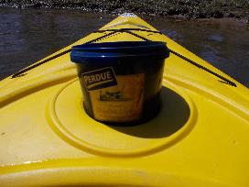
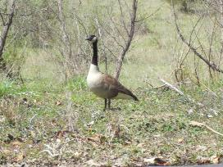
Figure 1: One of the many geese we saw Figure 2: Container of chicken livers found in the River

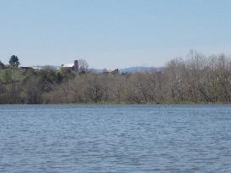
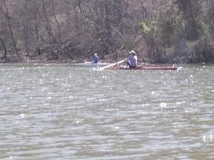
Figure 3: Some of the rowers we saw Figure 4: View of some farms and the mountains

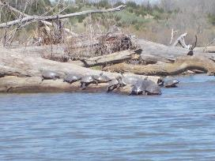
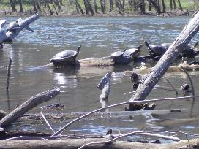

Figure 5: Lots of turtles sunning on a log Figure 6: More turtles near what we call “Turtle Island”

