RIVANNA RIVER STEWARD REPORT
River Stewards: Dan Triman and Justin Altice Date: 04-17-16
Starting Location and Time: Crofton (12:00 PM)
Ending Location and Time: Palmyra (3:00 PM)
Weather: Sunny Recent Precipitation: Not much rain this week
USGS Gauges: Earlysville 1.76 ft (72 ft³ / sec), Palmyra 3.39 ft (441 ft³ / sec),
Water Color: Very clear Water Odor: None Air Temp. : 75 deg F
DO: 4 ppm PH: 9 Turbidity: 0 JTU Water Temp. : 16 deg C
Water Testing Location: Pettit Island River Left (37°53'19.9"N 78°16'29.5"W)
---------------------------------------------------------------------------------
Land Use:
Mostly open space and wooded areas, with some farms and residential.

Wildlife Sightings and Plant Life:
Turtles, Crows, Bass, Catfish, Gar, Hawk, Ducks, River Otter. Some Spring flowers blooming, variety of trees and vegetation seen along the banks, with some invasives such as bamboo noticed.

People Interactions:
Saw 12 other people on the River today, some of which were fishing, some canoeing and kayaking, and some swimming in the River.

Litter and Pollution:
We removed ½ a bag of trash from the River. It was mostly cans and bottles, and we also found a few larger pieces of trash along the way. There are still a number of tires buried in the River or on the banks in this stretch of the Rivanna, some of which are pretty large in size.

Overall Summary:
We were joined on this paddle by Gabe Silver from Rivanna River Company and Eric Rogan. This paddle was a scouting trip for our Sojourn paddle next week on the same stretch of the Rivanna. Water levels were down slightly, but were good enough to paddle without much trouble. The water was about as clear as we have seen it, making for good fish visibility. Lots of turtles out today, and spotted a River Otter as well. Overall it was a beautiful day to be out on the River.

Actions Needed – level of priority (1 highest/5 lowest):
4 – Remove remaining tires from the River

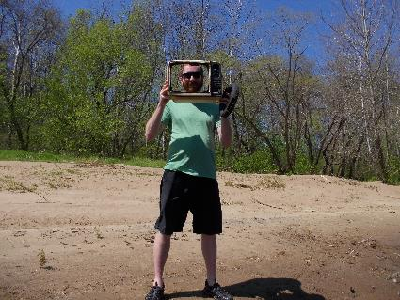
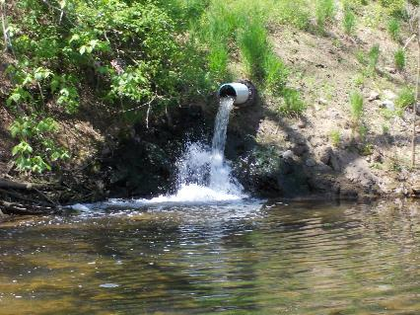
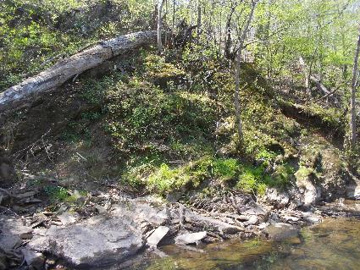
Figure 1: Lake Monticello pipe outfall near Crofton Figure 2: Justin with some of the larger trash items found
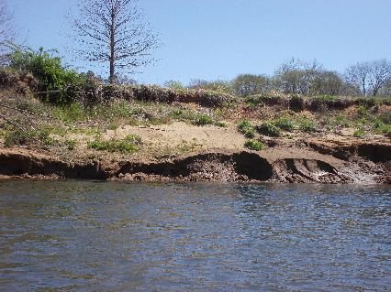
Figure 3: Erosion on banks near Crofton Figure 4: Moss and flowers on rocky bank
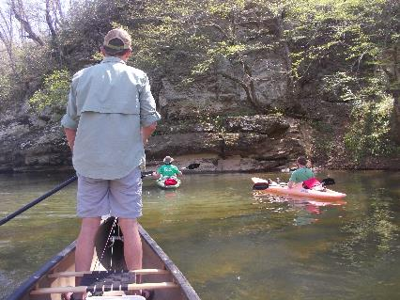
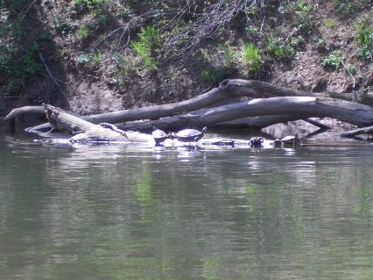
Figure 5: Some of the many turtles we saw today Figure 6: Gabe, Justin, and Eric looking for the River Otter

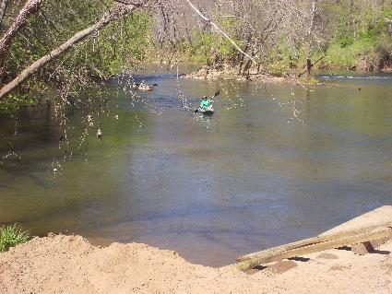
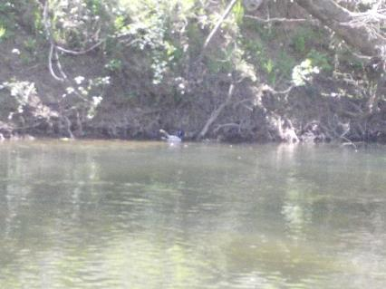
Figure 7: Couple of ducks swimming Figure 8: Finishing up the paddle at Palmyra

