RIVANNA RIVER STEWARD REPORT
River Stewards: Justin Altice Date: 04-2-16
Starting Location and Time: Riverview Park (3:00 PM)
Ending Location and Time: Milton Access Point (5:30 PM)
Weather: Fair Sky, Breezy Recent Precipitation: Some moderate rain the previous night
USGS Gauges: Earlysville 1.90 ft (93 ft² / sec), Palmyra 3.7 ft (671 ft² / sec),
Water Color: Mostly Clear Water Odor: None Air Temp. : 68 deg F
DO: 4 ppm PH: 9 Turbidity: 10 JTU Water Temp. : 14 deg C
Water Testing Location: At Milton takeout.
---------------------------------------------------------------------------------
Land Use:
Some residential near Riverview Park, with more open land with sparse residential and the railroad track beyond the park

Wildlife Sightings and Plant Life:
Turtles, Ducks, Fish, Geese, Crows and Heron.
Redbuds were observed along with a few other trees starting to bud from recent warmer temps.

People Interactions:
A good amount of folks were out enjoying Riverview Park. I took two community members that I know along with me on my paddle. We saw one other person in a canoe along the way. We also saw a few people on bikes using the County Trail along the River.

Litter and Pollution:
I removed a bag of trash from the River. Mostly consisted of plastic bottles, bags, can, Styrofoam items, and a larger plastic item.

Overall Summary:
Water levels were at a moderate level with recent rains with the water pretty clear most of the way. The Riverview Park steps mentioned before really need attention as the soil has eroded at the bottom and they are a hazard as they currently stand. Encountered a train near the 64 overpass which offers a rare vantage point. Many birds were out and a few fish were sighted. The forest is still mainly barren from winter which offers increased sight lines. I took out two community members who were new to kayaking and enjoyed the experience immensely. This stretch of the River is one of the most active and offers 4 different rapid areas. The Milton access point needs a marker to indicate its location as you can easily paddle right by it and the water moves fast in this area. The pH at the Milton access point was 9, this is the highest I have ever received on the Rivanna in 3 years. I took the test 3 times to make sure it was accurate. This increased acidity at this location could have been due to the abundance of plant life there and also the late afternoon timeframe of the day. This can be rechecked when this site is visited again.

Actions Needed – level of priority (1 highest/5 lowest):
4 – fix Riverview Park steps for safety issues
3 – Create Marker at Milton pull out on the water.
2 – Retest pH at Milton access point.

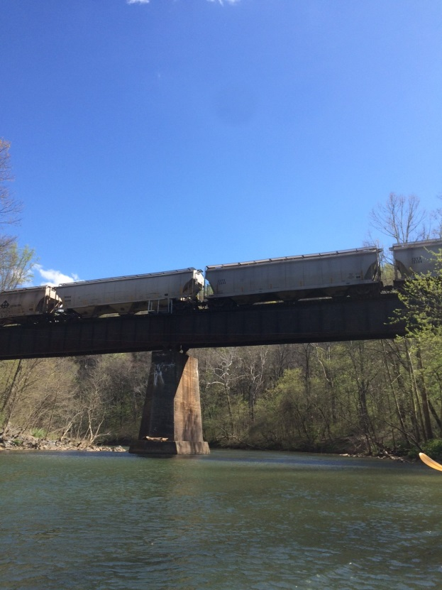
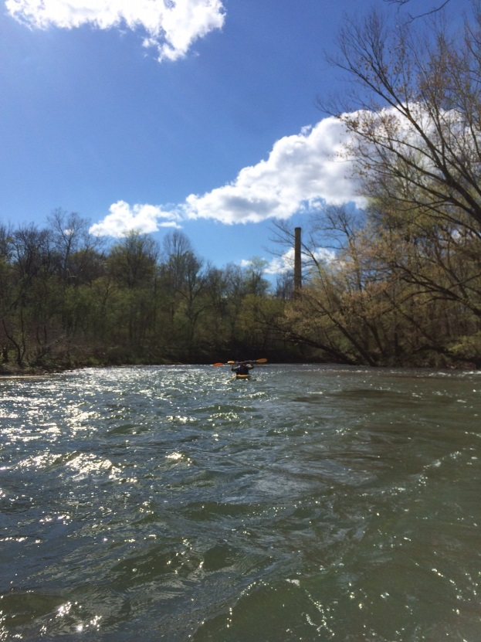
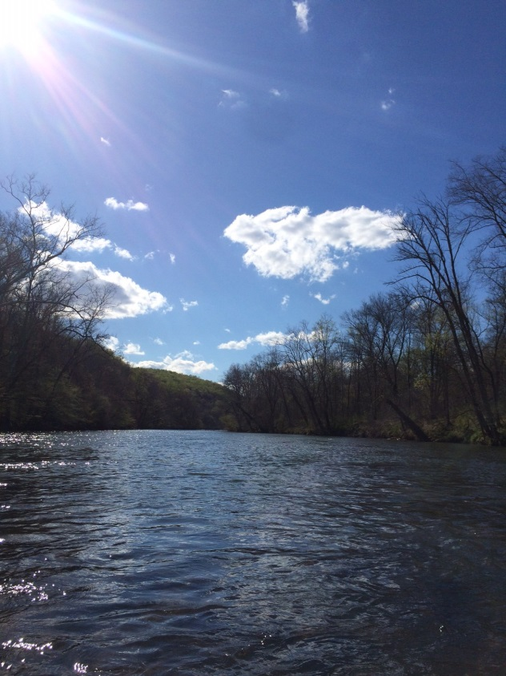
Figure 1: Looking up back up River at Woolen Mills. Figure 2: Train going overhead near I-64 overpass.
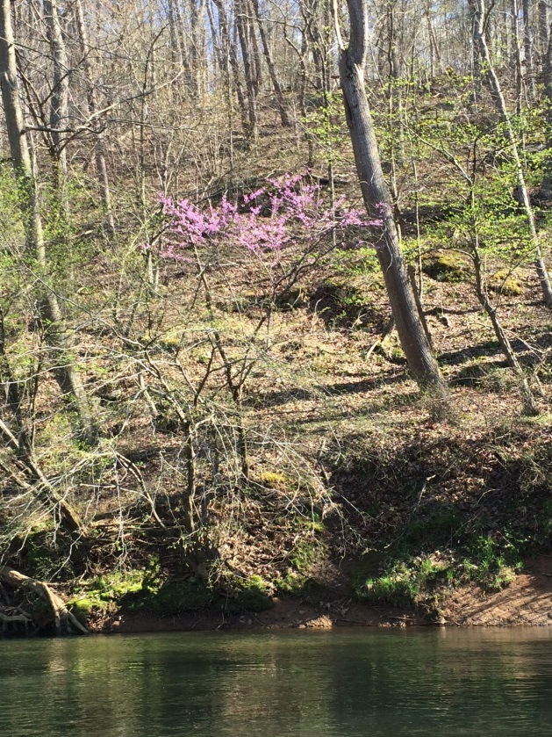
Figure 3: Redbud blooming along the River. Figure 4: Beautiful day to be on the Rivanna.

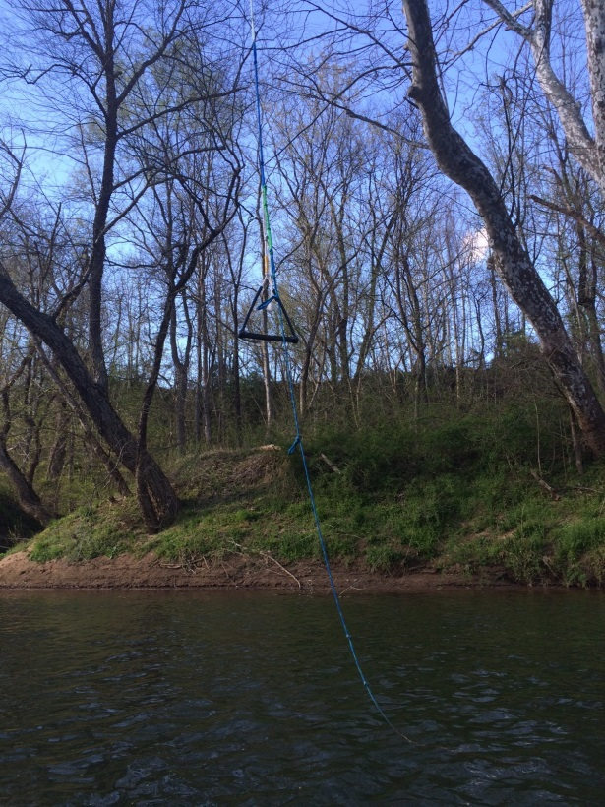
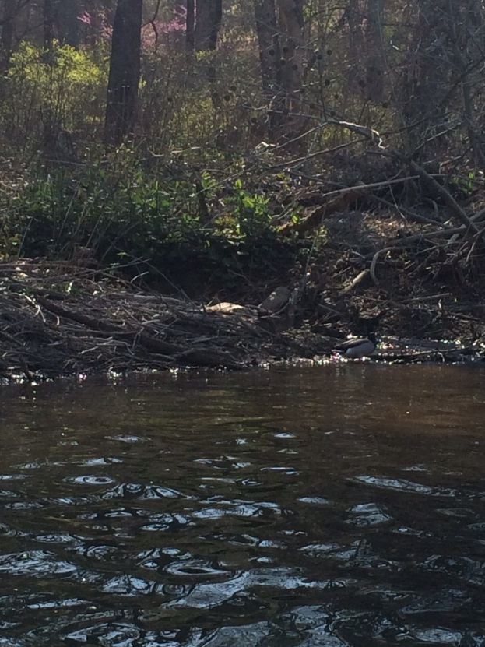
Figure 5: A pair of Ducks on the River. Figure 6: A rope swing tied to a tree.

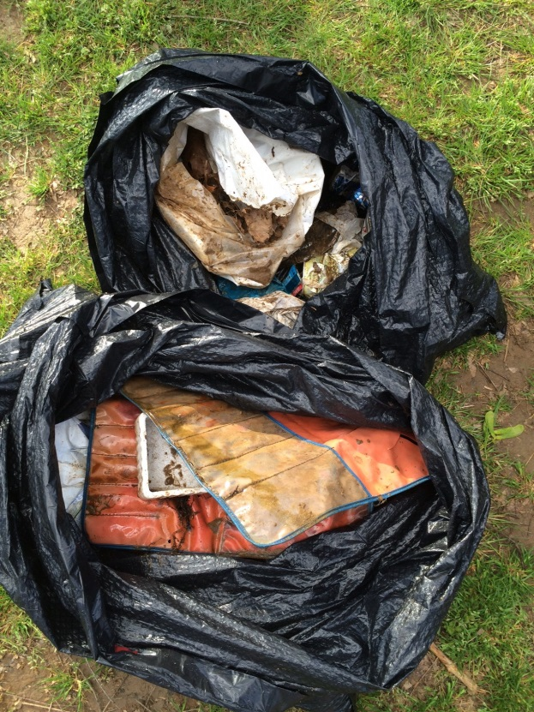
Figure 7: Trash picked up along paddle.

