RIVANNA RIVER STEWARD REPORT
River Steward Name(s): Dan Triman Date: 05-02-15
Starting Location and Time: Palmyra 10:15 AM
Ending Location and Time: Columbia 4:45 PM
Weather: Overcast Recent Precipitation: Some rain recently
Water Flow: Moderate Water Color: Brownish / Murky Water Odor: None
Water Temp. : 16 deg C Air Temp. : 70 deg F
DO: 6 ppm PH: 8.0 Turbidity: 40 JTU
USGS Water Gauge Reading: Earlysville 2.2 ft, Palmyra 4.1 ft
Physical Location Characteristics: Sand bank River right near Fork Union
Specific Location Testing Performed: 37°48'5.23"N 78°13'50.32"W
Land Use:
Mostly farmland and wooded areas with only a few scattered residential areas along the way.

Wildlife Sightings and Plant Life:
Today we saw an otter, turtles, Cormorants, numerous smaller birds, Hawks, Crows, Geese and babies, Ducks and babies, Fish jumping out of the water, butterflies, and 2 black water snakes. Lots of trees and plants growing along the banks, with a good deal of downed trees in the water.

People Interactions:
During the entire 16 mile paddle we only saw a couple of people fishing as we got within the last ¼ mile of the trip in Columbia.

Litter and Pollution:
We managed to pick up about 1/2 bag worth of trash from the river. It was mostly bottles and cans, with a few larger items like balls and foam pieces. About 10 tires were spotted in or along the banks of the River.

Overall Summary:
This was a great paddle trip overall. There wasn’t much litter on this stretch, but there was significant erosion on the banks with lots of trees down. Saw a good amount of wildlife as well as tracks in the sand from other animals. Not many people seen during the trip. Power line wire is down and in the water just past the VA-6 Bridge.

Actions Needed – level of priority (1 highest/5 lowest)
2 – Remove power line from the water; 4 – Remove tires from River.
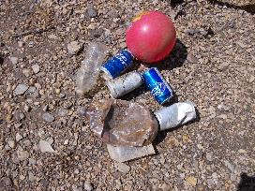
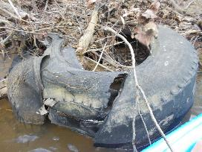
Figure 1: One of the tires spotted in the River Figure 2: Some of the trash collected on one of the beaches

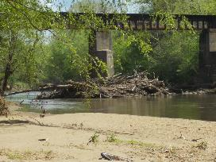
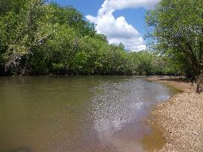
Figure 3: View of the Rivanna looking upstream Figure 4: Large amount of debris piled below bridge

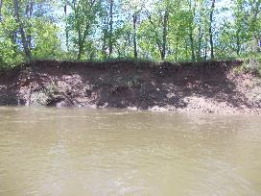
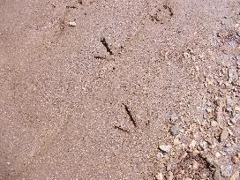

Figure 5: Bird tracks in the sand Figure 6: Example of one of the eroded river banks

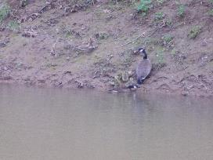
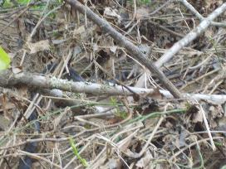
Figure 7: Black water snake hiding amongst the branches Figure 8: Adult and baby geese along the river bank (lower left of the photo)

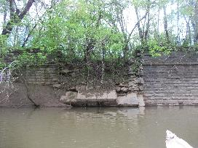
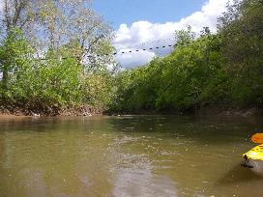
Figure 9: Power line down in water just after VA-6 bridge Figure 10: Remains of old bridge near Columbia
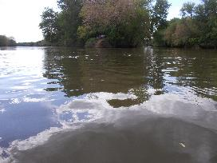
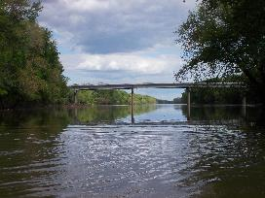
Figure 11: View of James River where it meets the Rivanna Figure 12: Confluence of the James and Rivanna Rivers

